Tiny URL (URL Shortener)
Editorial Solution
Quiz
AI Whiteboard
Overview
Introduction
Requirements
Data Model
API Design
Basic Implementation
Advanced Implementation
Create URL Flow
Redirect URL Flow
Additional Discussion Points
Introduction
Tiny URL (URL shortener) is one of the most popular system design questions out there. On the surface it can appear as a very simple problem to solve, but it is possible to go deep on some of the scalability issues which many interviewers will expect.
This example will cover two solutions, a basic implementation and an advanced implementation. The basic implementation, has scalability issues but is worth noting, as discussing those flaws and a potential solution in the advanced implementation, will show a depth of understanding most candidates will not have.
Requirements
Functional Requirements
Given a long URL create a short URL
Given a short URL redirect to a long URL
Non Functional Requirements
Very low latency
Very high availability
Not covered
Updating of URLs
Deleting of URLs
Data Model
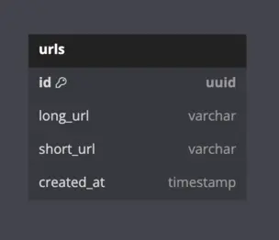
This data model contains one table urls which has the following fields:
longUrl: The URL provided by the user.
shortUrl: The generated short URL which will be used to redirect users.
createdAt: When the short URL was created.
API Design
Given the simplicity of the of data, a classic RESTful API could be used. RESTful APIs are simple, widely used, stateless, and support caching which make it a perfect candidate for our system.
Our REST API will comprise of two main endpoints:
POST: /create-url
Params: longURL
Status code: 201 created
GET: /{short-url}
Status code: 301 permanent redirect
From the data model we can see that the data is not deeply nested or interrelated which would negate many of the benefits of using a GraphQL API.
Key Questions
How long should the URL be?
Need to know the scale of the application to answer this question.
Example: 1,000 URLs generated per second.
1,000 * 60 * 60 * 24 * 365 = 31.5 billion URLs created each year
10 to 1 read to write requests means ≈ 300 billion reads per year
What characters can we use?
Alphanumeric:
a - z: 26 characters
A - Z: 26 characters
0 - 9: 10 characters
Total: 62 characters
Unique short URLs (varying characters):
1 character: 621 → 62 URLs
2 characters: 622 → 3,844 URLs
...
6 characters: 626 → 56 billion URLs
7 characters: 627 → 3.5 trillion URLs
Basic Implementation
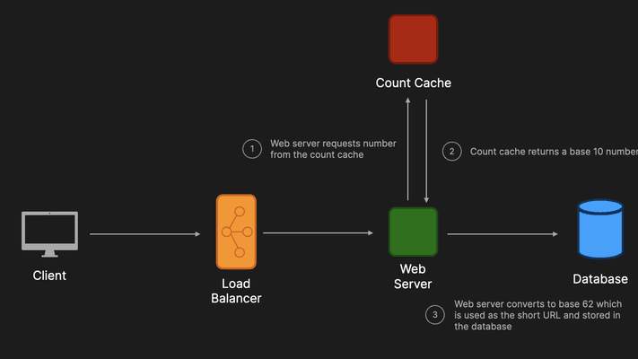
In the basic implementation we could have a client make a request which goes to a load balancer which then distributes the request to a web server. This web server will receive a base 10 number from the count cache which it will then convert to base 62 and be used as the short URL. This short URL can then be stored in a database and returned to the user.
While this does technically work, it will not be able to handle the scale discussed previously. It also introduces single points of failure in the web server, count cache, and database and so a better solution is needed.
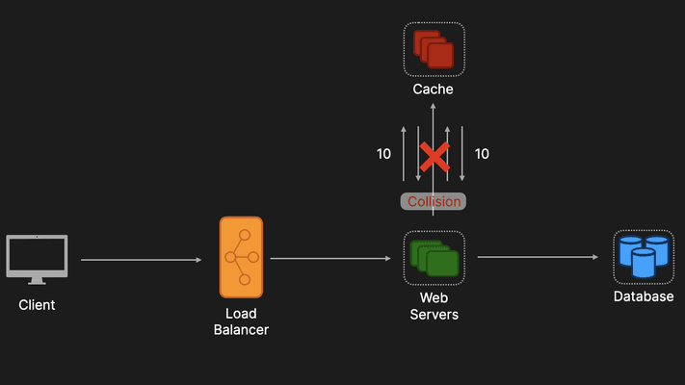
To remove the single point of failures, the web servers, count caches, and database have all been horizontally scaled.
However, if one web server makes a request to one count cache and another web server makes another request to another count cache, as there is no coordination among the caches there is nothing stopping them returning the same number which would cause a collision. Collisions are something that cannot be tolerated in our system and so a better design is needed.
Advanced Implementation
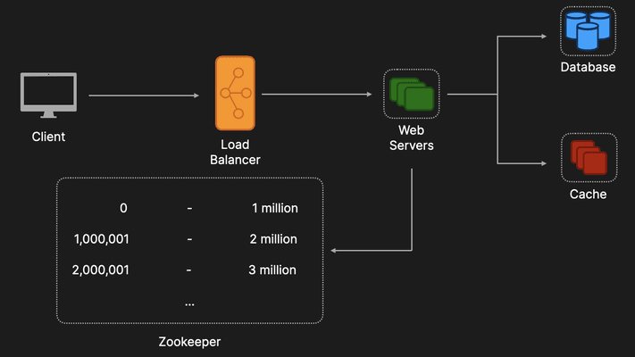
ZooKeeper
Instead of having distributed count caches, ZooKeeper will be used instead. ZooKeeper can be used as a centralized service for maintaining configuration information and synchronization in a distributed setting.
In this architecture ZooKeeper will being used to maintain number ranges (1 million values per range). When a web sever comes online it will reach out to the ZooKeeper to get a range. Once given a range a web server will use those numbers to generate short URLs. This will allow us to avoid the collision problem encountered in the previous design.
Even if a web server were to go down straight after being given a range and those million values were lost, given that we have such a large number of values (3.5 trillion) it isn't really an issue.
An interviewer could point out that the ZooKeeper is now a single point of failure. So we could horizontally scale instances of the ZooKeeper, but it is also important to remember that unlike the count cache which received a request every time a new URL was to be created. A web server will only make a request to ZooKeeper to get a range of values which reduces the load by a factor of a million (the range chosen).
Database Selection
An SQL database like MySQL or PostgreSQL could be a valid choice of database in our design but we may have to introduce sharding to handle the high read volume. However, in this particular case given the high read volume a NoSQL database like Cassandra may be a better choice.
Caching
If we wanted to further reduce the load on the database we could also introduce a cache where popular short URLs and their corresponding long URLs are stored. Popular choices of caches include Memcached or Redis.
A cache eviction policy of least recently used (LRU) could be an adequate solution for this system.
Create URL Flow
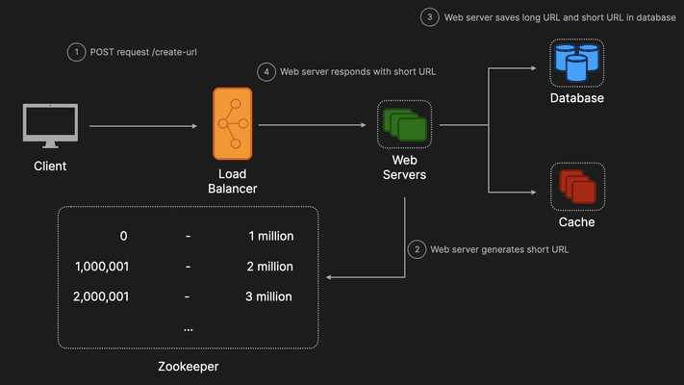
A client makes a POST request with the long URL in the request parameters. (The load balancer distributes the request to a web server)
A web server generates the short URL.
A web server saves the long URL and short URL in the database (can also store the URLs in the cache with a specified TTL).
The web server responds to the client with the newly created short URL.
Redirect URL Flow
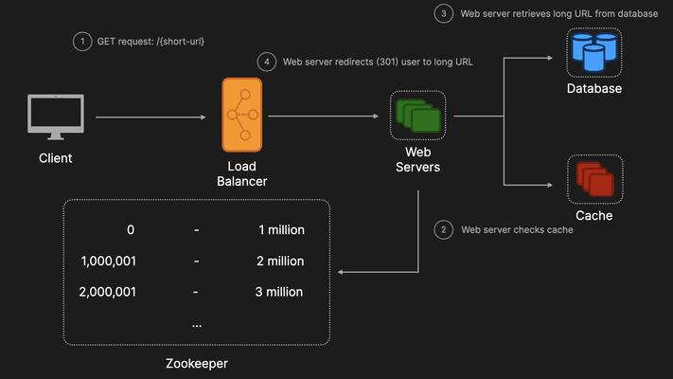
A client makes a GET request with the short URL. (The load balancer distributes the request to a web server)
A web server checks to see if the short URL is stored in the cache.
If the short URL is not present in the cache, the web server retrieves the long URL from the database.
The web server redirects (301 permanent redirect) the user to the long URL.
Additional discussion points
Analytics
Counts for each URL to determine which short URLs to cache.
IP address to store location information to determine where to locate caches etc.
Rate Limiting
Prevent DDoS attacks by malicious users.
Security Considerations
Add random suffix to the short URL to prevent hackers predicting URLs.
Will give rise to longer URLs but the tradeoff between URL length and security can be worth discussing in the interview.

Rate Limiter
Editorial Solution
Quiz
AI Whiteboard
Overview
Introduction
Use Cases
Where to Implement?
Requirements
Popular Rate Limiting Algorithms
Architecture
Real World Example
Additional Discussion Points
Introduction
A rate limiter is a tool or mechanism that controls the number of requests or actions a user or system can perform within a specific time frame.
Think of it like a bouncer at a club, deciding how many people can enter at a time to keep everything running smoothly.
Use Cases
Prevent Overload: They stop too many requests from overwhelming a system, ensuring it remains responsive and doesn’t crash.
Protect Against DDoS Attacks: Rate limiters help mitigate Distributed Denial of Service (DDoS) attacks by controlling the flood of incoming traffic from multiple sources aimed at overwhelming a system.
Fair Usage: They ensure that all users have equal access to resources, preventing a few users from hogging all the bandwidth or computing power.
Cost Management: By controlling usage, they help manage and predict costs, especially in services that charge based on usage.
Where to Implement?
Client Side
Where: On the user’s device, such as within a mobile app or web browser.
Purpose: To prevent the client from making too many requests to the server, either accidentally or intentionally.
Pros:
Immediate Feedback: Users receive instant responses about request limits without needing server interaction.
Reduced Server Load: Limits some traffic before it even reaches the server, saving resources.
Cons:
Easily Bypassed: Users can modify or disable the limiter, rendering it ineffective.
Inconsistent Enforcement: Different clients might implement rate limiting differently, leading to uneven control.
Server Side
Where: On the backend servers that handle requests from users.
Purpose: To protect the server from being overwhelmed by too many requests at once.
Pros:
Centralized Control: Ensures consistent enforcement of rate limits across all clients.
Enhanced Security: More difficult for attackers to bypass compared to client-side limits.
Cons:
Increased Server Load: Rate limiting logic consumes server resources.
Scalability Challenges: May require additional infrastructure to handle high traffic volumes efficiently.
Middleware
Where: In the intermediary layer between the client and the server, often part of the infrastructure like APIs or gateways.
Purpose: To manage and distribute incoming traffic before it reaches the main server, providing an additional layer of protection.
Pros:
Scalable Management: Can handle high volumes of traffic more efficiently by offloading rate limiting from the main servers.
Flexible Policies: Easily apply different rate limiting rules for various services or user groups.
Cons:
Additional Complexity: Introduces another component to manage and maintain within the system architecture.
Potential Bottleneck: If not properly scaled, the middleware itself can become a point of failure or congestion.
Middleware rate limiters are commonly used in large-scale systems with microservices architectures. They come in the form of API gateways (AWS API Gateway) to enforce rate limits, authenticate requests, and route traffic efficiently.
Requirements
Define Rate Limits: Specify the maximum number of requests allowed per user, IP address, or service within a certain time frame (e.g., 100 requests per minute).
Configurability and Flexibility: Allow dynamic configuration of rate limits without requiring system downtime, and support different policies (e.g., fixed window, sliding window).
Low Latency and High Performance: Implement the rate limiter with minimal impact on request processing time.
Popular Rate Limiting Algorithms
Token Bucket
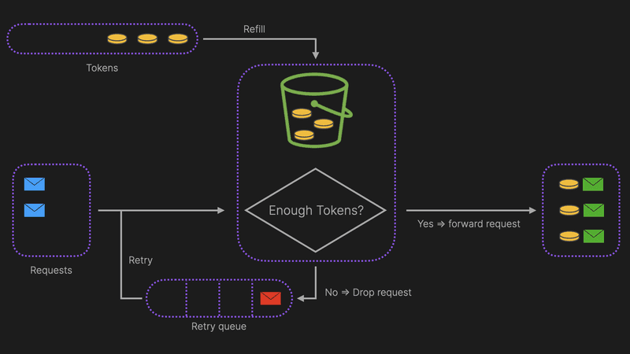
How It Works:
Imagine a bucket that holds a fixed number of tokens.
Tokens are added to the bucket at a steady rate (e.g., 5 tokens per second).
Each incoming request requires a token to proceed.
If a token is available, it's removed from the bucket, and the request is allowed.
If no tokens are available, the request is denied or queued until a token becomes available.
Example:
API Rate Limiting: An API allows users to make up to 100 requests per minute. Tokens are added to the bucket at a rate of ~1.67 tokens per second. If a user bursts and sends 50 requests quickly, the bucket allows it as long as there are enough tokens. Subsequent requests are limited based on the token availability.
Leaky Bucket
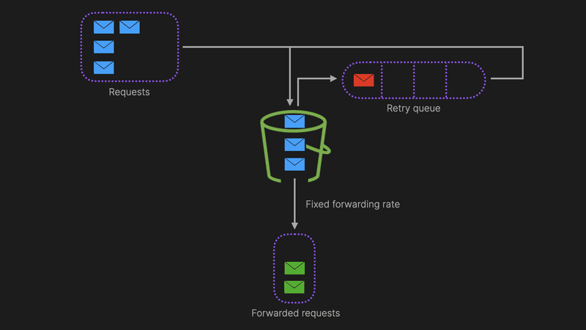
How It Works:
Visualize a bucket with a small hole at the bottom through which water (requests) leaks out at a constant rate.
Incoming requests are added to the bucket.
If the bucket overflows (i.e., too many requests arrive too quickly), excess requests are discarded or delayed.
This ensures that requests are processed at a steady, predictable rate.
Example:
Streaming Services: A video streaming service uses the leaky bucket algorithm to ensure a smooth playback experience. Requests to stream video segments are regulated so that data flows at a consistent rate, preventing buffering and ensuring uninterrupted viewing.
Fixed Window
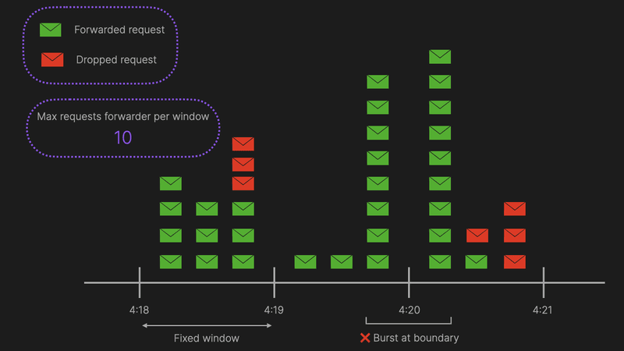
How It Works:
Time is divided into fixed intervals or "windows" (e.g., 1 minute).
The number of requests is counted within each window.
Once the limit is reached within a window, additional requests are blocked until the next window starts.
Simple to implement but can lead to bursts at window boundaries.
Example:
Login Attempts: A website restricts users to 10 login attempts per hour using a fixed window. If a user exceeds this limit within the hour, further login attempts are blocked until the next hour begins, reducing the risk of brute-force attacks.
Sliding Window
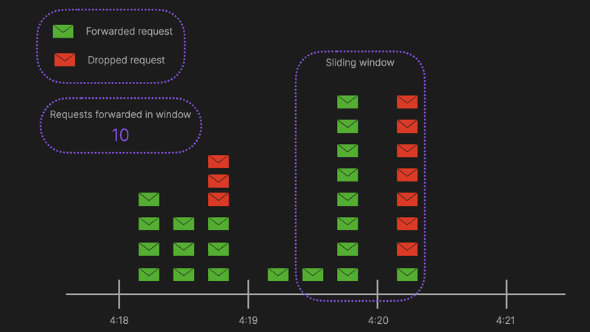
How It Works:
Similar to the fixed window but offers more granularity.
Instead of fixed intervals, it continuously tracks the number of requests in the past defined period (e.g., last 60 seconds).
As time moves forward, the window "slides," removing old requests and adding new ones.
Prevents the burst issue seen in fixed windows by distributing request limits more evenly over time.
Example:
Chat Applications: A messaging app limits users to sending 20 messages per minute using a sliding window. This ensures that users can't flood the chat with messages all at once and maintains a steady flow of communication, enhancing user experience.
Architecture
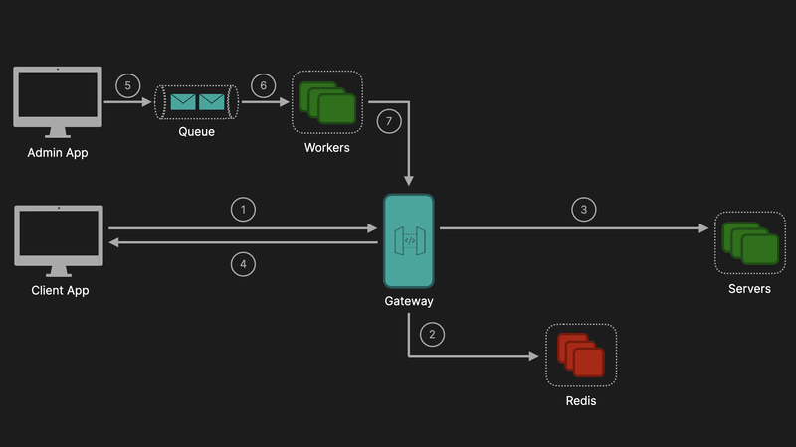
Client Request Flow:
Client Sends Request: The process begins with the client initiating a request to your system.
API Gateway with Rate Limiting Logic: The request first hits the API Gateway, which is responsible for managing and enforcing rate limits. Embedding the rate limiting logic within the API Gateway is a common and effective approach, as it centralizes control and simplifies management.
Rate Limit Verification:
Redis Integration: The API Gateway communicates with Redis to verify if the user has available tokens in their dedicated token bucket. Redis is an excellent choice for this purpose due to its high performance and low latency, which are crucial for real-time rate limiting.
Allowed Request:
If the user has sufficient tokens, the request is forwarded to the appropriate backend service for processing.
Rejected Request:
If the token bucket is empty, the API Gateway responds with a 429 Too Many Requests status code, indicating that the user has exceeded their rate limit.
Admin Dashboard:
An administrator makes changes to the rate limiting rules via the admin dashboard which will publish a messages to a queue (which can be implemented using something like Amazon SNS).
Lambda Function:
The Lambda function receives a message from SNS, and then updates the API Gateway's in-memory configuration using AWS APIs or SDKs.
Real World Example
Stripe uses the token bucket algorithm to do rate limiting. As we discussed the algorithm has a centralized bucket host where tokens are removed on each request, and tokens are slowly added into the bucket. And If the bucket is empty, the request is rejected. In Stripe's case, every user has a bucket, and every time they make a request we remove a token from that bucket.
Stripe implements rate limiters using Redis.
Additional Discussion Points
Burst Handling:
Implementing a burst capacity in your token bucket algorithm can allow temporary spikes in traffic without immediately rejecting requests, improving user experience.
Distributed Rate Limiting:
If operating in a highly distributed environment, ensure that your Redis setup is optimized for distributed access, possibly using Redis Cluster for better scalability and reliability.
Logging & Alarms:
All rate-limiting events, including allowed and rejected requests, are logged using Amazon CloudWatch. This provides visibility into the system’s performance and user behavior. CloudWatch alarms can be set up to trigger notifications when certain thresholds are met (e.g., a spike in rejected requests), enabling proactive analysis and potential adjustments to the rate limiting strategy.

Notification System
Editorial Solution
Quiz
AI Whiteboard
Overview
Introduction
Requirements
Data Model
Basic Implementation
Advanced Implementation
Additional Discussion Points
Introduction
A notification system is a system that provides a means of delivering a message to a set of recipients.
There are many different channels notifications can be delivered through including Email, SMS, iOS, Android and many others. Nowadays notification systems are commonplace, (e.g. placing and order on Amazon and receiving an email confirming the order has been placed).
Requirements
Functional Requirements
Send notifications to different channels (Email, SMS, iOS, Android)
Extendable (ability to add more notification channels)
Non Functional Requirements
High availability
High scalability
Reliable (no notifications are lost)
Not covered
Bulk sending of notifications (e.g. for all users that match a specific criteria)
Data Model
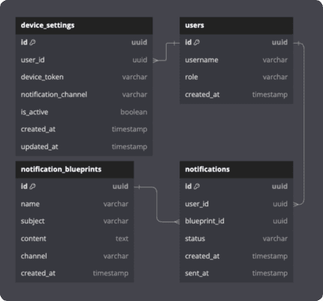
This is a basic outline of some of the core tables that could be included in a notification system data model.
users
Contains information related to the user.
device_settings
user_id: Foreign key which is used to identify which user to which the notification was sent.
device_token: The token which is used to enable the pushing of notifications to different services (e.g. FCM, APNs)
notification_channel: The channel which the settings belong to (e.g. email, SMS etc.)
is_active: Whether a user has consented to receiving notifications for that device.
notifications
user_id: Foreign key which is used to determine which user is associated with the notification.
blueprint_id: Foreign key which is used to determine which blueprint is associated with the notification.
notification_blueprints
content: The actual contents if the notification (e.g. HTML, plain text, JSON etc.)
channel: The channel which this blueprint is intended to be sent to (e.g., email, SMS etc.)
To support bulk notifications a table user_notifications could be added to create a many to many relationship between users and notifications.
Basic Implementation
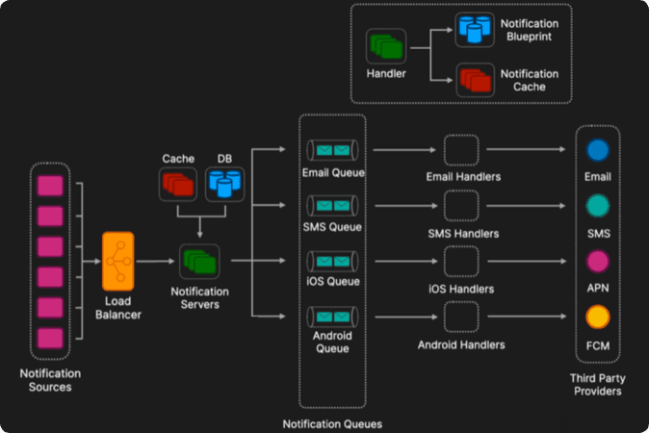
Notification Sources
Notification Sources are the upstream services that trigger notifications and can include internal services, external services, scripts, and cron jobs.
Load Balancer
Ensures that requests are distributed evenly among the Notification Handler servers.
Notification Servers
The servers will check the device_settings table to ensure that a user has consented to receive notifications in this channel. Given the relational nature of the data this database could be implemented with an SQL database.
Rate limiting can also be implemented here with a cache like Redis for each user to track how many notifications of each type they have been sent. Rules can be configured to improve the user experience (e.g. a user can receive a maximum of only two promotional marketing notifications per day).
Notification Queues
If a user hasn't consented to receiving notifications on that channel, the system can stop processing the notification.
If the user has consented, the system can then push the message onto the relevant queue based on the associated channel.
This can be implemented with Kafka or Amazon SNS, or Pub/Sub in Google Cloud Platform.
In this system we will use Kafka and to prevent duplicates during retries, Kafka offers an idempotent producer feature. When enabled, the producer ensures exactly once delivery to a Kafka topic, even across retries.
Notification servers are the producers and each topic corresponds to a specific channel.
It is easy to add new topics to Kafka which makes the system extendable for adding channels in the future as the system evolves.
Lightweight Handlers
The lightweight handlers act as the consumers and pull messages off their designated topic. These could be implemented with AWS lambda functions or Google Cloud Platform Functions.
Each lightweight handler will query the notification cache and database to get the blueprint associated with the notification. The notification can then be sent onto the relevant third party service.
If message processing fails, the lightweight handler can either retry immediately or reset the offset to reprocess the message later. Commit strategies (automatic or manual) and policies (e.g. at least once, at most once, exactly once) influence how and when offsets are committed.
Exponential backoff is a strategy used in computing to gradually and adaptively increase the waiting time between retries of a failed operation, with the goal of reducing the load on the system and increasing the likelihood of success in subsequent attempts.
A dead-letter queue (DLQ) could be implemented for messages that can't be processed after several attempts, a common pattern is to redirect these messages to a dead-letter queue, a separate Kafka topic can be created where failed messages are stored for further investigation or reprocessing.
Third Party Services
For iOS and Android notifications they can be sent to Apple Push Notification Service (APNs) and Firebase Cloud Messaging (FCM) respectively.
For email notifications, using third party services like MailChimp or MailJet is a good option as they handle many common issues when trying to send emails at scale include implementing authentication protocols such as Sender Policy Framework (SPF), DomainKeys Identified Mail (DKIM), and Domain-based Message Authentication, Reporting, and Conformance (DMARC), as well as reputation management and IP warming, which ensure that emails are actually delivered and not marked as spam. They also include other tools like audience segmentation and analytics so the system will be able to see which notifications users are actually viewing.
For SMS notifications, using third party services like Twilio is a good option as it again handles the infrastructure to ensure SMSs are actually delivered and will also provide monitoring and analytics to see which SMS notifications are performing well.
Advanced Implementation
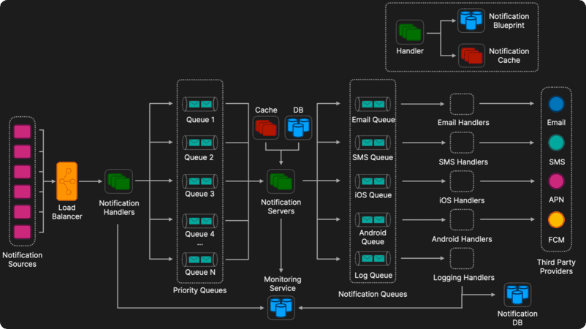
The Advanced Implementation is identical to the basic Implementation except for the following additions:
Notification Handlers
This service has a few roles including simple authentication to ensure that the service interacting with the notification service is able to do so. We can use basic API keys to ensure that a service has the appropriate access level.
The handlers also push each message onto the priority queues.
Priority Queues
Each notification belongs to a channel and some channels will be more important than others (e.g. billing and invoice notifications are typically more important than generic marketing notifications)
Each message will be placed on a queue and this is done as we want to improve scalability, and to decouple the system services.
To implement this you could use something like Kafka or Amazon SNS, or Pub/Sub in Google Cloud Platform.
In this system we will use Kafka. While Kafka doesn't natively support priority queues, you can implement a similar mechanism by creating separate topics for each priority level (e.g. high, medium, low). Producers send notifications to the appropriate topic based on their priority. Consumers first consume messages from higher-priority topics before moving to lower-priority ones. This approach is simple and leverages Kafka's scalability and reliability, but it requires careful consumer management to ensure that higher-priority messages are always processed first.
Notification Servers
Pulls messages off the priority queues with a bias towards pulling from the more important queues to ensure that the more important notifications are being handled first. Also implements rate limiting and ensures the user has consented to receive notifications for that channel as described in the Basic Implementation.
Notification Logger
A log queue can be added to the Notification Queues where every message is sent regardless of its channel and then stored in the Notification Database which can be used for auditing purposes. Given that this database will be write heavy with bulk read, a NoSQL database like Cassandra would be a good choice.
Analytics Service
The analytics service will be used to see the lifecycle of each notification as it passes through the system.
Again this database will be write heavy with bulk read, a NoSQL database like Cassandra would be a good choice.
Additional Discussion Points
Scalability
Horizontal scaling of individual services.
Reliability
Multi-data center approach.
Kafka can act as a highly durable message buffer, ensuring that messages are not lost even in the event of processing failures.
Retry mechanisms: Elaborate on how the system can intelligently retry sending notifications without overwhelming the server or the user, including exponential backoff strategies.
Dead letter queues to ensure delivery
Notification blueprint storage
Cloud Storage (e.g., AWS S3, Azure Blob Storage): Scales well, accessible from anywhere, and integrates with cloud ecosystems. However, access might introduce latency. Best used with caching mechanisms.
Content Delivery Network (CDN): Ideal for global systems to reduce latency. Can be used to cache templates closer to the user. However, it can be more complex to set up and manage.
Security and Privacy
Address how you would protect user data and ensure that the notification system complies with data protection regulations like GDPR or CCPA.
Basic vs Advanced Implementation
In some interviews there may not be enough time or the interviewer may not want the additional services implemented in the Advanced Implementation like prioritisation, auditing, or analytics, so make sure to ask clarifying questions early to determine which implementation would best suit the interview.

News Feed (Twitter, X)
Editorial Solution
Quiz
AI Whiteboard
Overview
Requirements
Estimates
Data Model
API Design
Feed Publishing
Architecture Overview
Additional Discussion Points
Requirements
Functional Requirements
Feed publishing
Feed retrieval
Notification, Analytics service etc.
Non Functional Requirements
High availability
Minimal latency
Not covered
Machine learning generated newsfeed (assuming reverse chronological newsfeed)
Estimates
20 million DAU (daily active users)
Average 5 tweets per day
5 * 20 million = 100 million tweets / day
100 million / ( 60 secs * 60 mins * 24 hrs ) ≈ 1,000 tweets / second
Assume 100 : 1 read to write ratio: ≈ 100,000 read requests / second
100 million * 100 bytes ≈ 10 GB / day
10 GB * 365 days * 10 years = 36.5 TB
Data Model
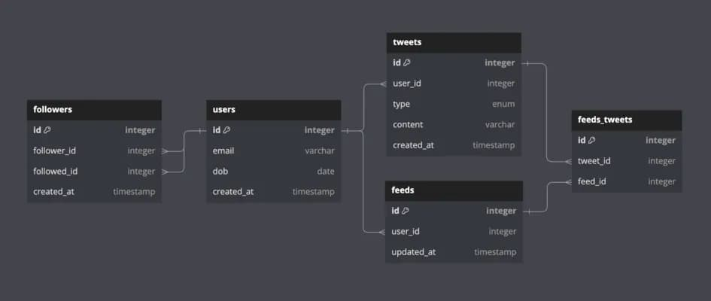
This is a basic outline of some of the core tables that could be included in a newsfeed data model.
users
Contains information related to the user.
tweets
user_id: Foreign key which is used to identify which user created the tweet.
type: Enum which used to determine which type of tweet it is (retweet etc.)
content: Actual content of the tweet (only text allowed in this model).
followers
follower_id & followee_id: Two foreign keys which enable the system to know which users are following each other
feeds
user_id: Foreign key which is used to identify which user the feed belongs.
Note: users can have several feeds (e.g. Instagram, home and explore feeds)
feeds_tweets
feed_id: Foreign key which is used to identify which feed the tweet belongs to.
tweet_id: Foreign key which is used to identify the specific tweet.
API Design
Given the interrelated nature of the data, a GraphQL API could be a good solution for this system. More specifically a GraphQL API would allow the client to determine which fields to fetch and prevent the over fetching of data which could lead to slower response times and an overall worse UX.
Here is an example GraphQL query for a feed:
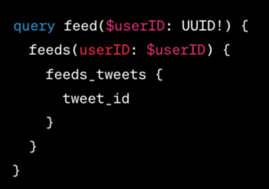
Similarly we could also use a classic RESTful API to interact with the data. RESTful APIs are simple, widely used, stateless, and support caching which make it a good candidate for our system.
Our REST API will comprise of two main endpoints:
POST: /tweet
Params: content and auth_token
Status code: 201 created
GET: /news-feed
Params: auth_token
Status code: 200 success
Feed Publishing
In our system we are going to use the fanout method to construct the newsfeeds. Fanout is the process of distributing a message or content update to all the subscribers of a particular feed.
Two main fanout strategies include:
Fanout on write (push model)
Fanout on read (pull model)
1. Fanout on write (push model)
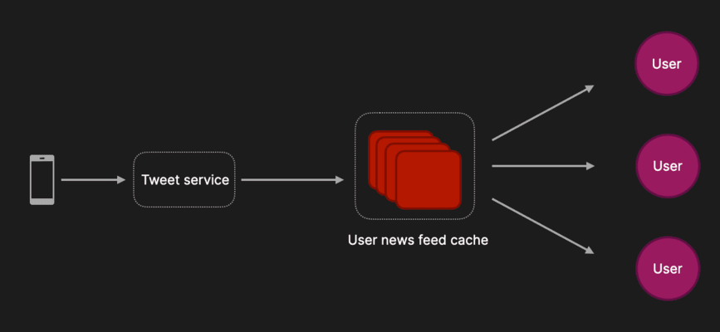
In this approach when a new piece of content is published (e.g. tweet), that content is then pushed to all the user's followers' newsfeeds cache, so that a user's newsfeed is precomputed. This makes reads very fast as a user's newsfeed has been precomputed before they make a request.
Pros:
Reads are faster as the feed is precomputed at write.
Feed is generated in real time.
Cons:
Precomputing for inactive users is a waste of resources
HotKey problem: Generating news feeds for a user with lots of followers.
E.g. If a user has millions of followers, updating millions of newsfeeds will be very resource intensive.
2. Fanout on read (pull model)
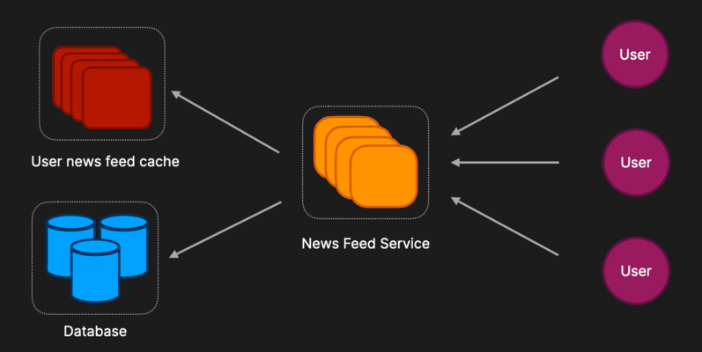
In this approach, instead of pushing content to a user's newsfeed cache on write, the system waits until a user requests (pulls) for their newsfeed and then computes the newsfeed on read.
Pros:
Don’t waste resources for inactive users.
HotKey problem is avoided.
Cons:
Reads are slower as feeds are generated when a request is made.
Hybrid Approach (recommended approach)
Use a combination of the push and pull models.
Use the push model for the majority of users.
i.e. when most people post the news feed caches of their followers are updated.
Use the pull model for celebrities (people with large followings).
To avoid overloading the system, force each user to get the latest posts from celebrities they follow on read.
Architecture Overview
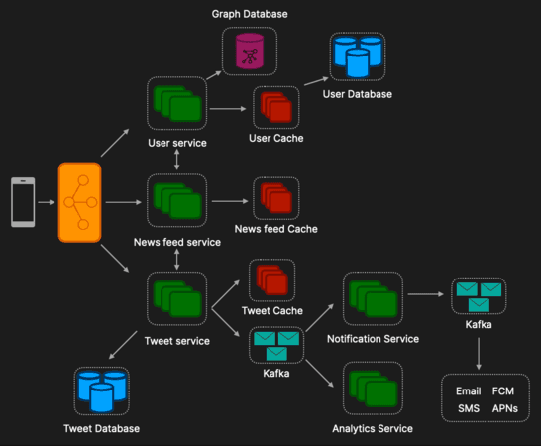
User service
Handles user related functionality including following other users etc.
Given the interconnected nature of the user data using a graph database like Neo4j would be a good choice.
Newsfeed service
Handles the publishing and retrieval of newsfeeds.
Tweet service
Handles all functionality related to tweets including posting and favoriting.
Tweet messages can also be pushed to Kafka which can then be ingested by a notifications service which can send notifications to users via Firebase Cloud Messenger (android), and Apple Push Notifications (iOS).
Notification service
Handles sending push notifications to users.
Analytics service
Tracks usage metrics which can be used to analyse the user behaviour and system performance.
Additional Discussion Points
Keep services stateless.
Horizontally scale each service to prevent single points of failure.
Spreading services across multiple data centres.
Many database read replicas to handle large read load.
Cache as much data as possible.
Monitor usage metrics in order to predict peak queries per second (QPS).
Media content and storing that media in a CDN.

Messaging App (WhatsApp, WeChat, Messenger)
Editorial Solution
Quiz
AI Whiteboard
Overview
Requirements
Estimates
Data Model
Architecture Overview
Messaging Flow
Presence Service
Additional Discussion Points
Requirements
Functional Requirements
1 - 1 Chats
Group chats (max. 150)
Media Sharing
Push notifications
Online / offline indicator
Non Functional Requirements
High availability
High scalability
Not covered
End to end encryption
Estimates
Queries Per Second (QPS)
Daily active users (DAU) = 100 million (100 * 10⁶)
Average number of daily messages sent per user: 50 messages / day / user
Average number of messages sent per day: (100 * 10⁶) * 50 = (5 * 10⁹) messages
(5 * 10⁹) / (24 hours * 60 minutes * 60 seconds) ≈ 58,000 QPS
Storage Estimate
Average message size: 150 bytes
Daily message storage: (5 * 10⁹) messages * 150 bytes ≈ 750 billion bytes ≈ 750 GB / day
Percentage of messages that include media: 10%
Daily media messages: (5 * 10⁹) * 0.1 = (5 * 10⁸)
Average media size: 100 KB
Daily media storage: (5 * 10⁸) * 100 KB ≈ 50 TB / day
Total daily storage: 750 GB + 50 TB = 50.75 TB / day
Assume store for 10 years
Total storage: 50.75 TB * 365 days * 10 years ≈ 185 PB
Data Model
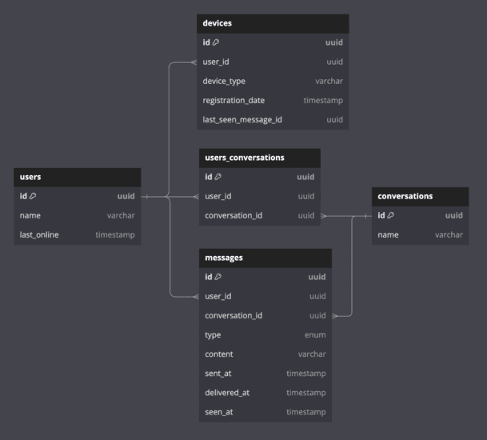
This is a basic outline of some of the core tables that could be included in a messaging system data model.
users
Contains information related to the user.
devices
user_id: Foreign key which is used to identify which user the device belongs to. Many-to-one relationship where a user can have many devices and a device can only belong to one user.
last_seen_message_id: Used to identify which message was last seen by the device so that if there are any messages with a large message_id the device knows it needs to fetch that message.
conversations
Covers both 1-1 messaging as well as group messaging, where 1-1 messaging is simply a group with only two people and a different user interface (UI).
user_conversations
user_id: Foreign key which is used to identify a user.
conversation_id: Foreign key which is used to identify a conversation.
This table facilitates the many-to-many relationship between users and conversations.
messages
Represents a message in the system.
user_id: Who the message was sent by.
conversation_id: Which conversation the message belongs to.
content: The content of the message.
sent_at, delivered_at, seen_at: Timestamps that indicate different points in a message lifecycle.
Architecture Overview
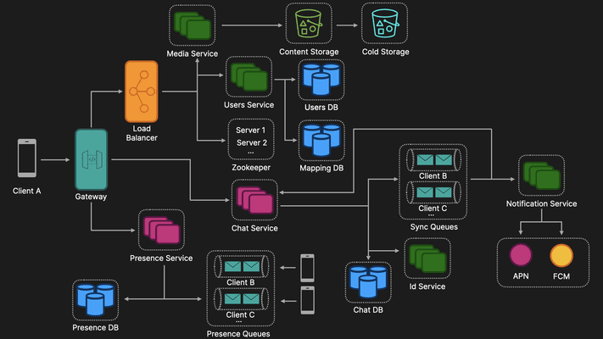
Gateway
As we are using many different protocols like HTTP (application layer), TCP (transport layer) two layers of the The Open Systems Interconnection (OSI) Model is a conceptual framework that provides a protocol-agnostic description of how the various layers of a network stack combine to enable network communications.
The Gateway (e.g. AWS API Gateway) will also include rate limiting.
User Service
HTTP-based servers that handles all user related information as well as authentication.
User information can be quite relational in nature so we could choose an SQL database like MySQL or Postgres.
We may also have to introduce sharding to handle the scale of the application.
The data can also be replicated in different geographic regions, with a multi datacenter approach to handle availability requirements.
Media Service
Media Service used to store content in object storage (e.g Amazon S3) .
Given the volume of data being stored, we could also do some analysis and move old data into cold storage (e.g. Amazon S3 Glacier) to reduce storage costs.
Chat Service
Pull (polling) vs. Push
Pull: Long polling is where the client makes a request to the server which holds the request open ("hangs") until new data is available or a timeout occurs. Once the client receives new data or a timeout signal, it immediately sends another request, and the process repeats. This creates a near real-time effect, but with the overhead of repeatedly establishing HTTP connections.
Push: Web sockets are a TCP based protocol that use bi-directional full duplex communication. It is lightweight and both the client and server can independently send messages to each-other.
Stateless vs. Stateful
Stateless services process each request independently without retaining user session information, enhancing simplicity and scalability. Stateless protocols include HTTP (Hypertext Transfer Protocol). For example in our Users Service it doesn’t matter which server a user connects to, as the Users Database is the source of truth.
Stateful services, on the other hand, maintain session data across requests, adding complexity but enabling continuous user interactions. Stateful protocols include TCP (Transmission Control Protocol). For example let's say Client A creates a WebSocket connection with Chat Server 1 and then proceeds to send and receive messages from that server, until the client disconnects or server goes down, Client A will always be connected to that server.
Database Selection
Given the scale discussed in the Estimates section a NoSQL database like Cassandra or Dynamo DB, would be a suitable choice. Discord used Cassandra for a long time before recently moving to SyllaDB.
If the system were to use an SQL database, while indexes can speed up data retrieval, they can significantly slow down data insertion and updates, which we want to avoid especially in a high-volume, real-time chat application where new messages are constantly being sent and received.
ID Service
Twitter Snowflake is a distributed system for generating unique, time-sequenced identifiers (IDs) at high scale.
We want message IDs to be globally unique, but we also want them time sequenced. This is so that each device can have a last last_seen_message_id, so that if there are any new messages for a user on a queue where the user and the message_id is larger than the last_seen_message_id the device knows that is hasn't seen that message.
Service Discovery
ZooKeeper can be used to maintain a list of available chat servers and their statuses. This allows each client to query ZooKeeper to discover which server to connect to.
ZooKeeper's strong consistency model ensures that all clients see the same view of the server list and their statuses, which is crucial for correctly balancing the load and ensuring reliability.
A Mapping Database (user_id, server_id) can be used to store which users are connected to which chat servers. This data is solely comprised of key-value pairs which makes MongoDB a good candidate for this mapping table.
Messaging Flow
Client A is authenticated.
Client A is allocated to a chat server by ZooKeeper and this mapping is stored in the Mapping Database.
Client A can then send a message to the Chat Service.
The Chat Service reaches out to the ID Service to generate a unique ID.
The message is stored in the Chat Database.
The message is then put into the relevant Sync Queues.
In this case the message is sent to a group chat with two other users (Client B and Client C)
A message will be put on both of their queues (we can do this because of the 150 person group chat limit).
Client C is offline so the Notification Service sends a notification to the relevant service (e.g. Apple Push Notifications [iOS] or Firebase Cloud Messaging [Android])
Client B is online, so the message is forwarded to the Chat Server Client B is connected to which is known from the Mapping Database.
Presence Service
Each client will have a web socket connection to a stateful Presence server.
A heartbeat mechanism will be used for maintaining real-time user status (e.g. online, offline).
How it works is a periodic signal is sent from the client (user's device) to the server to indicate that the client is still connected and active. This information (e.g. user_id, online_status, last_online_timestamp) is then stored in the Presence Database as well as having messages pushed onto Presence Queues so that other users that user was messaging could know that that user was online.
If the Presence Service does not receive a heartbeat from a client for a specified period of time it can insert a new row in the database indicating that that client is no longer online, as well as push messages onto the relevant Presence Queues to let other users know that that user is no longer online.
Additional Discussion Points
End to end encryption
Media file handling
Rate limiting and abuse prevention
Monitoring and logging
Compliance and data retention
Disaster recovery

Web Crawler
Editorial Solution
Quiz
AI Whiteboard
Overview
Introduction
Requirements
Key Questions
Architecture Overview
URL Frontier
System Flow
Additional Discussion Points
Introduction
A web crawler, (a.k.a. spider, spiderbot), is a type of bot that is used to systematically browse the Web. Common use cases of web crawlers include:
Indexing for Search Engines
Data mining
Archiving
Requirements
Functional Requirements
Given seed URLs, crawl related pages
Ignore duplicate pages
Non Functional Requirements
Ability to prioritise URLs
Politeness (i.e. not overloading a website with requests)
Key Questions
1. What type of content will we need to store?
HTML, but should be extendable for other forms of content
2. How many pages will we need to crawl each month (total storage requirements)?
Average pages crawled / month: 1 billion / month (10⁹)
Average page size ≈ 2.5 MB (2.5 * 10⁶ bytes)
Monthly storage requirements: 10⁹ pages * (2.5 * 10⁶ bytes/page) = 2.5 * 10¹⁵ bytes
Yearly storage requirements: 12 months * (2.5 * 10¹⁵ bytes) = 3 * 10¹⁶ bytes
Assume store for 5 years
Total storage: 5 years * (3 * 10¹⁶ bytes) = 1.5 * 10¹⁷ bytes
Petabyte (PB): 1PB = 1024⁵ bytes
(1.5 * 10¹⁷ bytes) / (1024⁵ bytes) ≈ 133 PB
Architecture Overview
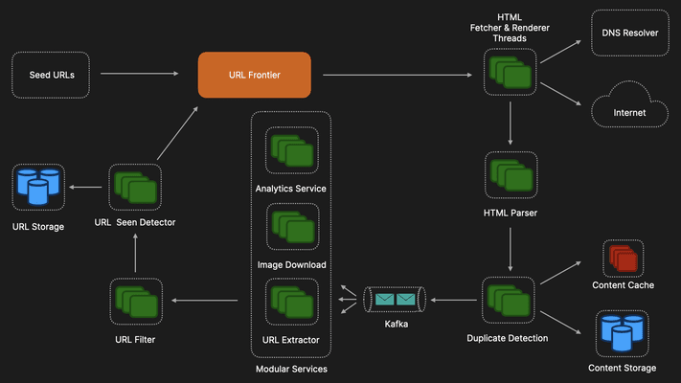
Seed URLs
Seed URLs are the URLs that have been chosen from which to start crawling.
The seed URLs to choose will depend on the use case of the web crawler. For example:
High level directories like Wikipedia, Government websites etc.
News aggregators like RSS feeds, social media platforms etc.
URL Frontier
The URL Frontier is one of the most important parts of the web crawler as it used for URL prioritisation and to ensure politeness.
Deeper dive in the next section.
HTML Fetcher & Renderer Threads
Horizontally scaled with consistent hashing to distribute the load, to ensure that the system can handle the large number of URLs to be crawled.
Reaches out to a custom DNS resolver which is used to convert domain names into IP address. A custom approach is used to avoid the expensive DNS resolution process.
Implement caching here, especially if we are visiting the same domain multiple times.
HTML Parser
Content Parser parses HTML pages and checks if pages are malformed.
Instead of just discarding malformed content, the system could have some formatting logic which can attempt to resolve common HTML issues like missing closing tags etc.
Duplicate Detection
There’s a lot of duplicate information on the web and so the system needs some way of detecting this.
One way is to use MD5 hashing function which is used to create a unique "fingerprint" of a digital file or message.
It takes any input of arbitrary length and produces a fixed-length output (128 bits, represented as 32 hexadecimal characters) that serves as a compressed representation of the original data.
Pros: Fast, efficient, and easily scalable.
Cons: Ignores minor changes, might miss near-duplicates, potential collisions (although less likely with stronger hashes).
Caching
To make sure our system is performant having some sort of caching mechanism which can quickly check if there is a duplicate is important.
A bloom filter could be used for this purpose. A bloom filter is a probabilistic data structure that is very space-efficient and could be implemented using tools like Redis.
Content Storage
This system could use a NoSQL database like Cassandra which supports indexing and filtering and is good for frequent updates. However, it isn't optimal for the kind of data this system will be storing.
Instead this system could use a distributed file system:
Pros: Highly scalable, cost-effective at large scale, good for static data.
Cons: May not be as efficient for frequent queries, requires expertise in distributed systems.
Examples: HDFS, Google Cloud Storage, Amazon S3.
URL Extractor
Extract links from the page so that the crawler can continue to crawl and discover new content.
Kafka
Instead of just having the URL Extractor, the system could utilize Kafka to allow us to add additional services like analytics, image downloading and ultimately make the system extendable for future enhancements.
URL Filter
Filters URLs based on predefined rules
For example we could prevent certain sites (e.g. adult sites, malicious sites) as well as malformed URLs.
This improves the overall efficiency and effectiveness of the system by reducing the amount of irrelevant content crawled.
URL Seen Detector
Check that the URL has not been seen before adding it to the URL Frontier. This prevents infinite loops where the same pages are repeatedly being crawled.
Bloom filters or hash tables could be used here to achieve this.
The URLs that have not been previously seen are then sent to the URL Frontier for crawling.
URL Storage
Stores URLs that have previously been visited.
A NoSQL database like Cassandra could be used here. It is highly scalable, often more cost-effective for large datasets than other SQL databases.
URL Frontier
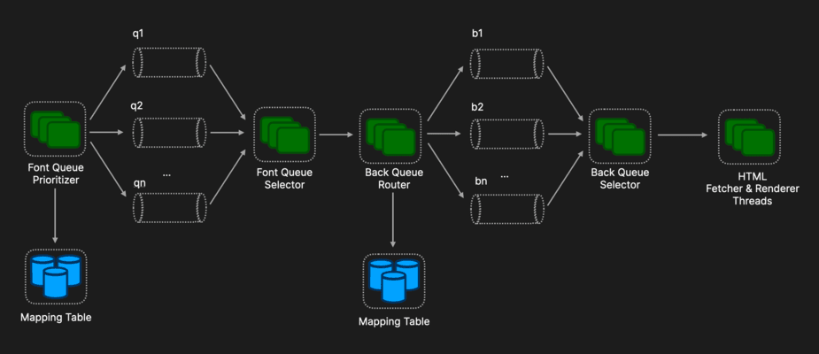
The primary functions of the URL frontier is to prioritise URLs and ensure politeness.
Front Queue Prioritizer
The Front Queue Prioritizer takes URLs and computes their priority. This could be based on numerous predefined factors including update frequency, page rank, and traffic volume.
Depending on its priority, a URL is placed on one of the queues. In this example, q1 has the highest priority, q2 has the second highest priority and qn has the lowest priority.
Front Queue Selector
The Front Queue Selector will then randomly choose URLs from each queue with a bias towards queues with a higher priority. Therefore, queues with higher priorities will be more likely to be chosen and thus, we have established a way of prioritizing URLs.
Back Queue Router
Then Back Queue Router will then take each URL and place it on a queue.
For example, the queue b1 could be exclusively for wikipedia.com, meaning that the queue b1 will only ever contain wikipedia related domains. The reason for this is so that the system is polite.
Back Queue Selector
Politeness in this context means not overloading websites with requests and harming their performance for real users or getting rate limited.
By having each queue dedicated to a specific website the Back Queue Selector can add delays between requests to ensure that our system is polite and not interfering with the sites its crawling.
HTML Fetcher & Renderer Threads
Once the Back Queue Selector has selected a URL, it can then be sent to the HTML Fetcher & Renderer for processing, which has been horizontally scaled with consistent hashing to distribute the load, to ensure we can handle the large number of URLs to be crawled.
System Flow
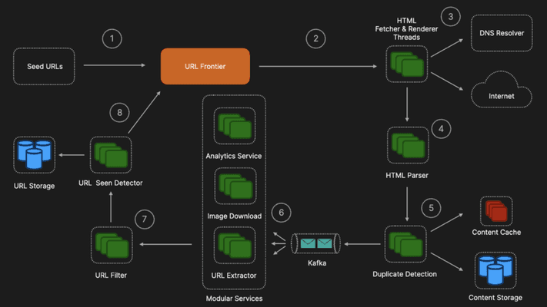
Seed URLs
URLs from which we want to start crawling
URL Frontier
Selects URLs to be crawled and implements priority and ensures politeness
HTML Fetcher
Fetches URL from the URL frontier
DNS Resolver gets IP address
HTML Parser
Parses & tries to reformat
Duplicate Detection
Check for duplicates
Modular Services
Passes content to relevant services
URL Filter
Filter out unwanted URLs
URL Seen Detector
Checks for seen URLs, puts back in URL Frontier if not seen and and needs to be crawled
Additional Discussion Points
Server side rendering
Horizontal scaling
Content storage and caching
Additional services

Cloud File Sharing Service (Dropbox, Google Drive)
Editorial Solution
Quiz
AI Whiteboard
Overview
Introduction
Requirements
Estimates
Core Problem
Data Model
Architecture Overview
System Flow
Additional Discussion Points
Introduction
A cloud file sharing service is an online platform that allows users to store, share, and collaborate on files and documents over the internet. Examples include:
Google Drive
Dropbox
Requirements
Functional Requirements
File upload and download
Sync files across multiple users and devices
Non Functional Requirements
Highly scalable
Highly reliable
Not Included
Real time multi-user editing
Estimates
Storage Estimates
Daily active users (DAU) = 500 million (500 * 10⁶)
Number of files uploaded = 1 file / user / day
Average file size = 150 KB ≈ (15 * 10⁴ bytes)
Daily storage:
(500 * 10⁶ users) * (15 * 10⁴ bytes) ≈ 7.5 * 10¹³ bytes
Yearly storage requirements:
365 days * (7.5 * 10¹³ bytes) ≈ 2.7 * 10¹⁶ bytes ≈ 27 PB
Assume store for 10 years
Total storage: 10 years * (27 PB) = 270 PB
Queries per second (QPS)
(500 million * 1 upload) / 24 hours / 60 minutes / 60 seconds ≈ 6,000 QPS
Core Problem
The core problem revolves around sending lots of unnecessary data across the network.
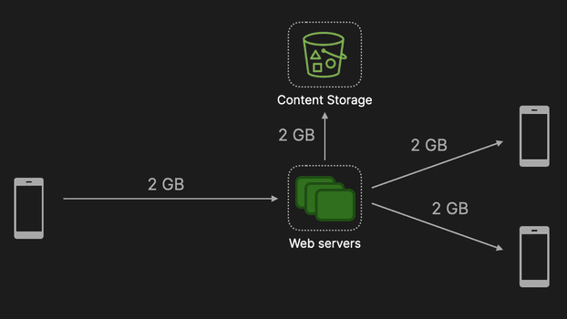
For example, let's say we were working on a large file of size 2GB. If we added a single character to the end of that file, we would then have to send the entire 2GB to web servers which would then have to store the entire 2GB in a content storage (e.g. S3), and then that 2GB would have to be sent to other clients who also had access to that file.
That's a lot of data to be sent across the network for a single character change!
To solve this problem we will introduce the concept of blocks.
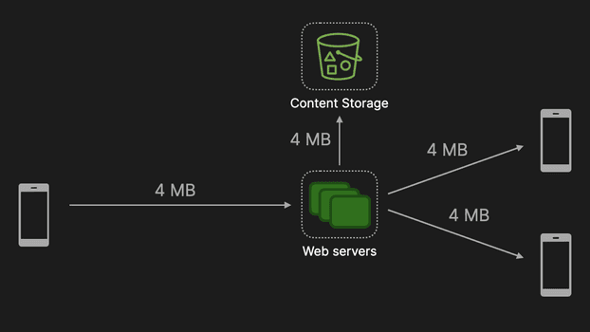
Each file will be comprised of blocks of a predetermined size (4MB in our case). This means that we greatly reduce the amount of data that is sent across the network by only sending the blocks that changed instead of the entire file.
With this new approach, we would only need to send and store 4MB as apposed to 2GB.
Data Model
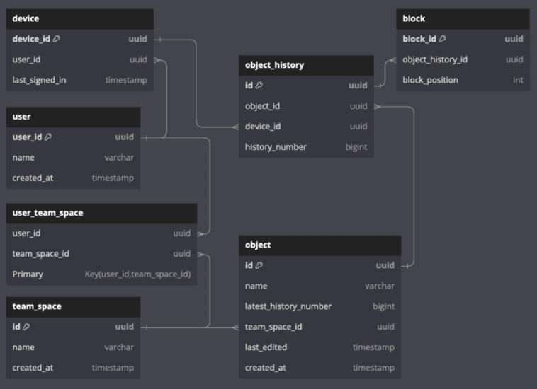
This is a basic outline of some of the core tables that could be included in a cloud file sharing service data model.
users
Contains information related to the user.
devices
user_id: Foreign key which is used to identify which user the device belongs to. Many-to-one relationship where a user can have many devices and a device can only belong to one user.
team_space
name: The name given to the space (e.g. personal files)
user_team_space
user_id: Foreign key which is used to identify a user.
team_space_id: Foreign key which is used to identify a team space.
This table facilitates the many-to-many relationship between users and team spaces.
object
Represents a file in the system.
latest_history_number: Points to the latest version of the object and enables versioning of objects.
team_space_id: Indicates which team_space the object belongs to.
object_history
history_number: Indicates where in the object history this object belongs.
block
object_history_id: Which object the block belongs to.
block_position: The position of the block within in the object. Allows files to be recreated in the correct order.
Architecture Overview
Client
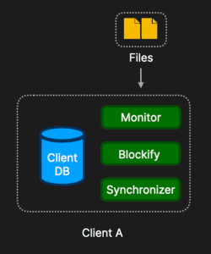
The Client is responsible for several functions in this system.
Monitor
Monitors for changes of files in the local workspace and notifies the Blockify service when changes have been made.
Blockify
Blockify splits files into smaller blocks and is also responsible for reconstructing blocks into their corresponding files.
Once the blocks are created the Synchronizer is notified.
Synchronizer
The Synchronizer, as the name suggests relays these changes to the Client Database as well as the Block and Metadata service which will be discussed later.
Client Database
Locally stores information about the shared space, blocks, hashes of the objects, object history etc. Can be implemented with a lightweight database like SQLight.
It is focused on managing the local file state and is tailored to individual clients.
Block Service
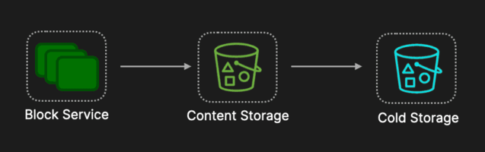
Handles storing blocks sent by clients in the content storage.
To reduce storage costs and improve security the Block service will also implement compression and encryption.
Compression: Huffman coding or arithmetic coding. (Note: Google and Dropbox would have their own proprietary compression algorithms as well).
Encryption: 256-bit Advanced Encryption Standard (AES).
To further reduce storage costs the system could ultilize cold storage like Amazon S3 Glacier.
However, the policy for determining when to place blocks in cold storage is important. Analysis should be done beforehand to ensure with high confidence that the block will not be accessed again as it is expensive to access data from cold storage.
Metadata Service
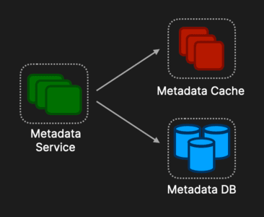
The Meta Service is concerned with the global state of files across the system, facilitating synchronization, and is designed to handle the complexities of a multi-client system.
Information that gets sent here relates to shared spaces, blocks, hashes of the objects, object history etc.
Having a cache (e.g. Redis or Memcached) to store frequently accessed objects could improve the overall systems performance.
The choice of eviction policy is very important, as getting this right could significantly reduce the load on the database
The database will be used to store the metadata about users, objects, blocks etc.
Choice reliability and consistency are key here as we don’t want two users in the same file looking at different data
We can use the CAP theorem trade off to help determine which type of database to use. Reliability and consistency are key for this system as we don’t ever want two users in the same file looking at different data
Therefore, using an SQL database with it’s ACID properties would be a good choice (e.g. MySQL, PostgreSQL).
In the estimates section the system will have to handle massive scale and so sharding might be a good choice to distribute the load.
So this involves partitioning the database into smaller, more manageable pieces, called shards, each of which can be stored on different servers.
This strategy is used to scale databases horizontally, allowing them to handle more data and traffic by distributing the load across multiple servers. Key things to note:
Shard Key Selection: For file sharing metadata, common shard keys might include user IDs, file IDs, or a hash of the file name. The choice of shard key is crucial, as it affects the database's performance and scalability.
Sharding Strategy: There are different sharding strategies, such as range-based sharding, hash-based sharding, etc. For file sharing metadata, hash-based sharding is often used, where a hash function is applied to the shard key to distribute rows evenly across shards. This can help ensure balanced load distribution and improve query performance.
Consistency and Replication: To ensure high availability and data durability, each shard can be replicated across multiple servers. This adds another layer of complexity to shard management but is essential for fault tolerance.
Notification Service
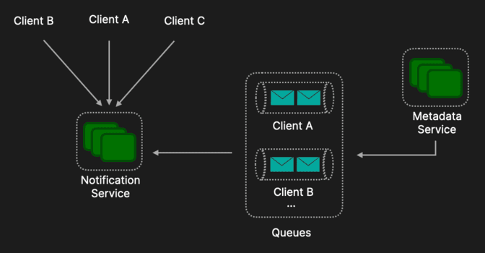
The Metadata Service also responsible for pushing messages onto queues. Each workspace will typically have several members so each member will then get a message pushed onto their queue when changes are made.
The Notification Service notifies clients when changes have been made to a file with which they are associated.
The Client Synchronizer listens to changes in the notification service via long polling which creates a near real-time effect, but with the overhead of repeatedly establishing HTTP connections.
System Flow
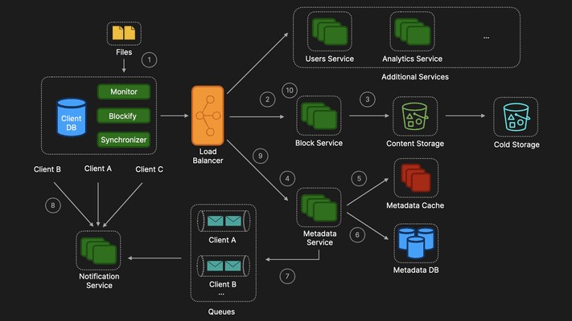
Client A makes changes to a file.
The Monitor notices these changes, Blockify converts the changes into blocks, and the Synchonizer first sends the changes to the Block Service.
The Block Service compresses and encrypts the blocks.
These blocks are then stored in the Content Storage (e.g. S3).
The Metadata Service is sent the metadata.
The Metadata Service stores the metadata in the Metadata Cache.
The Metadata Service also stores the metadata in the Metadata Database.
The Metadata Service will also send a message onto the relevant queues.
Clients associated with that file that have a long polling connection with the notification service will receive that message.
The Synchronizer will then reach out to the Metadata Service to get the relevant metadata.
The Synchronizer will then reach out to the Block Service to get the relevant blocks, which can then be downloaded to that client.
Additional Discussion Points
Reducing storage costs with cold storage
Reducing storage costs by removing duplicate objects
Compression of blocks
Encryption of blocks
Multi-datacenter approach
Additional services

Social Media Platform (Instagram)
Editorial Solution
Quiz
AI Whiteboard
Overview
Introduction
Requirements
Estimates
Data Model
API Design
Uploading Media Flow
Pre-Generating User Feed Flow
Requesting User Feed Flow
Additional Discussion Points
Introduction
Instagram is one of the most popular social media sites on the planet and unsurprisingly is often asked as a system design interview question in Meta.
The first thing to note is that there are many features on Instagram so its important to ask clarifying question to your interviewer to understand what exactly is is that they want. The video is going to focus on the main flows in app but the system is designed to very extendable so that adding more features is very easy.
Requirements
Functional Requirements
Upload media (image & video)
Follow / unfollow users
User feed generation
Search posts by caption / hashtag
Non Functional Requirements
High scalability
High availability (willing to accept eventual consistency)
High durability
Low latency
Not covered
Messaging
Image editing
Estimates
Storage
500 million DAU
Every user posts once every 5 days
Posts per day: (500 x 10⁶) * 0.2 = 100 x 10⁶ posts per day
Daily Storage: (100 x 10⁶) [posts] * 1MB [average post size] = 100 x 10⁶ MB / 1024 ≈ 97,656 GB
Total storage per year: 97,656 GB * 365 ≈ 35,635,440 GB / 1024 ≈ 34,800 TB / 1024 ≈ 34 PB / year
Queries Per Second (QPS)
Total posts per day: 100 * 10⁶
Seconds per day: 24 hours * 60 minutes * 60 seconds = 86,400
Writes per second: (100 * 10⁶) / 86,400 ≈ 1,150 writes / second
Read write ratio: 100:1
Reads per second: 100 * 1,150 ≈ 115,000 reads / second
Queries per second: 115,000 + 1,150 ≈ 116,150 QPS
Data Model
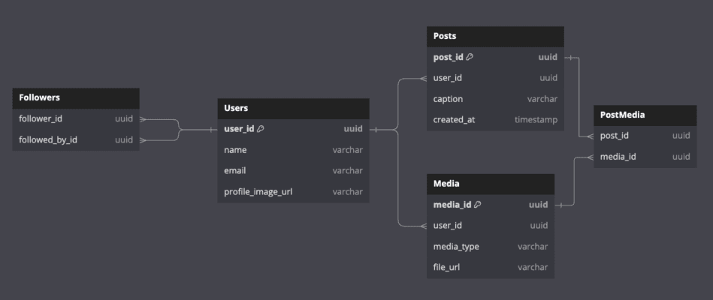
This is a basic outline of some of the core tables that could be included in an Instagram data model.
users
Contains information related to the user.
followers
follower_id & followed_by_id: Two foreign keys which enable the system to know which users are following each other
media
media_id: Uniquely identifies each media item.
user_id: Links each media item to a user, indicating who uploaded it.
media_type, file_url: Describes the media type (e.g., image, video) and its file location.
posts
post_id: Uniquely identifies each post.
user_id: Links each post to a user, indicating who created it.
caption: Stores the text or caption of the post.
created_at: When the post was created
post_media
post_id, media_id: Link posts to their associated media.
API Design
For Instagram we will use a classic RESTful API to interact with the data. RESTful APIs are simple, widely used, stateless, and support caching which make it a good candidate for our system.
Our REST API will comprise of two main endpoints:
POST: /api/upload
Params:
file: binary of photo or video
metadata: user_id, created_at, caption etc.
Response code: 201 created
GET: /api/posts/{id}
Params: post_id
Response code: 200 success
GET: /api/feed
Params: user_id, pagination
Response code: 200 success
Uploading Media Flow
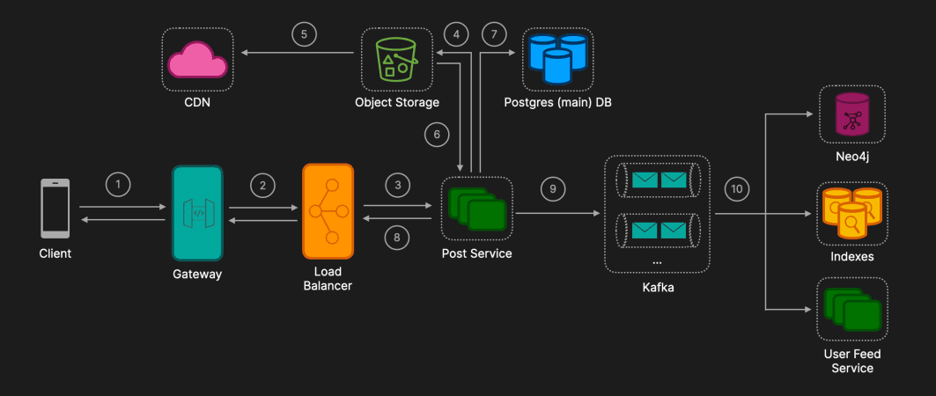
Client sends a POST request to the API Gateway
Request headers: Content-Tye: multipart/form-data; boundary=----WebKitFormBoundary7MA4YWxkTrZu0gW
The boundary is a unique string that acts as a delimiter in the body of the request. This helps the server identify where the file data starts and ends.
Request body contains the binary file data
API Gateway forwards request to Load Balancer
API Gateway handles routing, rate limiting, authentication and authorization.
Load Balancer routes the request to an instance of the Post Service
The use of a Load Balancer ensures that the incoming requests from clients are evenly distributed across instances of the Post Service, which helps in handling high traffic and ensures high availability.
The Post service has been horizontally scaled to handle large traffic volumes and to prevent a single point of failure.
Post Service uploads the image to Object Storage
When a file exceeds a certain size threshold (e.g., 5MB), the system employs a multi-part upload strategy. This approach divides the file into smaller chunks and uploads each chunk individually.
This method helps to manage large file uploads more efficiently, reduces the risk of upload failures, and allows for the resumption of uploads if an interruption occurs.
Object Storage triggers a CDN cache update or invalidation
Integration with a CDN like CloudFront improves the delivery speed of images to users by caching the images closer to the users geographically.
Post Service receives the image URL from Object Storage
Post Service uploads metadata to main Postgres storage
To ensure data consistency, the metadata storage process is tightly integrated with the image upload workflow.
By employing atomic transactions, we guarantee that both the image upload and the metadata storage either complete successfully or fail together, preventing any inconsistencies.
Post Service returns the image URL to the client
Post Service sends a denormalized message to Kafka
Using Kafka for asynchronous message processing to update various services allows decoupling of services and enhances overall system responsiveness and scalability.
Ensure that Kafka is configured to handle high volumes of messages efficiently. This includes partitioning topics appropriately and managing consumer groups to optimize throughput.
The message is denormalized to provide all necessary data in a single message, reducing the need for downstream services to make additional queries or joins, thereby simplifying processing and improving efficiency.
Kafka consumers (Neo4j, Postgres, Indexes, Newsfeed Service) process the message asynchronously
Neo4j: Updates the graph database with new post relationships and enhances social network analysis and relationship-based queries.
Indexes: Updates the search indexes with new post content which enables efficient and quick searching and retrieval of posts. Indexes could be imlpemented using Elasticsearch is a distributed, RESTful search and analytics engine built on top of the open-source Apache Lucene library.
User Feed Service: Updates user feeds with the new post information (detailed flow outlined below)
Pre-Generating User Feed Flow
To pre-generate user feeds our system will be using a hybrid model which is a combination of the push and pull models. (Also discussed in Design a News Feed).
1. Push model
When new content (e.g., a post) is published, it is immediately pushed to the feeds of all the user's followers in the cache, ensuring that each user's feed is pre-generated for quick retrieval. This approach significantly speeds up read operations. However, it poses a challenge known as the "hotkey problem," where pre-generating feeds for users with millions of followers can become exceedingly resource-intensive.
2. Pull model
In this approach, instead of pushing content to a user's feed cache on write, the system waits until a user requests (pulls) for their feed and then computes the feed on read. This approach avoids the hotkey problem however, reads are slower as feeds are generated when a request is made.
Hybrid Approach
Use the push model for the majority of users. Use the pull model for celebrities (people with large followings). (Below we assume non celebrity).
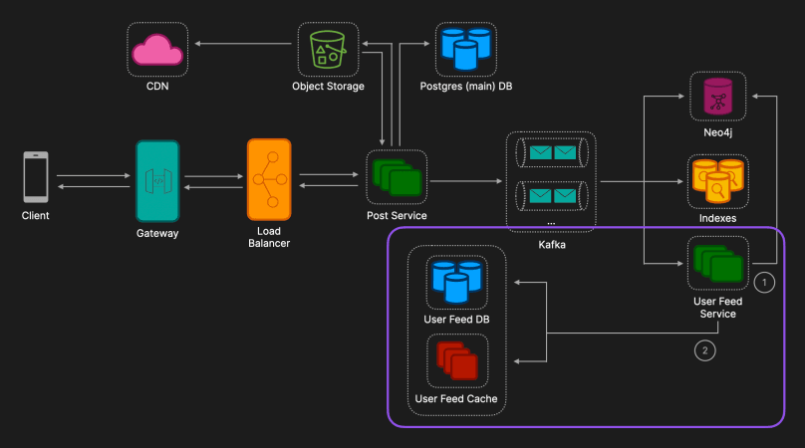
User Feed Service Retrieves Followers:
The User Feed Service fetches the list of followers from the Neo4j graph database.
User Feed Service Updates Feeds:
The User Feed Service updates the User Feed Cache and User Feed Database for each follower with the new post.
Requesting User Feed Flow
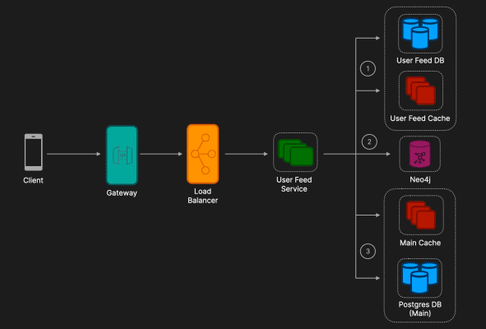
User Feed Service Retrieves Pre-Generated Feed:
The User Feed Service first checks the User Feed Cache for pre-generated posts.
If not found in the cache, it fetches from the User Feed Database.
This pre-generated feed contains posts from non-celebrities.
User Feed Service Retrieves List of Celebrities the User Follows:
The service queries Neo4j to get the list of celebrities followed by the user.
Celebrities are identified based on their follower count.
User Feed Service Retrieves Latest Posts of those Celebrities:
The most recent posts of the celebrities are fetched from the main Postgres database.
These posts are then combined with the pre-generated feed which is then returned to the user.
Additional Discussion Points
Comment service
Handles creating, editing, and deleting comments on posts, ensuring efficient and reliable operations.
Supports nested comments through hierarchical data structures, allowing for multi-level nesting.
Utilizes a data model like an adjacency list or nested set to manage and query nested comments efficiently.
Notification service
Manages and delivers notifications for events like new followers, likes, and comments. It listens for events via Kafka and sends notifications through in-app alerts, push notifications, or emails, ensuring scalability and separation of concerns.
Analytics service
Integrate comprehensive monitoring and logging throughout the system, especially at the API Gateway, Load Balancer, and Kafka. Monitoring these components can help in early detection of issues and in understanding traffic patterns for better scaling decisions.
Data Consistency
Between the Post Service, Kafka, and the database updates, ensure data consistency using techniques like eventual consistency models, idempotency in requests, and compensating transactions where necessary.
Hotel Reservation System (Airbnb, Booking.com)
Editorial Solution
Quiz
AI Whiteboard
Overview
Introduction
Requirements
Data Model
API Design
Adding Hotel Flow
Creating Reservation Flow
Complete Architecture
Additional Discussion Points
Bonus Section: What Top Tech Interviewers Really Want to SeeSample Answer

Introduction
Designing a hotel reservation system is a very popular system design interview question. While it is certainly not the most complex system design interview question, most interviewers will want to see specific problems addressed. Knowing what these problems are and how best to tackle them is critical in the interview setting and is exactly what we're going to cover in this solution.
Requirements
Functional Requirements
Hotel Management: Hotel Managers should be able to add and remove hotels, as well as add and remove rooms of given room types. They should also be able to update the pricing and inventory of room types to reflect changes in availability or rates.
Search and Reservation: Users should be able to search for hotels and rooms using various filters such as location, number of beds, price range, and check-in/check-out dates. The system should display available hotels and room types that match their search criteria. Users should be able to create and cancel reservations as needed.
Reservation History: Users should have access to view their past reservations, allowing them to review previous reservations and details.
Notifications: Users should receive notifications for important events, such as successful creation of a reservation or cancellation confirmations.
Non Functional Requirements
Consistency: The system must handle concurrent requests efficiently to ensure that no two customers can book the same room on a particular day, maintaining high data consistency.
Low Latency: The platform should provide quick responses to user actions, ensuring a smooth and responsive user experience.
Data Model
This is a basic outline of some of the core tables that could be included in a hotel reservation system data model.
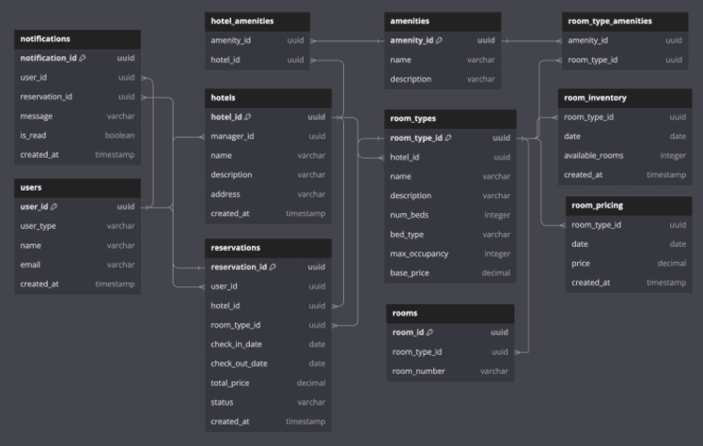
Users: Stores information about all users, including hotel managers and customers.
Hotels: Contains details about hotels managed by hotel managers.
RoomTypes: Defines different types of rooms available in each hotel.
Rooms: Represents individual rooms under each room type.
RoomPricing: Manages dynamic pricing for room types on specific dates.
Composite Primary Key: Combination of room_type_id and date to uniquely identify each pricing entry.
RoomInventory: Tracks the number of available rooms for each room type on specific dates.
Composite Primary Key: Combination of room_type_id and date to uniquely identify each inventory entry.
Reservations: Stores booking details made by users.
Notifications: Manages notifications sent to users regarding their reservations.
Amenities: Stores a list of possible amenities that a hotel or room type can offer.
HotelAmenities: Associates amenities with hotels.
RoomTypeAmenities: Associates amenities with specific room types.
API Design
For a hotel booking system we will use a classic RESTful API to interact with the data. RESTful APIs are simple, widely used, stateless, and support caching which make it a good candidate for our system.
Our REST API will comprise of four main endpoints:
POST: /api/hotels
Description: Allows a hotel manager to add a new hotel to the platform.
Params: name, description etc.
POST: /api/{hotel_id}/room-types
Description: Allows a hotel manager to add a new room type to a hotel.
Params: hotel_id, name, description etc.
GET: /api/search
Description: Allows users to search for hotels and room types based on filters and view available options.
Params: location, check_in_date, check_out_date, num_guests, num_beds etc.
POST: /api/reservations
Description: Allows a user to create a new reservation for a room type.
Params: hotel_id, room_type_id, check_in_date, check_out_date
Adding Hotel Flow
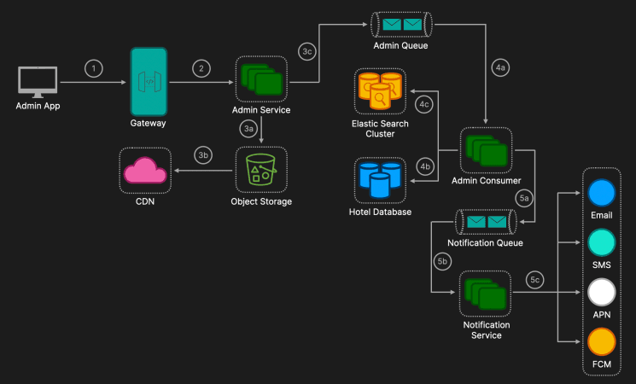
Admin App
Action: The hotel manager (admin user) sends a POST request to the Admin Service API endpoint with hotel and room details, including images and amenities.
Data Validation: Client-side validation ensures all required fields are filled and data is in the correct format.
Authentication & Authorization: The request includes an authentication token (e.g., JWT) verifying the user's identity and permissions.
API Gateway
Routing: The request reaches the API Gateway which analyzes the request and routes it to the appropriate microservice, in this case, the Admin Service.
Additional Functionality: Performs authentication, authorization, and implements rate limiting. Also handles load balancing by distributing incoming connections and requests to maintain optimal performance.
Admin Service
Server-Side Data Validation: Ensures that all mandatory fields are present and correctly formatted and validates image files (type, size limits).
Image Handling: Extracts images from the request, uploads images to the Object Storage Service (e.g., AWS S3, Azure Blob Storage), and retrieves URLs or keys for the uploaded images. Images uploaded to Object Storage are distributed via a Content Delivery Network. CDN Edge Servers cache the images to reduce latency for end-users.This offloads traffic from the origin server and enhances image load times globally.
Message Creation: Prepares a message containing hotel data, room details, amenities, and image URLs. The formatted data is then published to a messaging system like Kafka. This decouples the request-response cycle from heavy processing tasks and promotes scalability. Messages can be partitioned by Hotel ID (or a hash of the Hotel ID) for scalability and ordered processing. Returns a response to the client indicating that the hotel addition request has been received and is being processed.
Admin Consumer
Background Worker Service: A horizontally scalable service that listens to the Kafka topic and pulls messages from the topic.
Database Transaction: Begins a Transaction in the relational database (e.g., PostgreSQL, MySQL) and inserts the data into the appropriate tables (Hotels, RoomTypes, Amenities etc.). Relational databases like PostgreSQL or MySQL provide strong Atomicity, Consistency, Isolation, and Durability guarantees, which are crucial for transactional operations like hotel additions. If successful the transaction is committed.
Update Elasticsearch Cluster: Indexes the new hotel and room data into Elasticsearch for search functionality. Given that Elasticsearch does not support ACID transactions in the same way as relational databases we could implement a two-phase commit. While a two-phase commit could theoretically synchronize the database and Elasticsearch, it's impractical due to complexity and performance overhead. Here we are willing to accept eventually consistency as search functionality is not as critical as reserving a room. Therefore, if indexing fails a message can be placed on message queue for further review and retries and the use of idempotency keys would be useful to prevent duplicate processing of the same data.
Error Handling: If an error occurs rollback the database transaction, log the error with details for debugging, implement retry logic with exponential backoff, and move the message onto a Dead Letter Queue if retries fail.
Notification
Notification Queue: Once the hotel is successfully added the Admin Consumer adds a message onto the Notification Queue.
Notification Service: Pulls messages off the Queue and notifies the user via the relevant third party providers channel (e.g. Mailjet for email, APNs (Apple Push Notification Service) for iOS, and FCM (Firebase Cloud Messaging) for Android).
Creating Reservation Flow
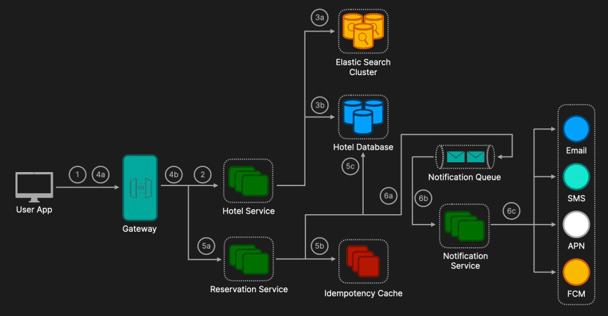
User App
Action: The user sends a GET request with search filters to find available hotels and rooms. The filters parameters can include: location, check_in_date, check_out_date, num_guests, num_beds etc.
Authentication & Authorization: The request includes an authentication token (e.g., JWT) verifying the user's identity and permissions (this is optional for public searches).
API Gateway
Routing: The request reaches the API Gateway which analyzes the request and routes it to the appropriate microservice, in this case, the Hotel Service.
Additional Functionality: Performs authentication, authorization, and implements rate limiting. Also handles load balancing by distributing incoming connections and requests to maintain optimal performance. Decrypts incoming SSL/TLS traffic for secure communication.
Hotel Service
Elasticsearch Query: The Hotel Service first queries the Elasticsearch Cluster to do an initial filter of available hotels and rooms based on the provided filters. Full-text search can be performed on hotel names and descriptions, geospatial queries for location-based information, and filtering based on amenities, price range etc. This will then return a list of hotels and room types that match the user's filters, excluding real-time availability and dynamic pricing.
Relational Database Query: Using the list of room_type_ids returned from Elasticsearch, a batch query is performed on the Hotel Database (which has been sharded by Hotel ID or a hash of the Hotel ID) to check if available_rooms > 0 for each date in the user's requested date range in the room_inventory table. This ensures that the room type is available for the entire stay. For dynamic pricing a sum can be performed on the price from the room_pricing table for the requested dates to calculate the total price.
Caching Layer: Use a distributed cache (e.g., Redis Cluster) for frequently accessed availability and pricing data to reduce database load and improve response times for users.
Response Compilation: The response is then compiled and sent back to the user. Included in the response are hotel and room details, real-time availability status, accurate pricing, and image URLs served via a Content Delivery Network (CDN).
User App
Action: The user selects a hotel and room type from the search results and initiates a reservation process. The user sends a POST request to the Reservation Service to create a reservation with the relevant parameters including an idempotency key (e.g. UUID) which is a unique key to handle retries and prevent duplicate reservations.
Reservation Service
Distributed Environment: The Reservation Service must handle reservations in a distributed environment, ensuring data consistency and preventing double bookings. Hotels have been sharded by Hotel ID (or a hash of the Hotel ID) and so all data related to a specific hotel is stored on the same shard which enables the use of local transactions on a single shard removing the need for distributed transactions.
Idempotency Key Check: The Reservation Service first checks if the provided idempotency key has already been processed by querying a distributed datastore (e.g., Redis) where processed idempotency keys are stored with a time-to-live (TTL). If the key exists the server retrieves and returns the result of the previous operation, avoiding duplicate processing. Otherwise, the server proceeds with processing the reservation and stores the idempotency key.
Begin Local Transaction: The Reservation Service begins a transaction with serializable isolation level ensuring transactions are executed as if they were sequential, preventing dirty reads, non-repeatable reads, and phantom reads. While it can reduce concurrency and system throughput, given the need to prevent double bookings, the trade-off is acceptable.
Serializable Isolation Level: Example Scenario

Using row-level locking, the database automatically acquires locks on rows that are read or modified during a transaction.
Pessimistic v Optimistic Locking

For reservation systems, pessimistic locking is preferred to prevent overselling rooms.
Check and Update Room Inventory: In room_inventory table for each date from check_in_date to the day before check_out_date ensure available_rooms ≥ number_of_rooms for each date. A database constraint will prevent available_rooms from going below zero. After the update, the locks are released by the database's transaction system.
Commit Transaction: If all operations succeed commit the local transaction, otherwise rollback the transaction and return an error to the user.
Notification Service
Upon successful reservation creation, the the Reservation Service publishes a message to a Notification Queue which will then be picked up by the Notification Service and sent to the relevant third party notification provider.
Complete Architecture
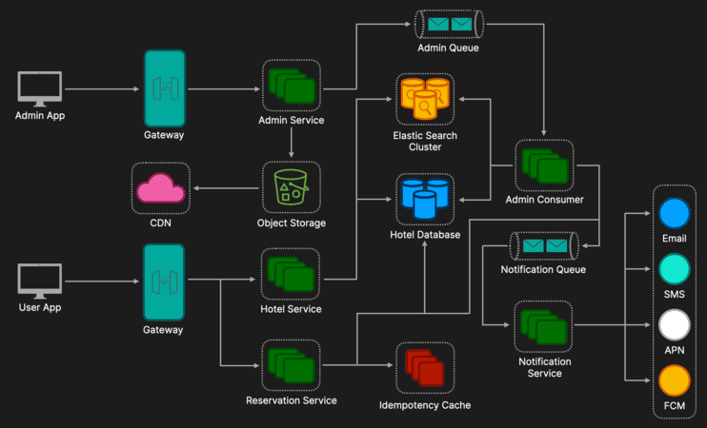
Additional Discussion Points
Payment Processing
Integration with Third-Party Payment Services: Utilize payment gateways like Stripe or PayPal for secure and reliable transaction processing. Implement tokenization to handle sensitive card information without storing it on your servers, ensuring compliance with PCI DSS standards. Use webhooks to handle asynchronous payment events and update reservation statuses accordingly.
Error Handling
Robust Error Handling and Retries: Implement comprehensive error handling with retries and exponential backoff for transient failures. Use try-catch blocks to manage exceptions gracefully and provide meaningful feedback to users. Employ circuit breakers to prevent cascading failures in dependent services and isolate faults.
Monitoring & Logging
System Monitoring: Use tools like Prometheus and Grafana for real-time metrics (CPU, memory, latency). Implement health checks and application monitoring tools to monitor service performance.
Centralized Logging: Aggregate logs with ELK Stack or Graylog. Employ structured logging (e.g., JSON) and set up alerts for critical events.

Proximity Service (Yelp)
Editorial Solution
Quiz
AI Whiteboard
Overview
Introduction
Requirements
Estimates
Data Model
API Design
Uploading Attractions Flow
Searching Attractions Flow
Reviewing Attraction Flow
Complete Architecture
Additional Discussion Points
Introduction
Proximity Services (like Yelp) are application that helps users find and access various services, businesses, or points of interest based on their current location.
Designing a proximity service is a very popular system design question as it covers many core system design concepts including storing and retrieving data from multiple data sources, scalability, reliability, and interacting with geolocation services.
Requirements
Functional Requirements
Create an attraction (location of service, business etc.)
Search attractions
Add a review to an attraction
Non Functional Requirements
High scalability
High availability (willing to accept eventual consistency)
Low latency
Estimates
Storage
50 million DAU (daily active users)
Average number of attractions added: 1,000 / day
Average number of reviews posted per user: 2 / month
Average attraction size (including metadata, images): 500 KB
Average review size: 2 KB
Yearly attraction storage: 1,000 attractions * 365 days * 500 KB = 182.5 GB
Yearly reviews storage: 50 million users * 2 reviews * 12 months * 2 KB = 2.4 TB
Total yearly storage: 182.5 GB (attractions) + 2.4 TB (reviews) ≈ 2.6 TB / year
Queries Per Second (QPS)
Writes per second (attractions): 1,000 / (24 hours * 3600 seconds) ≈ 0.0116 writes / second
Writes per second (reviews): (50 million users * 2 reviews) / (30 days * 24 hours * 3600 seconds) ≈ 38.58 writes / second
Total writes per second: 0.0116 + 38.58 ≈ 38.59 writes / second
Average number of reads per user: 20 / month
Reads per second: (50 million users * 20 reads) / (30 days * 24 hours * 3600 seconds) ≈ 385.8 reads / second
Queries per second: 38.59 (writes) + 385.8 (reads) ≈ 424.39 QPS
Data Model
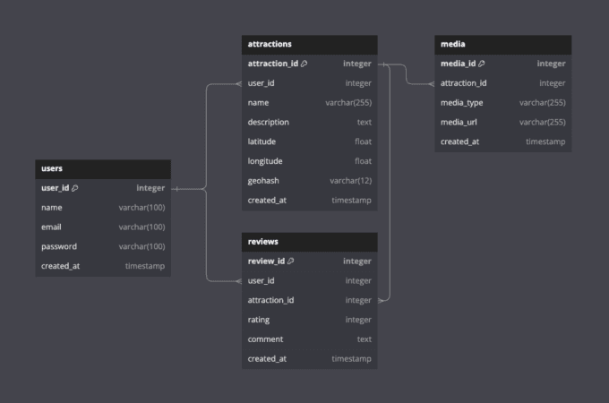
This is a basic outline of some of the core tables that could be included in a proximity service data model.
users
Contains information related to the user.
attractions
attraction_id: Uniquely identifies each attraction.
user_id: Indicates which user created the attraction it.
latitude: The latitude of the attraction.
longitude: The latitude of the attraction.
geohash: The geohash of the attraction location.
media
media_id: Uniquely identifies each media item.
attraction_id: Links each media item to an attraction.
media_type: Describes the media type (e.g., image, video).
media_url: Media file location.
reviews
review_id: Uniquely identifies each review.
user_id: Links each review to a user, indicating who created it.
attraction_id: Links each review to an attraction.
rating: The rating given to the attraction.
comment: The content of the review.
API Design
For a proximity services we will use a classic RESTful API to interact with the data. RESTful APIs are simple, widely used, stateless, and support caching which make it a good candidate for our system.
Our REST API will comprise of three main endpoints:
POST: /api/attractions
Params:
name: string (required)
description: string
category: string
latitude: float (required)
longitude: float (required)
creator_id: string (required)
media: array of binary files
metadata: JSON object (additional details like opening hours, phone, website, etc.)
Response code: 201 Created
GET: /api/attractions/search
Params:
latitude: float (required)
longitude: float (required)
radius: float (in kilometers, default: 5)
category: string (optional)
query: string (optional, for text search)
sort: string (options: "distance", "rating", "review_count", default: "distance")
page: integer (for pagination, default: 1)
per_page: integer (items per page, default: 20)
Response code: 200 OK
POST: /api/attractions/{attraction_id}/reviews
Params:
id: string (attraction ID in URL)
user_id: string (required)
rating: integer (required, 1-5)
comment: string
Response code: 201 Created
Creating Attraction Flow
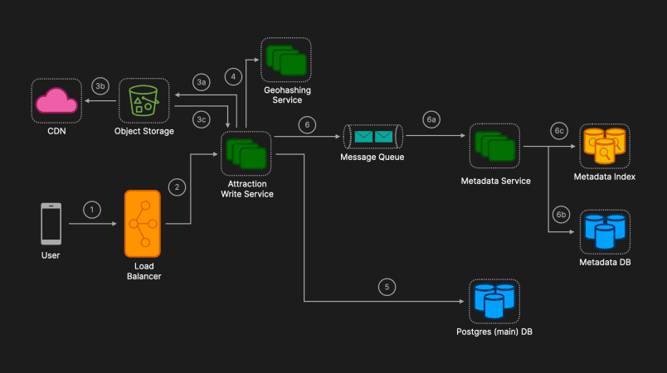
User sends a POST request
Request Initiation: The user, who must be signed in, sends a POST request to the /api/attractions API endpoint.
Load Balancer
Routing and Rate Limiting: The load balancer routes the request to an instance of the Attraction Write Service. It also performs rate limiting using either a sliding window or token bucket algorithm to ensure that the service does not get overwhelmed by malicious users. This helps maintain high availability and prevents service abuse.
The sliding window algorithm tracks requests over a rolling time period, allowing for more granular control and smoother traffic shaping.
The token bucket algorithm uses a fixed capacity bucket that fills at a constant rate, allowing for bursts of traffic within limits.
Image Upload:
Object Storage: The images included in the request are uploaded to an object storage service, such as Amazon S3 by the Attraction Write Service.
CDN: The images are then added to a Content Delivery Network (CDN) to ensure fast and reliable delivery to users globally.
URL Generation: The URLs pointing to these stored images are returned and will be used to reference the images in the attraction table.
Geohashing Service:
Geohashing: The Geohash of the location is calculated based on the provided latitude and longitude. Geohashing is a method of encoding latitude/longitude coordinates into a single string of letters and digits, which allows for efficient proximity searches by spatially indexing the location data. The length of the geohash determines the precision of the location representation: longer geohashes represent more precise locations.
Implementation Strategy:
Store the full 8-character (precision ≈ 38 meters) geohash in the database for each attraction.
For broader area searches, use prefix matching on the first 5-6 characters.
For precise local searches, use the full 7-8 characters.
Alternative Approach: Alternatively, a Quadtree implementation could be discussed, which is a tree data structure in which each internal node has exactly four children. Quadtrees are used to partition a two-dimensional space by recursively subdividing it into four quadrants or regions. However, for this system design, we will focus on using Geohash due to its simplicity and efficiency for our use case.
Storing the Attraction
Postgres Database: The attraction details, including the Geohash and image URLs, are stored in the main Postgres database. A Postgres database is chosen because it supports PostGIS, an extension that provides robust spatial database capabilities, enabling efficient geospatial queries (e.g., distance calculations, area overlaps) and indexing.
Asynchronous Processing:
Message Queue: Non-critical metadata is processed asynchronously. A message containing this metadata is sent to a message queue (e.g., RabbitMQ or Kafka).
Metadata Service: The Metadata Service reads the message from the queue and processes the data. Given the non-rigid nature of attraction metadata, a NoSQL database like DynamoDB is a suitable option for storage due to its flexibility and scalability.
Metadata Index: The Metadata Service also updates the Metadata index, allowing for efficient querying and retrieval of metadata. This could involve updating an ElasticSearch index to enable advanced search capabilities based on the metadata.
After successfully storing the attraction details and initiating metadata processing, a response is sent back to the user indicating that the attraction was successfully created.
Searching Attractions Flow
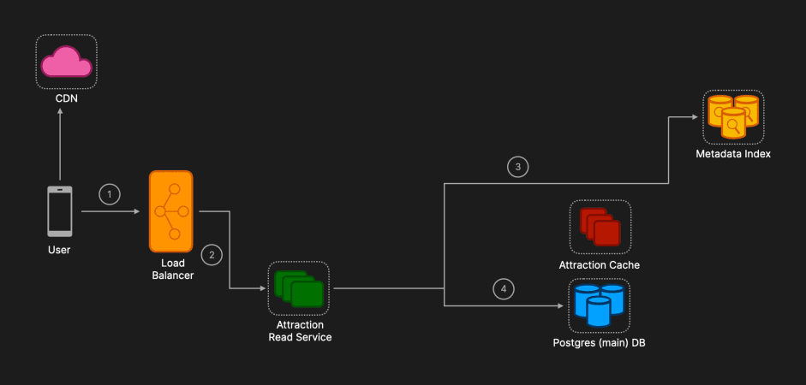
User sends a GET request:
Request Initiation: The user sends a GET request to the /api/attractions/search API endpoint.
Load Balancer:
Routing: The load balancer routes the request to an instance of the Attraction Read Service. The load balancer ensures that the request is distributed evenly across available instances to maintain high availability and optimal performance.
Elasticsearch Query:
Initial Filtering: The Attraction Read Service first queries Elasticsearch to find potential matches based on the query search (e.g. restaurant type) and a bounding box slightly larger than the specified search radius. This step leverages Elasticsearch's powerful text search and filtering capabilities.
List of Attraction IDs: Elasticsearch returns a list of attraction IDs that match the restaurant type and fall within the broader bounding box.
PostgreSQL Query with PostGIS:
Precise Distance Calculations: Using the list of attraction IDs obtained from Elasticsearch, the Attraction Read Service then queries PostgreSQL to get precise locations and details of these attractions. PostGIS, an extension of PostgreSQL, provides advanced spatial operations and precise distance calculations.
Spatial Operations: PostGIS performs spatial operations to accurately filter attractions that fall within the exact search radius specified by the user.
Response is sent to user
Image Retrieval:
CDN Access: The images associated with the retrieved attractions are also fetched from the CDN. This ensures that images are delivered quickly and efficiently to the user.
Benefits and Justifications
Hybrid Search Approach:
Elasticsearch for Text Search and Filtering: Elasticsearch's capabilities for full-text search and filtering allow for efficient matching of restaurant types and initial location-based filtering. This reduces the number of records that need to be processed by PostgreSQL.
PostGIS for Precise Spatial Operations: PostGIS provides accurate distance calculations and advanced spatial operations, ensuring that the final results meet the user's exact proximity requirements.
Caching for Performance Optimization:
Redis: Caching common search queries in Redis reduces the load on Elasticsearch and PostgreSQL, significantly improving response times for popular searches.
Scalable Database Architecture:
Leader-Follower Replication: Implementing leader-follower replication in PostgreSQL ensures that the system can handle high read volumes efficiently. This setup provides scalability and maintains performance under load.
Eventual Consistency: Accepting eventual consistency allows the system to scale and handle high read volumes without the need for real-time data synchronization, which is suitable for the nature of attraction data.
Reviewing Attraction Flow
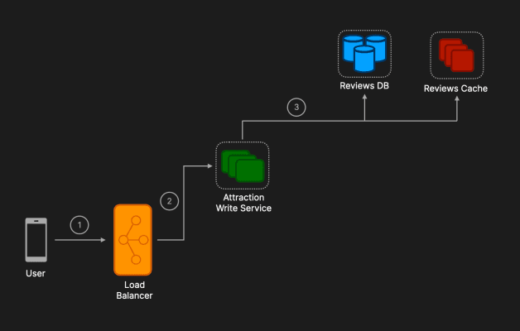
User sends a POST request:
Request Initiation: The user, who must be signed in, sends a POST request to the /api/attractions/{attraction_id}/reviews API endpoint.
Load Balancer:
Routing: The load balancer routes the request to an instance of the Attraction Write Service. The load balancer ensures even distribution of requests to maintain high availability and optimal performance.
Review Storage:
Database Choice: Given the high volume of reads relative to writes for reviews, a NoSQL database like Cassandra or DynamoDB is a good choice for storing reviews. These databases are designed for high scalability and fast read operations, making them ideal for handling large volumes of read requests efficiently. These databases use replication and partitioning to distribute data across multiple nodes, ensuring high availability and fault tolerance
Redis Cache: Frequently accessed reviews and aggregated data (e.g., average ratings) can be cached in Redis to further improve response times. Redis is an in-memory data store known for its low-latency data access.
Complete Architecture
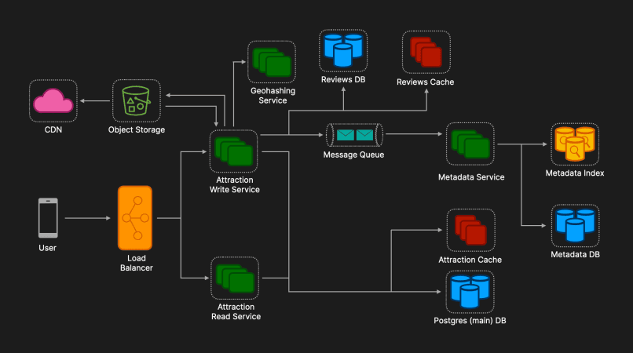
Additional Discussion Points
Data Consistency and Integrity:
Address how data consistency is maintained across different services and databases.
Discuss strategies for handling conflicting updates or concurrent modifications.
Content Moderation:
Fake users, inappropriate content etc.
Monitoring and Alerting:
Discuss the importance of implementing robust monitoring and alerting mechanisms to ensure the health and performance of the system.
Mention tools like Prometheus, Grafana, and AWS CloudWatch for monitoring database performance, request rates, error rates, and other key metrics.

Dating App (Tinder)
Editorial Solution
Quiz
AI Whiteboard
Overview
Introduction
Requirements
Creating Profile Flow
Swiping Flow
Generating Recommendations Flow
Updating Location Flow
Complete Architecture
Additional Discussion Points
Introduction
Designing Tinder may seem straightforward at first glance, given its simple user interface: a user creates a profile, swipes left or right on other profiles, and if two users swipe right, a match is made.
However, as former CTO of Tinder Maria Zhang described it, Tinder is like an iceberg all the complexity is hidden beneath the surface. As we dive deeper into the system design behind Tinder, you'll begin to understand why this complexity exists and why the challenges of building such a platform are far more intricate than they might initially appear.
Requirements
Functional Requirements
User Profile Creation: Users should be able to create and manage their profiles, including uploading photos, writing a bio, and specifying their preferences.
Location-Based Recommendations: The system should provide users with profile recommendations based on their current location, ensuring relevance and proximity.
Preference Settings: Users should have the ability to customize their search preferences, such as setting a desired radius, age range, and other filters to refine recommendations.
Matching Mechanism: Implement a matching algorithm that allows users to swipe left (dislike) or right (like) on profiles, with a match occurring when both users swipe right.
Passport Mode: Provide a feature that allows users to change their location and receive recommendations from different geographical areas, enabling interaction with users in other cities or countries.
Non Functional Requirements
Scalability: The platform must be able to handle millions of users simultaneously, scaling efficiently as the user base grows and as usage spikes in specific regions.
Availability: The system should maintain high availability, ensuring that users can access the service without interruptions, even during peak times.
Low Latency: User interactions, such as swiping and loading profiles, should be smooth and responsive, with minimal delay, to maintain an engaging user experience.
Non Covered
Chat Functionality: The implementation of chat or messaging between matched users will not be covered here, as it is discussed in detail in our Messaging App system design.
Creating Profile Flow
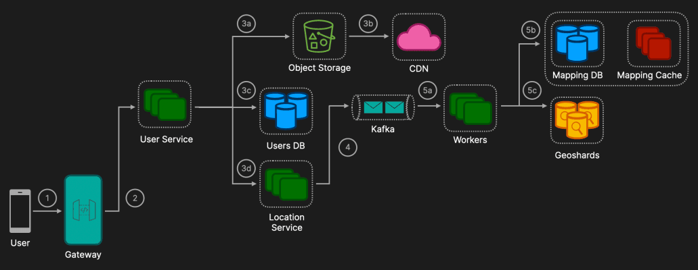
Request Initiation
User Action: The user initiates the profile creation process by sending a POST request to the /api/profile API endpoint.
Modular Requests: This process can be divided into multiple POST requests, each handling specific aspects of the profile (e.g., basic information, preferences, and image uploads). This modular approach ensures that each component of the profile is processed independently, allowing for better error handling and data consistency.
API Gateway
Tinder API Gateway (TAG): Routes incoming HTTP requests to the appropriate backend services, in this case, the User Profile Service.
Additional Functions: TAG also performs several other functions including rate limiting, session management, bot detection, and request & response scanning. For the technical interview you won't have to go into more detail than this, but if you want to learn more about TAG, this is a great Tech Blog Post by Tinder.
User Profile Service:
Object Storage: The user's images are uploaded to an object storage service, such as Amazon S3. This storage solution is ideal due to its scalability, durability, and ease of integration.
Content Delivery Network (CDN): The images are distributed via a Content Delivery Network (CDN) to ensure they are delivered quickly and reliably to users across the globe. A CDN reduces latency by caching images in servers close to the user's location, improving the overall user experience.
Data Storage: The user's basic information and preferences are stored in the User Profile Database. DynamoDB is an excellent choice for this database due to its high scalability and low latency, which are essential to meet Tinder's large-scale and performance requirements.
Location Service: The user's location information and preferences are then sent to the Location Service for indexing.
Location Service Functionality
Elasticsearch will be used to implement searching for users because it is highly scalable, provides powerful full-text search capabilities, and supports real-time querying. Given that Tinder is a location-based service with a maximum search radius of 100 miles, it is inefficient to include distant users - such as those in London when serving a user in California. Storing all users in a single global index would lead to significant performance issues due to the large index size and the computational load required to process queries.
Therefore, to handle Tinder's scale, which includes millions of users, we will use a geographically optimized solution known as geosharding. This approach involves storing users who are physically near each other within the same shard. By reducing the index size that each query needs to search, geosharding significantly improves query performance and minimizes computational overhead.
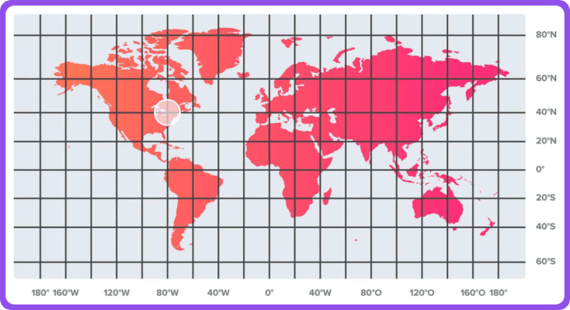
Tinder Medium Blog | Sharding Approach [1]
The challenge with geosharding is to ensure that the load is balanced across shards, avoiding the creation of "hot-shards" where certain shards become overwhelmed with data or queries. In practical terms as shown in the image above, there won’t be any users in cells over the ocean, however, large cities like New York or London may have millions of users within small geographic areas. To manage this, our service will calculate a load score for each shard based on factors such as user activity and density, ensuring that the distribution of users across shards remains balanced.

Hilbert Curve - Tinder Medium Blog | Sharding Approach [1]
To implement geosharding, the system will leverages Google's S2 library, which uses a Hilbert curve to preserve spatial locality. A Hilbert curve is a type of space-filling curve that ensures that points that are close on the curve are also close in physical space, making it ideal for mapping geographic data in a way that maintains locality.

Tinder Medium Blog | Sharding Approach [1]
The S2 library projects the Earth's surface onto a cube where each face of the cube is filled with Hilbert curve and subdivides it into cells, with each cell representing a specific geographic area. These cells are organized into a quadtree structure, where four smaller cells combine to form a larger cell.
By adjusting the size of these cells, the system creates geoshards that are tailored to balance load and performance effectively. For example, in densely populated areas, smaller cells (and thus smaller geoshards) are used to ensure that the load is evenly distributed. Each user is mapped to an S2 cell based on their location (latitude and longitude), and these cells are then grouped into geoshards.
When a query is made—such as a user searching for recommendations within a 100-mile radius, the system will first determine which S2 cells fall within the search area. These cells are then mapped to the corresponding geoshards, which are the specific Elasticsearch indexes that need to be queried. By querying only the relevant geoshards, the system optimizes search performance and minimizes unnecessary computation.
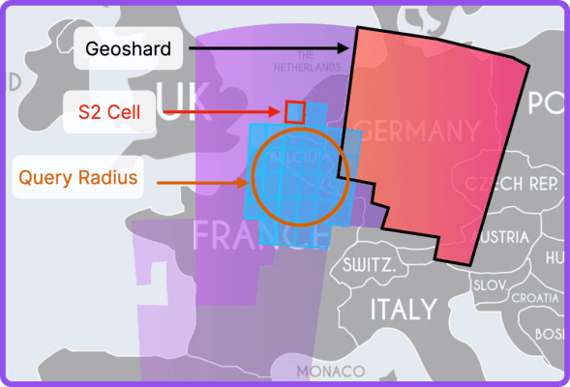
Adapted from Tinder Medium Blog | Sharding Approach [1]
In summary, Tinder’s use of geosharding with the S2 library allows it to efficiently manage a global user base, ensuring that search queries are fast, scalable, and geographically relevant.
Workers
Kafka Integration: After the Location Service identifies the appropriate S2 cell for the user, it pushes a message onto Kafka. Kafka ensures strict message ordering, crucial for maintaining consistency in location updates.which will be discussed in depth below in the Updating Location Flow.
Mapping Cache: Workers pull messages from Kafka and query the Mapping Cache (Redis) to determine the geoshard corresponding to the S2 cell. Redis is preferred here because the mapping is infrequently updated, making it ideal for caching purposes.
Document Creation: Finally, the worker creates the user document in the correct geoshard , ensuring that the user's profile is accurately stored and indexed based on their location.
Swiping Flow
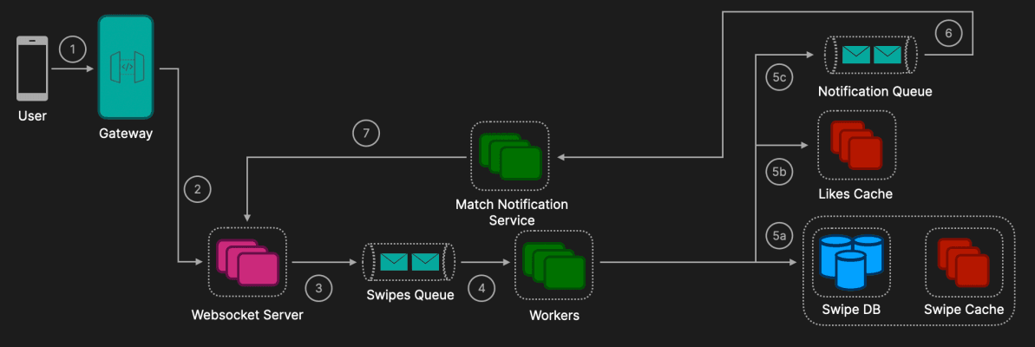
User action
The user performs a swipe action in the Tinder app. This action is sent through an established websocket connection.
API Gateway
Tinder API Gateway (TAG): Manages websocket connections for all active users and handles authentication and initial connection setup. Once the WebSocket connection is established, TAG routes the swipe action to the appropriate backend service for processing.
Websocket Server
Receives swipe actions directly from users through the established WebSocket connections.
Pushes swipe information onto the Swipes Queue (e.g., Kafka) for asynchronous processing, ensuring that actions are handled in the order they are received.
The WebSocket Server keeps the WebSocket connections open with active users, enabling bidirectional communication for real-time notifications.
Swipes Queue
This queue temporarily holds all incoming swipe actions, providing a buffer that helps manage load and ensures that swipe actions are processed in a scalable and efficient manner.
Workers
Workers pull messages off the Swipes Queue for processing. The swipe information is stored in the Swipe Database (Swipe DB), ensuring that all actions are persisted for future reference.
If the swipe is a "like" (right swipe) then store it in the Likes Cache (Redis) for quick access. It will also check if the other user had previously liked the current user.
If it's a match push a match notification onto the Notification Queue.
Notification Queue
This queue holds match notifications, ensuring they are processed in the correct order and delivered reliably.
Match Notification Service
This service pulls match notifications from the Notification Queue and processes the match data.
After processing, the Match Notification Service sends the match information back to the WebSocket Server, which then communicates the match details to the user via the open WebSocket connection, providing real-time feedback.
Generating Recommendations Flow
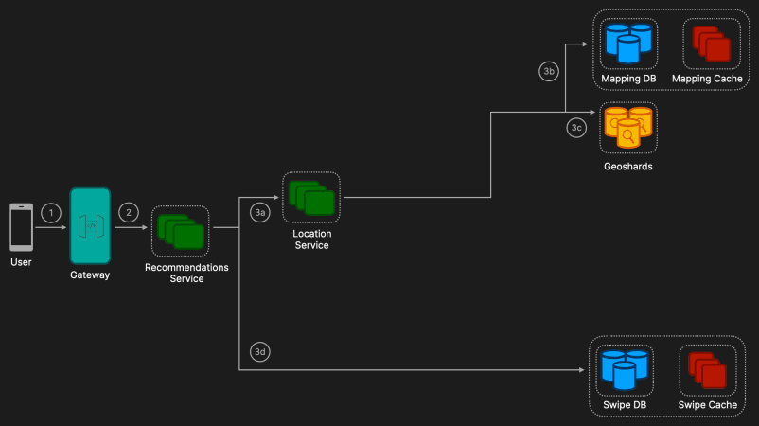
Request Initiation
User Action: The user requests to get the recommendations by sending a GET request to the /api/recommendations API endpoint.
The request includes parameters such as the user's current location and desired search radius.
API Gateway
Tinder API Gateway (TAG): Routes incoming HTTP requests to the appropriate backend services, in this case, the Recommendations Service.
Recommendations Service:
Location Calculation: The Recommendations Service first sends a request to the Location Service to determine the user's current location and the corresponding geographic cells (S2 cells) based on the user’s location and the search radius.
Mapping Query: The Location Service then queries the Mapping Cache (Redis) to get the corresponding geoshards for the calculated S2 cells. If there's a cache miss, it queries the Mapping DB and updates the Mapping Cache.
Geoshard Query: Once the appropriate geoshards are identified, the Recommendations Service queries Elasticsearch, where the geoshards are stored.
Filtering Previous Swipes: Simultaneously, the Recommendations Service makes a request to the Swipe Database to fetch a list of profiles that the user has already swiped on. To enhance performance, the Swipe Cache may also be utilized to quickly retrieve recent swipe actions without querying the main database. After filtering, the final list of recommended profiles is compiled and sent back to the user through the API Gateway.
Updating Location Flow
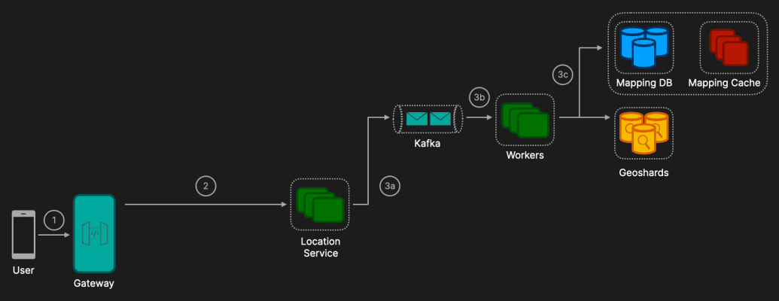
Request Initiation
User Action: The user requests to update their location by sending a PUT request to the /api/location API endpoint. This action typically occurs when the user moves to a new location and the app needs to reflect this change for accurate recommendations.
API Gateway
Tinder API Gateway (TAG): Routes incoming HTTP requests to the Location Service. The request includes both the user's current location and the new location to which the user has moved.
Location Service
S2 Cell Calculation: The Location Service calculates which S2 cell the user is currently located in and determines the new S2 cell that corresponds to the user's updated location. The S2 cell calculation is critical for identifying the geographic region in which the user should now be indexed.
Message Queueing: To manage consistency within Tinder's geosharded architecture, the Location Service pushes a message onto a Kafka queue. Kafka is used to ensure scalable, ordered message processing, which is crucial for maintaining consistency when a user's location changes rapidly or when there are concurrent updates. Kafka ensures that documents with the same keys (e.g., user IDs) are consistently sent to the same partitions, maintaining the order of updates and preventing inconsistencies that could arise from out-of-order processing.
Processing Updates: Workers pull messages off the Kafka queue and process the location update. The worker is responsible for ensuring that the user's data is moved to the correct geoshard based on the new S2 cell. For datastore consistency, Tinder utilized Elasticsearch's Get API, which refreshes the index if there are pending writes, thus eliminating inconsistencies between the mapping datastore and search index.
Complete Architecture
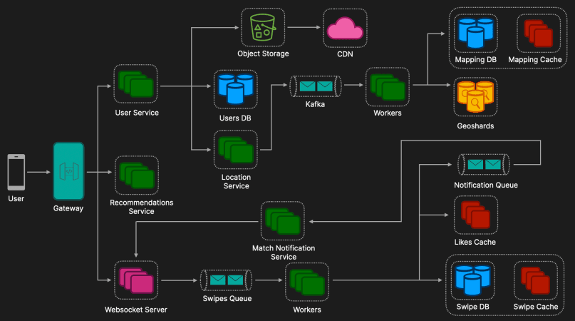
Additional Discussion Points
Error Handling and Retries
Retry Mechanisms: Implement retries for failed Kafka operations and database writes to handle transient issues.
Dead-Letter Queues (DLQs): Use DLQs for messages that fail repeatedly, preventing them from blocking other processes.
Scaling and Load Balancing
Auto-Scaling: Auto-scale WebSocket Servers, Workers, and the Match Notification Service based on demand.
Load Balancing: Distribute WebSocket connections and service requests evenly across servers to prevent overloads.
Database Scaling: Use partitioning, sharding, and read replicas for horizontal scaling and improved performance.
Data Privacy and Compliance
Ensure GDPR/CCPA compliance, anonymize data, and use encryption for security.

Ride Sharing Service (Uber, Lyft)
Editorial Solution
Quiz
AI Whiteboard
Overview
Introduction
Requirements
Data Model
API Design
Driver Location Update Flow
Ride Request Flow
Complete Architecture
Additional Discussion Points
Bonus Section: What Top Tech Interviewers Really Want to See

Introduction
Designing Uber is one of the more challenging system design interview questions because it's easy to become overwhelmed by the multitude of components and over-engineer the solution. In this system design, we will focus on the core flows that most interviewers expect to see covered, as well as provide deep dives into the most critical aspects of the system.
Requirements
Functional Requirements
Ride Request: Riders should be able to input their pickup and destination location, view nearby drivers, and receive real-time fare estimates.
Ride Matching: The system should be able to efficiently and effectively match a rider with an available driver that meets their requirements.
Driver Tracking: Once matched, the rider should be able to track the driver's location in real-time, along with the estimated time of arrival (ETA).
Push Notifications: The system should send notifications for ride updates, driver arrival, trip completion, promotions, etc.
Non Functional Requirements
Scalability: The platform must support more than 100 million daily active users (DAU), scaling efficiently with regional spikes in demand.
High Availability: The system should be reliable and available 24/7, ensuring minimal downtime, as the switching cost for users is extremely low.
Low Latency: The application must perform well even in areas with poor cellular networks, providing fast and responsive user interactions to ensure a smooth experience globally.
Non Covered
Ride-Pooling: The implementation of ride-pooling services (where multiple passengers share a ride) will not be covered here.
Data Model
This is a basic outline of some of the core tables that could be included in a ride sharing service data model.
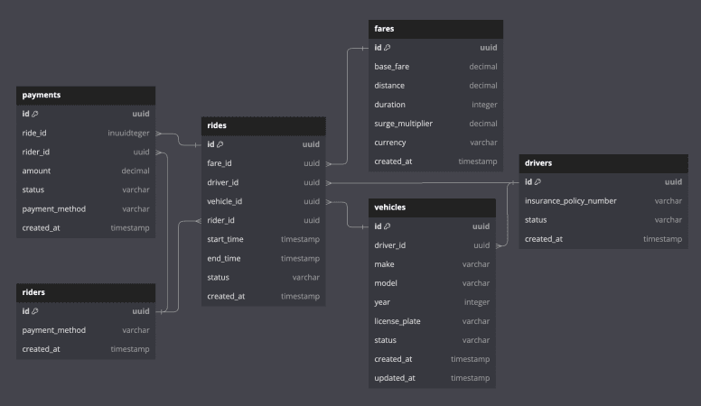
Riders: Stores information about individuals requesting rides.
payment_method: The preferred method of payment (e.g., card, cash, wallet).
Drivers: Stores details about drivers in the system.
status: Current status of the driver (e.g., active, inactive).
Vehicles: Tracks vehicles that are associated with drivers.
driver_id: Foreign key linking the vehicle to a specific driver.
make, model, year, license_plate: Vehicle identification details.
status: Indicates if the vehicle is available, busy, or under maintenance.
Fares: Stores information about fare options presented to a rider.
base_fare: The initial cost of the ride before any additional charges are applied.
surge_multiplier: A dynamic multiplier applied during periods of high demand or low driver availability. It increases the fare to encourage more drivers to become available.
Rides: Stores information about rides initiated by riders.
start_time, end_time: Timestamps marking the start and end of the ride.
status: Current status of the ride (e.g., requested, accepted, completed, cancelled).
Payments: Handles payment details for completed rides.
status: Indicates the current status of the payment (e.g., pending, completed, failed).
API Design
For a ride sharing services we will use a classic RESTful API to interact with the data. RESTful APIs are simple, widely used, stateless, and support caching which make it a good candidate for our system.
Our REST API will comprise of three main endpoints:
POST: /api/fares/estimate
Description: Provides fare estimates based on the rider's pickup and destination locations.
Params:
pickup_location: { latitude: float, longitude: float }
destination_location: { latitude: float, longitude: float }
POST: /api/rides/request
Description: Allows a rider to request a ride by selecting a fare.
Params:
fare_id: string
PUT: /api/rides/{ride_id}/accept
Description: Allows a driver to accept a ride.
Driver Location Update Flow
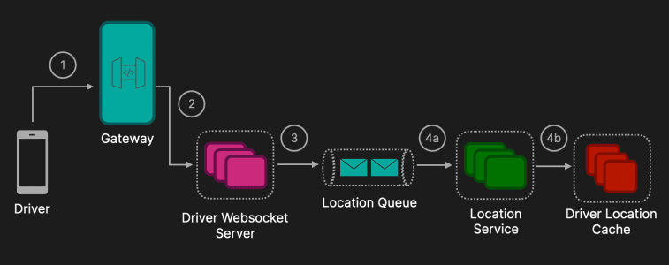
Driver App
Long Polling vs Server-Sent Events vs WebSockets vs QUIC

WebSocket Connection: Establishes a secure, persistent connection to the Driver WebSocket Service via the API Gateway.
Location Updates: Sends high-frequency (≈ 10s) location updates with relevant metadata.
API Gateway
Connection Management: Manages WebSocket connections and routes them to the appropriate services.
Additional Functionality: Performs authentication, authorization, and implements rate limiting. Also handles load balancing by distributing incoming connections and requests to maintain optimal performance.
Driver WebSocket Server
Updates Handling: Receives location updates from the driver app sends onto the Location Queue.
Scalability: Designed to scale horizontally to handle a large number of concurrent connections.
Location Service
Geospatial Indexing Techniques

Data Processing: Pulls messages off the Location Queue and converts GPS coordinates to geohashes and updates the Location Cache.
In-Memory Datastore: Stores the data in Redis with geospatial indexing for fast data access. Expiration policies are also implemented to remove inactive drivers from the location cache.
Ride Request Flow
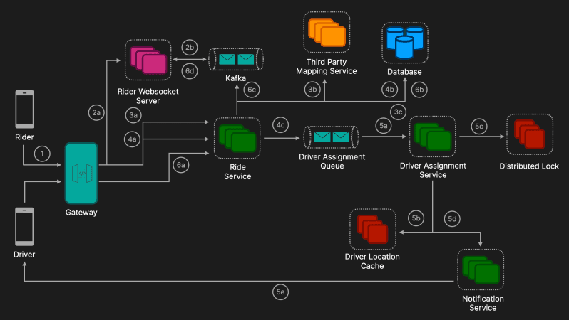
User Action
The rider (user) opens the ride-sharing app on their mobile device. The app initiates connection to Rider WebSocket Service through the API Gateway.
API Gateway
Persistent Connection: The rider's app establishes a persistent WebSocket connection to the Rider WebSocket Service via the API Gateway. Enables real-time communication for updates like ride status changes and driver location tracking. Performs authentication, authorization, and implements rate limiting. Also handles load balancing by distributing incoming connections and requests to maintain optimal performance.
Subscription to Message Broker Topics: When the rider connects via WebSocket, the Rider WebSocket Service subscribes to a specific topic in a message broker (e.g., Apache Kafka) associated with that rider. Uses a hash of the Rider ID to create a unique and secure topic name. Facilitates the delivery of personalized real-time notifications to the rider, such as ride acceptance by a driver.
Ride Estimate
Rider POST Request: The rider inputs their pickup and destination locations in the app and the app sends a POST request to the /api/fares/estimate endpoint to the Ride Service via the API Gateway.
Third Party Mapping Service: Utilizes mapping services (e.g., Google Maps, Mapbox) to generate the best route between the origin and destination.
Fare Calculation: Fares are calculated for different ride types (e.g., economy, XL) based on several factors including: distance, time, traffic conditions, demand factors (e.g. dynamic surge pricing) and stored in the database. An SQL database like PostgreSQL could be a good option as it supports Atomicity, Consistency, Isolation, Durability (ACID) properties ensure that transactions are processed reliably, which is critical for financial operations like fare calculations and ride status updates.
Ride Request
POST Request: The app presents available ride options with corresponding fares. The rider selects a preferred ride option which will send a POST request to the /api/rides/request endpoint to the Ride Service via the API Gateway.
Create Ride Entry: This will create a new ride entry in the database with status set to "Created". Also can implement optimistic or pessimistic locking in the database to prevent duplicate ride entries or conflicting updates during high traffic.
Message Sent to Queue: The new ride is placed onto a Driver Assignment Queue for processing. This queue decouples ride creation from driver assignment to improve scalability and reliability.
Driver Assignment Service
Processing Ride Requests: Listens to the Driver Assignment Queue and pulls new ride requests for processing.
Locating Nearby Drivers: Geohashing converts the rider's origin coordinates into a geohash which is a hierarchical spatial data structure that encodes geographic locations into short alphanumeric strings.
Querying the Location Cache: Uses the geohash prefix to find drivers in the immediate vicinity. Quickly narrows down potential drivers by searching within a specific geohash cell. If not enough drivers are found, expands the search to neighboring geohashes. Continues until a sufficient number of candidate drivers are identified. Drivers are prioritised using a scoring algorithm based factors such proximity to rider, vehicle type compatibility, driver status, etc.
Sequential Driver Notification with Locking: Uses a distributed lock (e.g., Redis-based lock) to ensure the ride request is offered to one driver at a time to prevents multiple drivers from accepting the same ride. Sends a ride request to the highest-priority driver first.
Sends Push Notification: Utilizes push notification services like Firebase Cloud Messaging (FCM) for Android or Apple Push Notification Service (APNS) for iOS. Sets a timeout period (e.g., 15 seconds) for the driver to respond. If accepted the driver confirms acceptance, and the ride status is updated accordingly. If no response or declined, releases the lock and proceeds to notify the next driver in the list. Repeats until a driver accepts the ride or the candidate list is exhausted. Ensures that at any given time, only one driver holds the lock for the ride request.
Driver Accepts the Ride
PUT Request to Ride Service: The driver app sends a PUT request to the Ride Service to confirm acceptance of the ride. The request includes the driver's JWT (JSON Web Token) in the authorization header, which contains the driver's ID and other authentication claims. Ensures that only authenticated drivers can accept ride requests.
Updating the Database: Updates the ride's status in the Ride Database from "Created" to "Accepted". Performs the update as an atomic transaction to prevent race conditions and ensure data integrity.
Publishing Notification to Rider: Ride Service can create a message which indicates that the driver has accepted the ride and includes driver's name, profile picture, vehicle information (make, model, color, license plate), and estimated time of arrival (ETA). The Rider ID is included in the response from the update allowing the Ride Service to construct the rider's Kafka topic using a secure method, such as hashing the Rider ID.
The Rider WebSocket Service is already subscribed to the rider's topic in Kafka, established when the rider app connected and authenticated. This persistent WebSocket connection is then used to send the notification to the rider's app in real time.
Complete Architecture
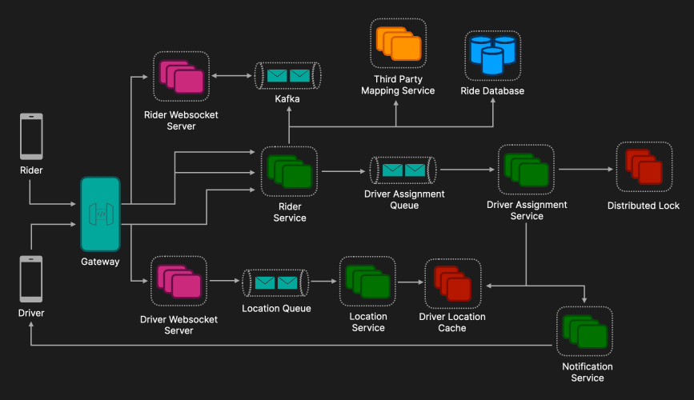
Additional Discussion Points
Scaling
Scaling Driver Location Redis Cluster: Use Redis Cluster to partition data by region or driver ID. Set up master-replica configurations with Redis Sentinel for failover.
Scaling PostgreSQL Database: For read scaling implement read replicas and load balancing for read operations. For write scaling using partitioning (sharding) is a viable option.
Scaling WebSocket Servers: Use sticky sessions or TCP-level load balancing. Optimize resource usage and implement heartbeat mechanisms to ensure proper connection management.
Security
Authentication & Authorization: Use token-based authentication (e.g., JWT) and enforce role-based access control (RBAC).
Data Encryption: Encrypt data in transit (TLS/SSL) and at rest in databases.
Monitoring & Logging
System Monitoring: Use tools like Prometheus and Grafana for real-time metrics (CPU, memory, latency). Implement health checks and application monitoring tools to monitor service performance.
Centralized Logging: Aggregate logs with ELK Stack or Graylog. Employ structured logging (e.g., JSON) and set up alerts for critical events.

Video Streaming and Sharing Platform (YouTube, Vimeo)
Editorial Solution
Quiz
AI Whiteboard
Overview
Introduction
Requirements
Estimates
Data Model
API Design
Upload Video Flow
Receive Notification Flow
Stream Video Flow
Complete Architecture
Additional Discussion Points
Bonus Section: What Top Tech Interviewers Really Want to See

Introduction
Designing a video streaming platform like YouTube is a highly popular and relevant system design interview question. While it may not be the most complex system to design, it presents unique challenges that interviewers expect candidates to address. From handling massive amounts of video data and optimizing video delivery to managing user-generated content and implementing scalable search and recommendation systems, the scope is broad. In this solution, we'll explore the key problems that need to be solved and provide insights into how to tackle them effectively in an interview setting.
Requirements
Functional Requirements
Video Upload: The system should allow users to upload video files of various formats and sizes efficiently and securely. This includes handling large files, providing progress feedback, and supporting resumable uploads in case of interruptions.
Video Encoding and Transcoding: The system needs to process and convert uploaded videos into multiple standardized formats and resolutions. This ensures compatibility across different devices and network conditions, enabling smooth playback for all users.
Stream Video Content: The system should enable users to stream video content seamlessly. It must support adaptive bitrate streaming to adjust video quality in real-time based on the user's network speed and device capabilities, minimizing buffering and ensuring a high-quality viewing experience.
Notifications: Users should be notified of key events in real time to improve user experience.
Non Functional Requirements
Low Latency: The system must deliver video content with minimal delay, ensuring quick load times and smooth playback. This involves optimizing network routes, using content delivery networks (CDNs), and efficient data retrieval methods to enhance the user experience.
High Availability: The system should be reliably accessible at all times, with minimal downtime. This requires implementing fault-tolerant infrastructure, redundancy, and failover mechanisms to maintain continuous service even in the event of hardware failures or high traffic volumes.
High Scalability: The system must be capable of handling increasing numbers of users and data volumes without performance degradation.
Estimates
Storage Estimate
Daily Active Users (DAU): 2 billion
Average video uploaded per user per day: 0.005 videos (0.5% of DAUs upload a video daily)
Average video size: 100 MB (at 1080p resolution, H.264 compression)
Daily uploads: 2B × 0.005 = 10M videos/day
Daily storage for uploads: 10M × 100MB = 1,000 TB/day = 1 PB/day
Annual video uploads: 1 PB/day × 365 days = 365 PB/year
Total storage over 10 years: 365 PB/year × 10 years ≈ 3,650 PB ≈ 3.65 EB (Exabytes)
Note: the actual storage requirements would likely be 3-4x higher when accounting for several copies for redundancy and multiple resolutions.
Bandwidth Estimate
Average number of videos streamed per user per day: 5
Average video duration: 5 minutes
Streaming bitrate (1080p): 5 Mbps
Average video size streamed per user per day: 5 videos × 5 minutes / video × 60 seconds × 5Mbps = 7,500 Mbps/user/day
Convert to GB: 7,500 Mbps × (1/8) ​× (1/1024) ​≈ 0.9155 GB/user/day
Total daily bandwidth: 2B users × 0.9155 GB/user/day ≈ 1.83 EB/day (Exabytes)
Data Model
This is a basic outline of some of the core tables that could be included in a video streaming and sharing platform data model.
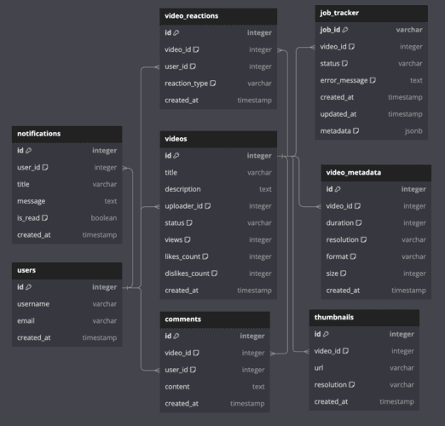
Users: Stores information about users.
Notifications: Stores information about notifcations sent to users (e.g. video published).
Videos: Stores the core information related to a video (e.g. title, description)
Video Reaction, Comments, Video Meta, & Thumbnails: Store additional information about the video
Job Tracker: Table used to track the progress of a video as it is being processed. Discussed in depth later.
API Design
For a video streaming and sharing plstform we will use a classic RESTful API to interact with the data. RESTful APIs are simple, widely used, stateless, and support caching which make it a good candidate for our system.
Our REST API will comprise of four main endpoints:
POST: /api/videos/upload/initiate
Description: Allows a user to initiate an upload session.
Params: Video metadata (title, description, tags) & number of chunks and their sizes.
Response: An upload_id (unique identifier for the upload session) & a list of presigned URLs for each chunk.
POST: /api/videos/upload/complete
Description: Allows a user to signal an upload has been completed.
Params: upload_id.
GET: /api/videos/search?query={query}
Description: Allows a user to search for videos.
Response: List of video metadata (e.g., titles, thumbnails, video IDs).
GET: /api/videos/{video_id}/playback
Description: Allows a user to start playing a video.
Params: video_id
Upload Video Flow
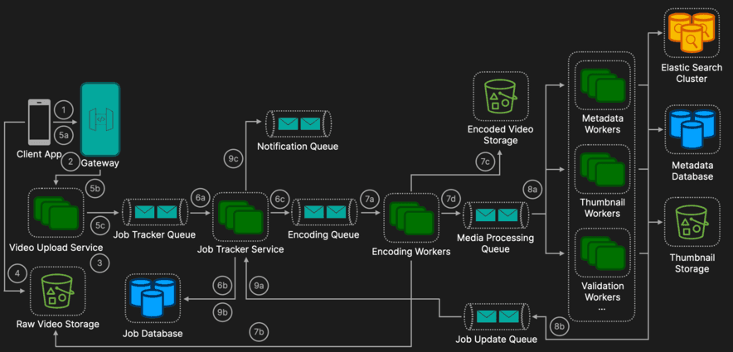
Client App
Action: A user attempts to upload a video in the UI which will send a POST request to the /api/videos/upload/initiate endpoint to initiate an upload session.
Authentication & Authorization: The request includes an authentication token (e.g., JWT) verifying the user's identity and permissions.
API Gateway
Routing: The API Gateway receives the request, authenticates the user, applies rate limiting, and forwards the request to the Video Upload Service.
Additional Functionality:
Authentication and Authorization: Verifies the JWT token.
Rate Limiting: Prevents abuse by limiting the number of uploads per user.
Load Balancing: Distributes requests across multiple instances of the Video Upload Service for optimal performance.
Video Upload Service
Presigned URLs: Generates presigned URLs which are short lived and scoped to the relevant chunks, using the storage service's SDK (Amazon S3). Each URL allows the client to upload a specific chunk directly to the storage service. Presigned URLs are great for security as they ensures that only authenticated users can upload data, as well as efficiency as it enables direct upload to storage without routing through the application servers.
Client App
Chunk Uploads: The client uploads each chunk using the presigned URLs. Chunks can be uploaded concurrently to optimize speed. Each chunk is uploaded via an HTTP PUT (generally used for chunk uploads) to the corresponding presigned URL. The client can also tracks the upload progress of each chunk and displays feedback to the user via the UI. If a chunk were to fail most modern browser file upload APIs support retries and support error states if they persist.
Temporary Storage: Chunks are stored as part objects associated with the upload_id in the Raw Video Storage. There can also be an optional checksum verification step to verify data integrity for each chunk.
Client App
Upload Complete: Once the upload is complete the client sends a request to the POST /api/videos/upload/complete endpoint.
Routing: This request is again routed via the API Gateway.
Video File Construction: The Video Upload Service first validates that all chunks have been received. It can then instructs the storage service to assemble the chunks into the final video file which is stored in a designated bucket. This is often achieved using an API call like CompleteMultipartUpload in AWS S3.
Message Creation: Upon successful assembly, the Video Upload Service places a message in the Job Tracker Queue (which can be implemented using either AWS SQS, Apache Kafka). The message includes the video metadata and storage location. This queue is important as it decouples the services making them easier to scale.
Job Tracker Service
Message Consumption: Pulls messages off the Job Tracker Queue.
Job Creation: It then creates a job in the Job Database. The purpose of the Job Database is to store the state relating to the processing of a video so that once successfully processed or an error has occurred a user can be notified accordingly. In terms of what database to use, it will simply hold one table that has a few columns tracking each of the individual processing tasks and it will be write heavy, so therefore, a NoSQL database like DynamoDB would be a great choice here.
Message Creation: Once a job has been created in the database, the Job Tracker Service places a message on the Encoding Queue (which can be implemented using either AWS SQS, Apache Kafka).
Encoding Workers
Message Consumption: Pulls messages off the Encoding Queue and starts to the process of encoding (which typically also includes compressing) the video.
Raw Video Retrieval: Videos are retrieved from the Raw Video Storage.
Process:
Encoding: Converts the video into multiple resolutions (e.g., 1080p, 720p, 480p) and formats (e.g., MP4, WebM).
Compression: Reduce the file size without significant loss of quality, ensuring faster streaming and lower storage costs and often happens as part of the encoding process using codecs like H.264 or H.265, which simultaneously encode and compress the video.
Encoded Video Storage: Videos are stored in the Encoded Video Storage bucket.
Message Creation: Once complete the worker puts a message on the Media Processing Queue. The reason this step is decoupled is because all of the downstream services rely on the videos being encoded in the correct format and therefore, this encoding process must run sequentially before the other media processing tasks, which can subsequently run in parallel as they do not rely on each other.
Media Processing Workers
Message Consumption: Each of the workers are subscribed to the topic and consume messages when they arrive.
Validation Worker: Checks for compliance with content policies by detecting inappropriate content using AI/ML models.
Thumbnail Worker: Generates thumbnail images for video previews by selecting frames that best represent the video. Once the thumbnails are selected they are stored in an object storage (e.g. AWS S3, Google Cloud Storage). Easily integrate with CDNs for fast, low-latency delivery. Data is replicated across multiple availability zones.
Metadata Worker: Stores metadata in variety of datastores. While a two-phase commit could theoretically synchronize the database and Elasticsearch, it's impractical due to complexity and performance overhead. Here we are willing to accept eventually consistency as search functionality is not the most critical feature of the application. If a failure were to occur it would be important to have appropriate retry and alerting mechanisms in place.
Relational Database (PostgreSQL): Stores core metadata (e.g., video_id, uploader_id, duration, upload_date). This can be useful for administrative tasks or reports.
Elasticsearch: Indexes video metadata for fast, full-text search.
Message Creation: Once a worker completes it sends a message to the Job Update Queue. If for any reason one of the workers fail, retries are implemented with exponential backoff and if for a predefined number of retries it fails a failure message is placed on the Job Update Queue.
Job Tracker Service:
Job Update: Pulls messages from the Job Update Queue and updates the corresponding job in the Job Database accordingly.
Notification Creation: If all processes are completed (successful or unsuccessful) a message can be placed on the Notification Queue to notify the user that processing has completed.
Receive Notification Flow
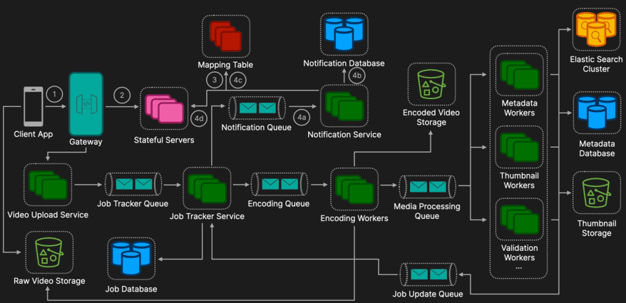
User Initiates SSE Connection
Action: When a user logs into the app or starts using features that require real-time updates, the Client App establishes an Server-Sent Events (SSE) connection by making a GET request to the /api/notifications/connect endpoint (here is a deep dive video on Polling vs WebSockets vs SSE). SSE is an ideal choice for this scenario as it provides a lightweight and efficient mechanism for delivering real-time updates from the server to the client. Unlike more complex protocols like WebSockets, SSE is optimized for uni-directional communication, making it well-suited for use cases such as in-app notifications, where updates only flow from the server to the client.
API Gateway for Connection Routing
Routing: The API Gateway validates the JWT token to confirm the user’s identity. The API Gateway uses a load-balancing strategy (e.g., round-robin, least connections) to select a stateful server for the user’s SSE connection. The connection request is forwarded to the selected stateful server.
Stateful Server Updates the Mapping Table
Mapping Table Update: Once the SSE connection is established, the stateful server updates the Mapping Table to track which users are connected and to which server. Typically implemented using an in-memory key-value store like Redis for low-latency reads and writes. Each mapping entry can have a TTL to automatically remove stale entries if the user disconnects unexpectedly without properly closing the connection.
Connection Maintenance: The stateful server maintains the SSE connection and listens for messages from the Notification Service. Keeps the connection alive by periodically sending heartbeat events to prevent timeouts.
Notification Service:
Message Consumption: Pulls notifications from the Notifications Queue.
Notification Creation: It first stores the notification in the Notification Database for persistence and future retrieval. To handle a high volume of notifications and for quick retrieval when users view their notifications NoSQL Document Store (e.g., MongoDB, DynamoDB) is a good option.
User Status: It then checks the Mapping Table to determine if the user is currently online and which server they are connected to.
Forward Notification: If the user is online, the Notification Service forwards the notification to the corresponding server, which sends the notification directly to the user's SSE connection.
Stream Video Flow
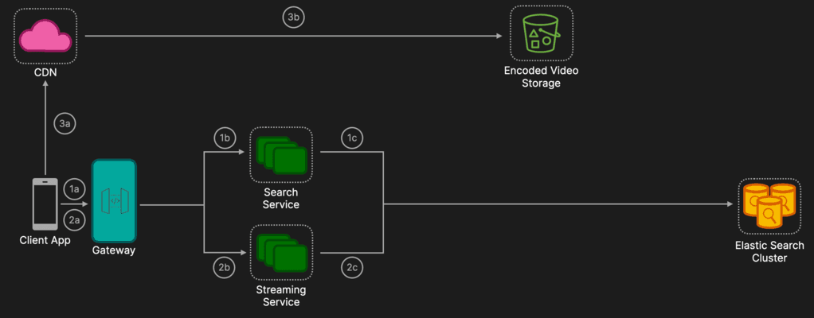
User Sends a GET Request to Search for Videos
Action: The user sends a GET request the the /api/videos/search?query={query} endpoint search query.
Routing: The API routes this request to the search service.
Search Service: Queries the Elasticsearch Metadata Cluster, which stores indexed video metadata (titles, descriptions, tags) and returns a ranked list of videos matching the query. The Search Service sends the list of matching videos (video IDs, titles, thumbnails, durations) back through the API Gateway to the client.
User Clicks on a Video They Want to Watch
User Action: When the user selects a video, the client sends a GET request to (/videos/{videoId}/playback) the API Gateway for playback.
Routing: API Gateway routes the request to the Streaming Service.
Manifest Construction: The Streaming Service constructs a playback manifest by getting the metadata information. (e.g., an HLS .m3u8 or MPEG-DASH .mpd file), which lists the available video segments for different bitrates and resolutions. The Streaming Service returns the manifest URL to the client.
Client Requests Video Segments from the CDN
Action: The client begins fetching video segments using the manifest file. The client sends requests to the CDN to get video segments (e.g., GET /api/videos/video123/720p/segment1.ts).
Adaptive Bitrate Logic: Occurs on the client side (e.g., in the video player logic). The client monitors the user’s network conditions and buffering state. Based on the available bandwidth, the client dynamically adjusts the video quality by switching between different resolutions (e.g., from 1080p to 720p or 480p).
CDN Behavior: Cache Hit or Cache Miss
CDN Cache Hit: If the requested segment is already cached in a nearby CDN edge server, it is immediately served to the client with low latency.
CDN Cache Miss: If the segment is not cached. The CDN retrieves the segment from the origin server (e.g., the S3 bucket). The CDN uses its internal configuration to request the segment from the S3 bucket. This typically happens over a secure channel, and presigned URLs are generally not needed for the CDN itself since the CDN is configured to have direct access to the S3 bucket as its origin. Once retrieved, the segment is cached at the CDN edge server for subsequent requests.
Complete Architecture
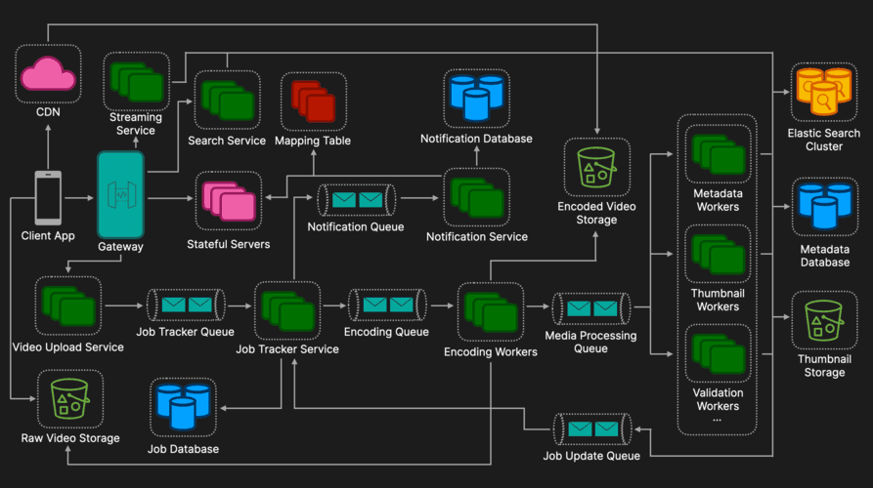
Additional Discussion Points
Trade-Offs: Lazy Loading vs. Proactive Caching
Lazy Loading: The CDN only fetches segments from the origin on demand when a user requests them. Segments are cached dynamically, reducing initial load on the CDN and storage costs.
Pros:
Cost-Efficient: Only frequently accessed segments are cached.
Scalable: Can handle a large variety of content without preloading.
Cons:
First Request Latency: The first user to request a non-cached segment experiences higher latency.
Proactive Caching (Preloading): Segments are preloaded into the CDN edge servers before user requests. Often used for popular videos (e.g., trending content).
Pros:
Low Latency: Immediate response for the first request.
Better User Experience: Ideal for high-traffic or time-sensitive content (e.g., live streams, premieres).
Cons:
Higher Costs: Increased storage and bandwidth usage.
Potential Wastage: Caching unpopular videos may result in unused resources.
Data Redundancy
Data Replication Across Multiple Availability Zones: To ensure high availability and durability, video segments, metadata, and other critical data are replicated across multiple availability zones (AZs). This replication ensures that even if one AZ experiences a failure, the system can continue to serve requests from another AZ with minimal disruption.
Data Consistency
Ensure Idempotency in Critical Steps: Idempotency ensures that repeating a critical operation (e.g., assembling video files, retrying failed jobs) produces the same result without side effects. This prevents duplicate processing and ensures data consistency.
Encryption
Description: Videos are encrypted to protect them from unauthorized access both at rest (stored in object storage) and in transit (during streaming). This ensures that only authorized users can view the content.
Key Aspects:
At Rest: Videos are encrypted before being stored in S3 or equivalent storage.
In Transit: TLS (Transport Layer Security) is used to encrypt video segments during delivery.
Decryption: The video player decrypts the content on authorized devices for secure playback.
Analytics Service
Client Periodically Sends Playback Stats to Analytics Service: While the user streams video content, the client periodically sends playback statistics (e.g., playtime, buffering events, bitrate changes) to an Analytics Service. This data helps monitor and improve system performance and user experience.
Error Handling
Retry Mechanism with Exponential Backoff: The system implements a retry mechanism with exponential backoff for handling transient errors (e.g., network timeouts, temporary service unavailability). This approach reduces load on dependent services and increases the likelihood of success in subsequent attempts.
Continued failures: If retries exceed a predefined limit, the system should:
Trigger Alerts: Notify the operations team about the failure.
Fallback Mechanisms: Implement manual intervention workflows (e.g., reprocessing or reviewing failed jobs).
Feed Personalization
A personalized feed relies on user data like watch history, search queries, engagement metrics (likes, shares, subscriptions), and video metadata (tags, category, popularity). Machine learning models, such as collaborative filtering and content-based filtering, use this data to identify patterns and recommend videos tailored to individual preferences. Real-time updates can enhance personalization by dynamically adjusting the feed based on recent user activity, while reinforcement learning algorithms optimize recommendations to maximize engagement. Incorporating diversity into recommendations prevents over-personalization and keeps the feed fresh and engaging.

E-Commerce Platform (Amazon, eBay)
Editorial Solution
Quiz
AI Whiteboard
Overview
Introduction
Requirements
Estimates
Data Model
API Design
Product Browsing Flow
Cart Management Flow
Checkout and Order Placement Flow
Complete Architecture
Additional Discussion Points
Introduction
Designing an e-commerce system like Amazon is a complex challenge due to the vast array of services required in a production environment. However, given the time constraints of a technical interview, it’s critical to clarify with your interviewer which functionalities they expect to see implemented. In this solution, we focus on the core user-facing features - such as product browsing, shopping cart, and order processing - that most interviewers prioritize, while outlining a scalable and efficient design tailored to interview expectations.
Requirements
Functional Requirements
User Authentication: Enables login for cart persistence and order history.
Product Catalog: Allows browsing by category and searching by keyword with key details (e.g., price, availability).
Shopping Cart: Supports adding, updating, or removing items, persisted for logged-in users.
Order Management: Facilitates order placement, history, and status tracking.
Payment Processing: Supports multiple methods (e.g., credit card) and refunds securely.
Inventory Management: Ensures real-time stock updates (reduce on order, increase on return).
Non Functional Requirements
Scalability: Handle millions of users and transactions (e.g., horizontal scaling with load balancers, sharded databases), and support traffic spikes (e.g., Black Friday sales) using auto-scaling and caching.
Performance: Low latency for search and page loads (e.g., < 200ms for product searches), and fast checkout process to minimize cart abandonment.
Availability: The system should be reliably accessible at all times, with minimal downtime (e.g., using redundancy, multi-region deployment).
Security: Enforces encryption (TLS, HTTPS) and PCI DSS compliance.
Not Covered
The following features are typical in a production e-commerce system but are excluded here due to interview time constraints.
Notifications: Email or SMS updates for orders and promotions (full notification system design here).
Reviews and Ratings: User-generated product feedback.
Seller Portal: Tools for third-party sellers to manage listings.
Estimates
In this section, we estimate Query Per Second (QPS) and storage needs for the e-commerce system with simplified back-of-the-envelope calculations, suitable for an interview’s time constraints.
Query Per Second (QPS) Estimates
Assumption: 10M daily active users (DAU), with peak traffic 2x average
Traffic Breakdown: Mostly browsing/search (~80%), some checkout (~20%)
Calculation:
10M users/day × 10 page views/user = 100M views/day
100M / (24 × 3600 seconds) ≈ 1,150 QPS (average)
Peak QPS = 1,150 × 2 = 2,300 QPS
Storage Requirements
Assumption: 10M users, 100M products, 1M orders/day, 1-year retention
Calculation:
Users: 10M × 1KB/user = 10GB
Products: 100M × 10KB/product = 1TB
Orders: 1M/day × 5KB/order × 365 days = 1.825TB
Total = 10GB + 1TB + 1.825TB ≈ 2.84TB
Note: These are simplified estimates for interview brevity. A more comprehensive analysis (e.g., splitting QPS by operation or factoring in replication) is more accurate but omitted here due to time constraints of an interview.
Data Model
The data model encapsulates the core entities required to support the e-commerce system’s functionality. It’s designed to be simple yet extensible for an interview setting.
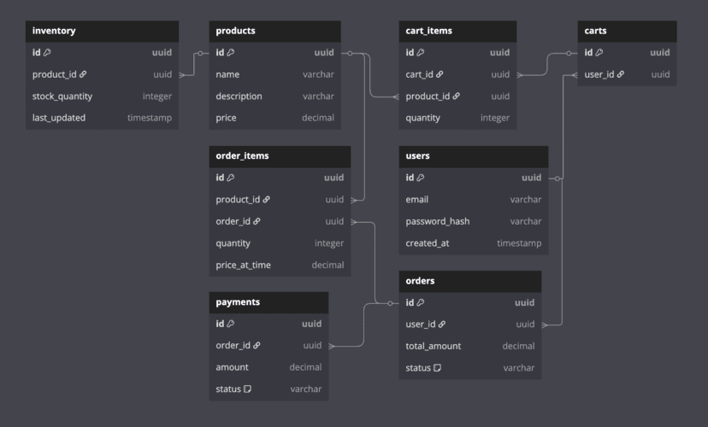
Core Entities
User: Authentication, personalization.
Product: Catalog data.
Inventory: Stock management (separate from products).
Cart, CartItem: User shopping cart tracking.
Order, OrderItem: Order details and inventory linking.
Payment: Transaction details and tracking.
Relationships
User → Cart (One-to-One)
Cart → CartItem (One-to-Many)
Product → CartItem (Many-to-One)
User → Order (One-to-Many)
Order → OrderItem (One-to-Many)
Product → OrderItem (Many-to-One)
Order → Payment (One-to-One)
Product → Inventory (One-to-One)
API Design
This API design outlines the core RESTful endpoints for the e-commerce system, focusing on the main user flows expected in an interview. All endpoints assume secure communication (HTTPS) and user authentication via a token (e.g., JWT in the Authorization header).
POST /auth/login
Authenticates user.
Request: {"email": "user@example.com", "password": "password123"}
Response (200): {"token": "jwt_token", "user_id": 123}
GET /products?category_id=5&search=phone&page=1&limit=20
Lists products with filters.
Response (200): {"products": [{"id": 1, "name": "Smartphone", "price": 699.99}], "total": 100}
POST /cart/items
Adds item to cart.
Request: {"product_id": 1, "quantity": 2}
Response (201): {"message": "Item added"}
POST /orders
Places order.
Request: {"payment_method": "credit_card", "shipping_address": "123 Main St"}
Response (201): {"order_id": 789, "total_amount": 1399.98}
POST /orders/{id}/pay
Processes payment.
Request: {"payment_token": "token"}
Response (200): {"payment_id": 101, "status": "completed"}
Product Browsing Flow
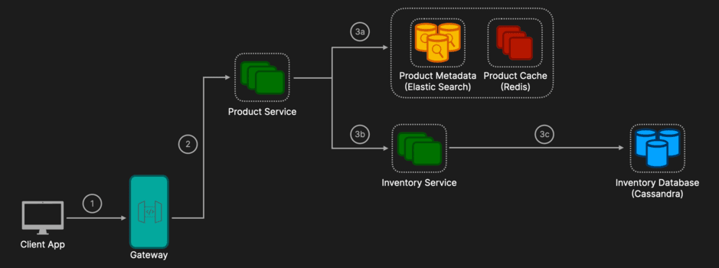
Client App
User Action: The user sends a request to browse products via GET /products?search=smartphone
API Gateway
Routing: The API Gateway receives the request, authenticates the user, applies rate limiting, and forwards the request to the Product Service.
Additional Functionality:
Authentication and Authorization: Verifies the JWT token.
Rate Limiting: Prevents abuse by limiting the number of requests per user.
Load Balancing: Distributes requests across multiple instances of the Product Service using a Round Robin approach for optimal load distribution.
Product Service
Elastic Search: Queries an Elasticsearch index for product metadata. Elasticsearch is used due to:
Full-text search capabilities (keyword, category filters).
Typo tolerance and low latency (<200ms).
Horizontal scalability to millions of products.
Redis: Caches frequently accessed product metadata (read-heavy data) with a short TTL (e.g., 5 minutes), reducing latency and load on Elasticsearch.
Inventory Service: Independently called by the Product Service to fetch real-time stock data.
Maintains accurate stock counts.
Utilizes a strongly consistent store (e.g., Cassandra with Lightweight Transactions, PostgreSQL, or Redis locks) to prevent overselling and ensure atomicity, especially critical during high-traffic periods (e.g., Black Friday). Cassandra is a great option here with its blend of high write performance, horizontal scalability, tunable consistency, and built-in atomicity via LWT makes it an ideal choice for the Inventory Service. It excels in high-traffic, write-heavy scenarios, ensuring stock accuracy without sacrificing availability, so it is perfect for a robust e-commerce browsing flow.
Response: Product Service aggregates the search results (from Elasticsearch/Redis) with stock data (from Inventory Service) and returns: {"products": [{"id": 1, "name": "Smartphone", "price": 699.99, "stock_quantity": 50}]}.
Cart Management Flow
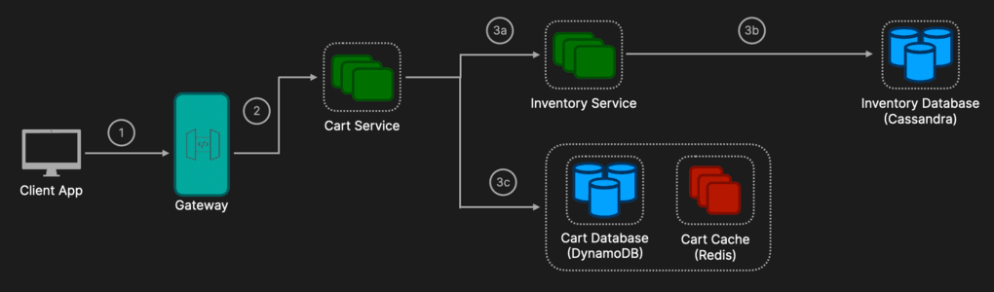
Client App
User Action: The user adds a product via POST /cart/items with {"product_id": 1, "quantity": 2}.
API Gateway
Routing: Receives the request, authenticates the user via JWT, applies rate limiting, and forwards it to the Cart Service.
Cart Service
Inventory Service: Independently called by the Cart Service to verify real-time stock availability.
Checks if sufficient stock is available for the requested quantity.
If stock is insufficient, the Cart Service returns an error (e.g., {"error": "Insufficient stock"}).
DynamoDB: Used to store cart items due to:
Single-digit millisecond latency.
Auto-scaling capabilities, suitable for millions of concurrent carts.
Eventual consistency is acceptable for cart updates (non-critical).
Redis: Caches user's cart data for quick retrieval (GET /cart), reducing DynamoDB load. Given frequent updates, a longer TTL (e.g., 24 hours) is appropriate.
Response: If inventory check passes, returns: {"message": "Item added"}. Supports additional operations: PUT (update quantity), DELETE (remove item).
Checkout and Order Placement Flow
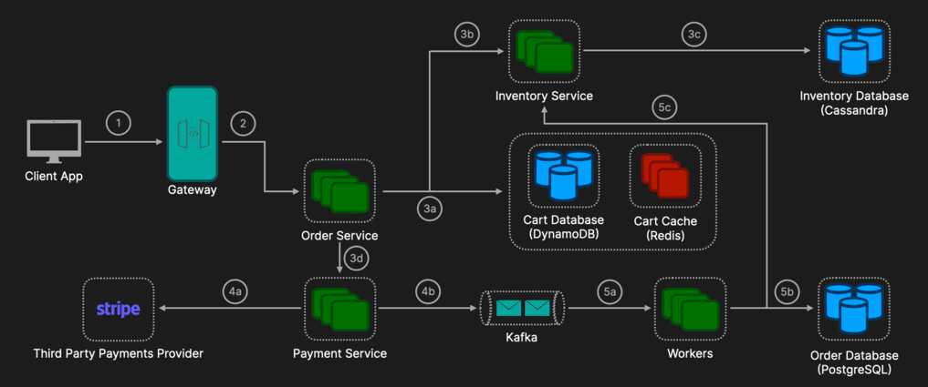
Client App
User Action: User initiates checkout via: POST /orders with {"payment_method": "credit_card", "shipping_address": "123 Main St"}.
API Gateway
Routing: Authenticates the user (JWT verification), applies rate limiting, and correctly forwards the request to the Order Service.
Order Service
Cart Retrieval: Retrieves the user's cart from DynamoDB or the Redis cache.
Inventory Validation & Reservation:
Calls the dedicated Inventory Service to atomically reserve stock.
Inventory Service manages reservations using a strongly consistent store (Cassandra Lightweight Transactions, PostgreSQL transactions, or Redis distributed locks).
If insufficient stock exists, returns an error to the client (e.g., {"error": "Insufficient stock available"}).
Payment Processing: Calls Payment Service (POST /orders/{order_id}/pay) to securely process payment via Stripe.
Payment Service
Third Party Payment Provider: Stripe is used as the payment gateway for secure transactions (security requirement) and supports multiple payment methods (functional requirement). It handles retries and refunds externally.
Async Processing: After successful payment confirmation, publishes an event to a message queue (e.g., Kafka).
Worker (Async via Kafka events)
Order Storage: Saves orders and order items in the Order Database. PostgreSQL’s ACID compliance, relational model, transactional consistency, and durability make it a great choice for Order Database. It ensures order data is accurate, queryable, and resilient - key requirements for an e-commerce system’s checkout flow, especially under pressure. While alternatives like DynamoDB or Cassandra excel in other areas, PostgreSQL’s strengths align perfectly with the need for trustworthy, structured order management.
Inventory Confirmation: Finalizes the reserved stock deduction atomically through the Inventory Service.
Response: After successful processing, the Order Service returns: {"order_id": 789, "total_amount": 1399.98}.
Complete Architecture
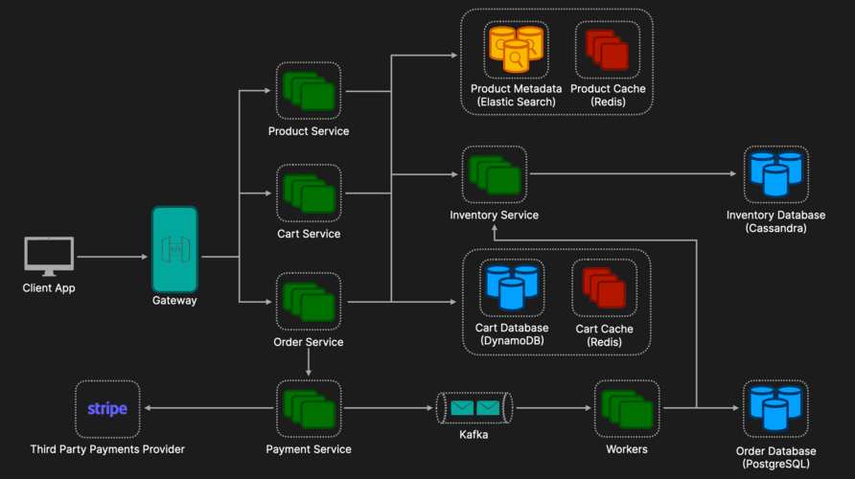
Additional Discussion Points
Security and Compliance
Secure authentication (JWT, OAuth): Ensures users securely authenticate using standardized methods like JSON Web Tokens (JWT) or OAuth protocols, enhancing security by delegating credential management to trusted providers.
Encryption at rest and transit (HTTPS/TLS): Data is encrypted when stored on disk (at rest) and when transmitted over the network (in transit) using secure protocols like HTTPS/TLS, preventing unauthorized access or interception.
PCI DSS compliance: Adhering to Payment Card Industry Data Security Standard (PCI DSS) ensures that sensitive payment information is stored, processed, and transmitted securely, reducing the risk of financial fraud or data breaches.
Load Balancing and Scalability
Round Robin or consistent hashing: Techniques used by load balancers to distribute incoming requests evenly (Round Robin) or consistently based on request attributes (consistent hashing), optimizing resource utilization and performance.
Kubernetes or AWS ECS auto-scaling: Kubernetes or AWS Elastic Container Service (ECS) auto-scaling dynamically adjusts resource allocation based on demand, ensuring optimal performance and cost-efficiency during traffic fluctuations.
Horizontal sharding for databases: Distributing database data horizontally across multiple servers to scale capacity and performance, reducing latency, and handling large volumes of data efficiently.
Error Handling and Reliability
Circuit breakers (external services): A mechanism to automatically halt calls to failing external services, preventing cascading failures and allowing systems to gracefully degrade when dependencies become unreliable.
Idempotency keys for payments and orders: Unique keys included with requests to ensure operations (such as payments or order submissions) can safely retry without unintended duplicate actions, improving reliability and consistency.
Monitoring and Logging
Metrics (Prometheus, Datadog): Tools such as Prometheus or Datadog collect real-time performance and usage metrics, allowing monitoring of system health, resource usage, and application behavior.
Centralized logging (ELK, CloudWatch): Aggregating application and infrastructure logs into centralized platforms like ELK (Elasticsearch, Logstash, Kibana) or AWS CloudWatch simplifies debugging and analysis across distributed systems.
Alerting (PagerDuty): Services like PagerDuty enable rapid incident response by immediately notifying on-call engineers or teams when critical issues occur, minimizing downtime and ensuring prompt issue resolution.

Ticket Booking System (Ticketmaster)
Editorial Solution
Quiz
AI Whiteboard
Overview
Introduction
Requirements
Data Model
API Design
Handling Concurrency & Double Booking
Handling Massive Traffic Spikes (The "Taylor Swift" Problem)
Managing "Held" Tickets (Expiration & Cleanup)
Complete Architecture
Additional Discussion Points
Introduction
Designing a ticket booking system is a classic system design problem that tests a candidate's ability to handle high concurrency and burst traffic. Unlike standard e-commerce platforms, ticket booking systems face a unique challenge: inventory is finite, immovable (a specific seat at a specific time), and demand is often extremely "spiky" (e.g., a Taylor Swift concert sale).
The core conflict in this design is between Consistency (preventing double bookings) and Availability/Latency (handling millions of users trying to buy the same tickets simultaneously).
Requirements
Functional Requirements
Search & View: Users can search for events (by artist, location, genre) and view event details.
Seat Selection: Users can view a seat map and select specific available seats.
Booking (Reservation): Users can temporarily "hold" tickets while they proceed to payment.
Payment & Confirmation: Users pay for the held tickets to confirm the booking.
Non Functional Requirements
Strong Consistency: Enforce strict ACID guarantees on seat inventory (linearizability) so no single seat is ever double-booked
High Availability: Target 99.99% uptime for the browsing/search path; 99.9% for the booking path.
Scalability (Burst Handling): Handle extreme burst traffic of 1M+ concurrent users, 100k seat view requests/sec, and 10k write transactions/sec during ticket drops.
Fairness: Ensure strict First-Come-First-Served (FCFS) order processing for users entering the booking flow from the waiting room.
Data Model
For a system requiring ACID compliance on inventory, a Relational Database (RDBMS) like PostgreSQL or MySQL is preferred for the core booking data. However, for search and caching, we will use NoSQL and in-memory stores.
Key Entities (SQL)
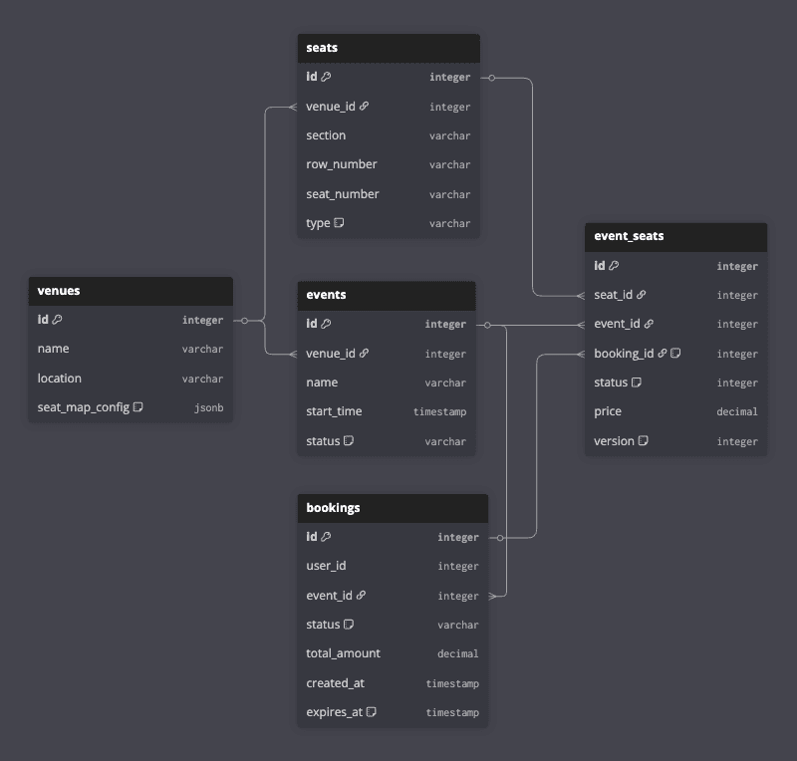
Event: id, name, description, venue_id, start_time, end_time
Venue: id, name, location, seat_map_config
Seat: id, venue_id, row, number, type (VIP, Regular)
Event_Seat: id, event_id, seat_id, status (AVAILABLE, RESERVED, BOOKED), price, booking_id
Booking: id, user_id, event_id, status (PENDING, CONFIRMED, CANCELLED, EXPIRED), created_at, expires_at
NoSQL/Cache
Elasticsearch: For full-text search on Events.
Redis: For caching active seat maps, storing temporary "locks" on seats, and user sessions.
API Design
For a hotel booking system we will use a classic RESTful API to interact with the data. RESTful APIs are simple, widely used, stateless, and support caching which make it a good candidate for our system.
Our REST API will comprise of four main endpoints:
GET /api/events?query={...}: Search events (Elasticsearch).
GET /api/events/{id}/availability: Retrieves the Dynamic Overlay
Response: Compressed Binary Bitfield (or Base64 blob) mapped to seat IDs (0=Free, 1=Taken)
POST /api/bookings/reserve: Critical Endpoint.
Payload: { event_id, seat_ids[] }
Response: { booking_id, expires_at } or Error (Seats taken).
POST /api/bookings/{id}/payment: Process payment.
Payload: { payment_token }
High Level Design
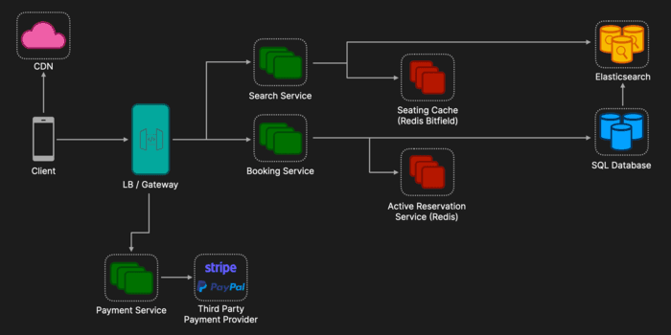
At a high level, the system is split into a Read Path (Browsing) and a Write Path (Booking).
Client:
The user interface (Web/Mobile) optimized for high-concurrency interactions.
CDN:
Serves static assets like venue images, JavaScript bundles, and specifically seat map templates (e.g., the SVG layout of a stadium) to reduce load on backend servers.
Load Balancer:
Distributes incoming HTTP/S traffic across availability zones. Terminates SSL and handles initial DDoS mitigation.
API Gateway:
The entry point for all client applications. Handles authentication (JWT), rate limiting (leaky bucket), request validation, and circuit breaking to protect downstream services from cascading failures.
Search Service (Read Path):
A high-throughput service backed by Elasticsearch. It handles complex queries ("concerts in NYC this weekend") and provides event metadata. It is eventually consistent, receiving updates via a sidecar indexer or CDC stream to avoid locking the primary database.
Seating Cache (Redis - Bitfields):
Utilizes highly space-efficient bitfields (1 bit per seat) to store real-time availability. This cluster acts as the authoritative Data Origin for the CDN. When the edge cache expires, the system fetches the latest binary state from here to ensure clients receive fresh data.
Booking Service (Write Path):
The transactional heart of the system. It handles the state machine for seats (Available → Reserved → Booked). It enforces ACID compliance using database transactions to prevent double-booking.
Active Reservation Service (Redis):
Acts as a Distributed Lock Manager. It stores temporary "holds" on seats using TTL (Time-To-Live) keys. If a user selects a seat, this service quickly sets a key (e.g., seat_123: locked_by_user_456) to block other buyers before the request even hits the slower SQL database.
Payment Service:
Orchestrates payments with external providers (Stripe/PayPal/Adyen). Crucially, it handles idempotency keys to ensure users aren't charged twice if network timeouts occur and manages the "reversal" logic if a payment fails.
Handling Concurrency & Double Booking
The Problem: Race Conditions. If User A and User B both read the database simultaneously and see Row A, Seat 1 is AVAILABLE, both proceed to booking. Without protection, the last write wins, resulting in two valid tickets for a single seat (overselling).
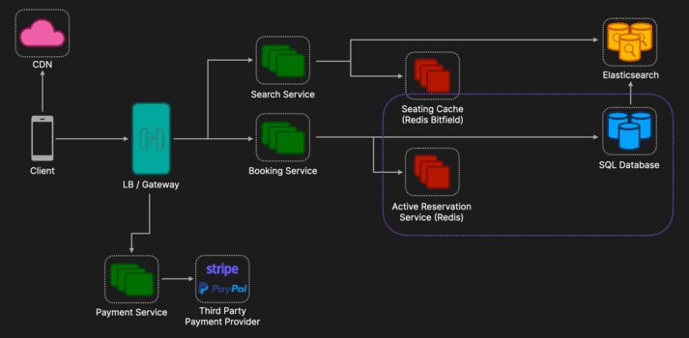
Solution 1: Pessimistic Locking (The Safety Net)
Mechanism: Database-level serialization. We cannot rely on application logic alone; we need the database to strictly order transactions.
Implementation:
Start Transaction: Begin a SQL transaction.
Lock Row: SELECT * FROM event_seats WHERE seat_id = X FOR UPDATE; (This freezes the row; other transactions must wait).
Validate: Check if status == AVAILABLE.
Update: If yes, set status = RESERVED, assign user_id, and set expires_at = NOW() + 10 mins.
Commit: Save changes and release the lock. If validation fails, rollback immediately.
Solution 2: Distributed Locking (The Performance Shield)
Mechanism: Cache-level guarding. Hitting the SQL database for every locking attempt during a massive sale (e.g., 10k requests/sec on one seat) will crush the database CPU.
Step 1 (The Guard): Before touching the DB, the Booking Service attempts to set a key in Redis:
Command: SET seat_A15 user_123 NX EX 600 (Set if Not Exists, Expiry 600s).
Step 2 (The Gate):
Success: If Redis returns OK, the user owns the "lock." Proceed to the SQL transaction (Solution 1) to persist the record.
Failure: If Redis returns null, someone else is already holding the seat. Return an error immediately without touching the database.
Step 3 (The Fallback): If the SQL transaction fails (e.g., database constraint error), delete the Redis key to release the lock for others.
Handling Massive Traffic Spikes (The "Taylor Swift" Problem)
The Problem: Extreme concurrency spikes (e.g., 10M simultaneous users) vastly exceed database write capacity, leading to immediate cascading failures.
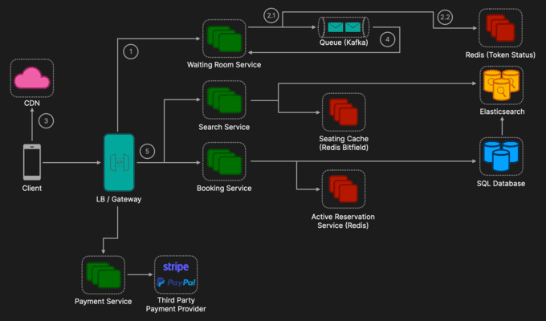
Solution: Implement a Virtual Waiting Room to apply backpressure and level the load using a Leaky Bucket pattern.
Admission Control: The API Gateway intercepts traffic surges, redirecting users to the Waiting Room Service and issuing a tracking token.
FIFO Queuing: Tokens are buffered in a Kafka topic to maintain strict arrival order and status set to QUEUED in Redis.
Feedback Loop (CDN Polling): Instead of fragile WebSockets, clients poll a CDN-cached endpoint (e.g., /queue-status) every 30 seconds.
The Payload: The endpoint returns a generic JSON (e.g., {"serving_up_to": 12000}) cached at the Edge for 10 seconds.
The Check: The client compares its local token (#15,000) vs. the serving ID (#12000). If Local > Serving, it continues waiting without touching the backend.
Controlled "Leak": A background worker consumes tokens from Kafka at a fixed rate matching downstream capacity (e.g., 500 TPS) and marks their status as ACTIVE in a dedicated Redis cluster and updates the global serving_up_to ID.
Gated Entry: When the client sees it is their turn (Local <= Serving), it redirects to the main site. The API Gateway performs a final validation against Redis to ensure the token is valid and ACTIVE before allowing access.
Managing "Held" Tickets (Expiration & Cleanup)
The Problem: Inventory Fragmentation. Users "hold" tickets (locking the DB row) but abandon the payment flow. If we don't release these seats promptly, the event appears "Sold Out" while valid seats sit idle in expired carts.
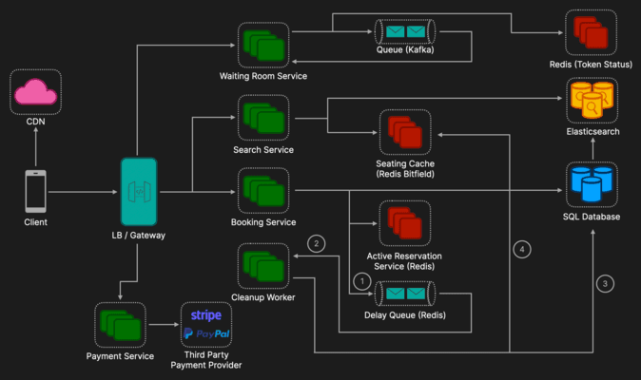
Strategy 1: Passive Expiration (The Safety Net)
Mechanism: "Just-in-Time" validation.
Logic: When any user attempts to view or book a specific seat, the Booking Service checks: if status == RESERVED && expires_at < NOW().
Action: If expired, the transaction treats the seat as AVAILABLE immediately, overwriting the old reservation.
Strategy 2: Active Cleanup (The Primary Mechanism)
Mechanism: Asynchronous event-driven release. This is critical for updating the "Seat Map" for other users so they see the seat turn green (Available) in real-time.
Step 1 (The Trigger): When a booking is created, the Booking Service adds a task to a Delay Queue (implemented via Redis Sorted Sets or SQS with delivery delay) scheduled for 10 minutes in the future.
Step 2 (The Listener): The Cleanup Worker polls the queue. When the 10-minute timer matures, it receives the booking_id.
Step 3 (Reconciliation): The worker checks the Primary DB. If the booking status is still PENDING (user never paid), it executes a rollback.
Step 4 (State Refresh): The worker updates the database status to AVAILABLE and updates the Redis Seating Cache (The Origin) by flipping the bit to 0.
Propagation: The CDN Cache sitting in front of Redis will expire naturally (e.g., within 1 second). On the very next fetch, the CDN will pull this new 0 state from Redis, and all users will see the seat turn green.
Complete Architecture
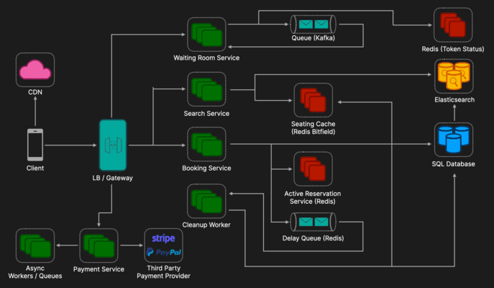
Now that we have our components, let's walk through the exact lifecycle of a user buying a ticket during a high-demand event. This flow demonstrates how we handle millions of users while maintaining data integrity.
Step 1: The Traffic Surge (The Waiting Room)
1.1 User Arrival: 1 million users arrive. Load Balancer intercepts traffic.
1.2 Admission Control: API Gateway redirects to Waiting Room Service.
1.3 Queueing (Ordering): User gets a token. Token goes to Kafka (FIFO) and Redis (Status: QUEUED).
1.4 Polling: Client polls CDN (/queue-status) to check position.
1.5 Leaking: A background worker consumes tokens from Kafka at a controlled rate (e.g., 500/sec).
The Leak: The worker updates the status of these specific tokens in Redis from QUEUED to ACTIVE (with a 10-minute TTL).
The Gate Check: When the client requests the Booking Page, the API Gateway checks Redis. If status == ACTIVE, the request is allowed through; otherwise, it is blocked.
Step 2: Browsing & Discovery (Read Path)
2.1 Event Search: User searches via Search Service (Elasticsearch).
2.2 Seat Map Loading: Client downloads static SVG from CDN.
2.3 Availability Overlay: Client polls Search Redis Bitfield (via CDN) to see seat availability (0= Green, 1= Red).
Step 3: Seat Reservation (Write Path - The Critical Section)
3.1 Selection: User clicks "Reserve".
3.2 Distributed Guard: Booking Service acquires SET NX lock in Redis.
3.3 ACID Transaction: Booking Service locks row in SQL DB, sets status to RESERVED
3.4 Timer: Booking Service pushes task to Delay Queue (10 mins).
3.5 Map Update: Booking Service flips bit in Seating Cache (Redis Bitfield) to 1 (Red).
Step 4: Payment & Confirmation
4.1 Processing: The user enters payment details. The Payment Service calls Stripe/PayPal with an Idempotency Key.
4.2 Success: DB status -> CONFIRMED. Kafka event emitted ("Ticket Sold").
4.3 Asynchronous Tasks: Notification Service sends email; Analytics updates dashboard.
Step 5: Handling Failure (Cleanup)
5.1 Timeout: If the user abandons the cart or payment fails, the 10-minute timer expires.
5.2 Reversal: Cleanup Worker consumes Delay Queue task.
5.3 Rollback: Worker checks DB (PENDING?). If yes, sets DB to AVAILABLE and deletes Redis Lock.
5.4 Refresh: Worker flips Seating Cache (Redis Bitfields) to 0 (Green). Next CDN poll reflects availability.
Additional Discussion Points
Seat Map Rendering: For stadiums with 50,000 seats, sending a JSON array of 50k objects is heavy. Tile-based rendering (like Google Maps) can be used, where the client downloads images of sections and only overlays the status data (a lightweight bitmask or vector overlay).
Archiving: Historical data (past concerts) should be moved to Cold Storage (e.g., S3/Data Warehouse) to keep the active DB tables light and fast.
Security: Bot prevention is massive here. Use CAPTCHA, IP rate limiting, and behavioral analysis (WAF) to prevent scalper bots from hoarding tickets.
Idempotency: Crucial for payments. The confirm_booking endpoint must accept a unique idempotency key to prevent double charging if the network flakes out.

Autocomplete System (Google Search)
Editorial Solution
Quiz
AI Whiteboard
Overview
Introduction
Requirements
Data Model
API Design
High Level Design
Deep Dive 1: Efficient Data Structures (The Trie)
Deep Dive 2: Reducing Latency (Multi-Level Caching)
Deep Dive 3: Zero-Downtime Updates (Blue/Green Deployment)
Deep Dive 4: Ranking & Real-time Trends (Lambda Architecture)
Complete Architecture
Additional Discussion Points
Introduction
An autocomplete system (also known as typeahead or search-as-you-type) predicts the rest of a word or sentence as the user types. This is a standard feature in search engines (Google), e-commerce sites (Amazon), and command-line interfaces.
The goal is to speed up user interaction by reducing keystrokes and guiding them toward likely queries.
Requirements
Functional Requirements
Suggestions: As the user types a query, the system must return the top k (e.g., 5) most relevant suggestions.
Ranking: Suggestions must be ranked by a combination of Historical Popularity (long-term accuracy) and Real-time Trends (breaking news).
Non Functional Requirements
Ultra-Low Latency: The system must return results in < 100ms (P99) to ensure a smooth typing experience.
High Availability: The system should prioritize availability over consistency (BASE). Serving slightly stale suggestions is better than an error.
Scalability:
DAU: 500 Million.
Daily Searches: 5 Billion.
Read Load (QPS): ~290k Avg / ~600k Peak
Calculation: (5B searches * 5 requests) / 86,400s ≈ 290k
Peak: Assumes standard 2 * traffic spike
Write Throughput: ~58k events/sec
Calculation: 5B searches / 86,400s ≈ 58k
Note: Logs only the final "Search" event, not intermediate keystrokes.
Data Model
We need distinct storage strategies for the Raw Data (optimized for write throughput and analytics) and the Index Data (optimized for read latency).
1. Storage / Analytics (Write-Optimized)
Purpose: Archival and offline batch processing.
Technology: AWS S3 (Storage) + Apache Parquet (Format - Columnar Storage).
Schema: query_string (String), timestamp (DateTime), geo_location (String).
2. Serving Index (Read-Optimized)
Purpose: Serving autocomplete suggestions in < 100ms. We cannot scan the Raw Data or use a standard SQL DB for this. We use a Trie (Prefix Tree) structure held in memory.
Structure: A Trie (Prefix Tree) is a tree where the root is empty, and each node represents a character.
Optimization: We flatten this logical structure into a Key-Value store (or In-Memory Map).
Key: Prefix (e.g., "sys")
Value: List of Top-5 Suggestions (e.g., ["system design", "sysadmin", ...])
Technology:
Redis Cluster (Primary Cache)
Role: The "Hot" Store. Serves 99% of traffic.
Key: The Prefix (e.g., "sys").
Value: Serialized JSON List of Top 5 suggestions (e.g., ["system design", "sysadmin", ...]).
Amazon DynamoDB (Persistent Store)
Role: The "Warm" Store. Used to rebuild Redis if it crashes and to serve "Cache Misses."
Partition Key: prefix (String).
Attributes: suggestions (List<String>), last_updated (Timestamp).
Why DynamoDB? It offers single-digit millisecond latency and scales horizontally to handle the "Long Tail" of billions of rare prefixes that won't fit in Redis RAM.
API Design
We need two distinct endpoints following the CQRS (Command Query Responsibility Segregation) pattern: one for reading (Autocomplete) and one for writing (Search).
1. Autocomplete Endpoint (Read)
GET /v1/autocomplete?query={prefix}&limit={k}
Response: JSON List of strings.
Protocol: HTTP/2 (to avoid TCP handshake overhead on every keystroke).
Note: This endpoint is read-only and cached heavily.
2. Search Endpoint (Write)
GET /v1/search?query={full_query}
Action: Returns search results (HTML/JSON) AND logs the query intent for analytics.
Note: This is the "Ground Truth" data source for our ranking models.
High Level Design
At a high level, the system implements the CQRS (Command Query Responsibility Segregation) pattern, splitting the architecture into two distinct flows: the Read Path (latency-sensitive) and the Write Path (throughput-heavy).
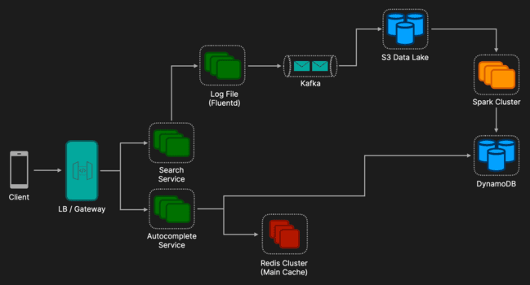
1. The Read Path (Query Service)
Client: Sends a request on every keystroke (debounced by ~50-100ms) to minimize network traffic.
Load Balancer (LB): Distributes incoming HTTP/2 requests across the stateless Autocomplete Service fleet.
Autocomplete Service: Orchestrates the lookup logic with a Multi-Level Caching strategy:
L1 Cache (Local RAM): Checks an in-process cache (e.g., Guava/Caffeine - Java Caching Libraries) first. This serves "Super Hot" keys (top 1%) with zero network I/O, preventing a "Hot Key" meltdown on Redis.
L2 Cache (Redis Cluster): If L1 misses, it queries Redis.
Fallback (DynamoDB): If Redis misses, it reads from the active DynamoDB table and populates the cache (Read-Through).
Redis Data Structure: Redis does not store a tree. It stores a Flattened Key-Value map (e.g., Key: "sys", Value: ["system", "sysadmin"]) for O(1) retrieval.
2. The Write Path (Data Gathering Service)
Client: When the user hits "Enter" or selects a suggestion, a "Search Commit" event is fired.
Search Service: Handles the web search logic and asynchronously logs the event to a local file (Fire & Forget), ensuring the user experiences zero added latency.
Log Agent (Sidecar): A background process (e.g., Fluentd/Filebeat) tails the log file and pushes events to the message queue.
Kafka: Acts as the high-throughput buffer to decouple the production services from the data processing layer.
Data Store: Store historical logs from in S3 Data Lake.
Batch Processor: Aggregates logs daily to rebuild the Main Trie (stored in DynamoDB).
Deep Dive 1: Efficient Data Structures (The Trie)
A standard database scan (LIKE 'sys%') is O(N) and too slow. We use a Trie (Prefix Tree).
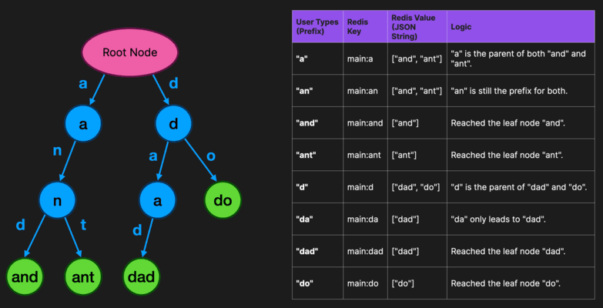
Problem: Traversing a whole sub-tree to find the top 5 queries is O(C) (where C is total children), which is too slow for a live service.
Solution (Top-K Cache): We pre-compute the top 5 results and store them directly at the node itself.
When a user types "sys", we jump to the node sys and return the cached list instantly (O(1)).
Structure: A tree where the root is empty, and each node represents a character. A path from the root to a node represents a prefix.
Aggregation: This is built by "bubbling up" the highest frequency queries from leaf nodes to the root during the offline build process.
Storage: Since the vocabulary of "popular queries" is finite (e.g., 100M queries), the entire optimized Trie fits into RAM (~10-20GB) on a modern server.
Deep Dive 2: Reducing Latency (Multi-Level Caching)
To handle 600k QPS without a "Hot Key" meltdown (e.g., millions requesting "a"), we use a tiered caching strategy:
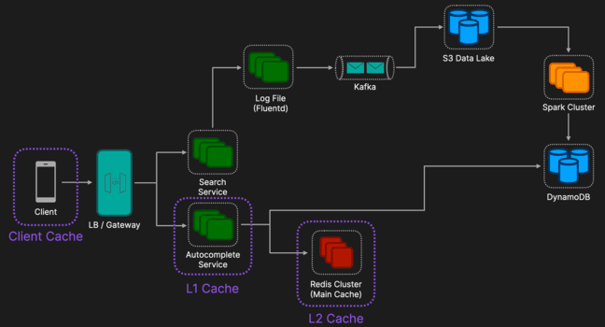
Client Cache (Browser): Leverage HTTP Cache-Control headers. If a user types "sys" -> backspaces -> "sys", the browser serves it from its local disk cache.
L1 Cache (Local RAM): The Service process uses an In-Memory LRU Cache (e.g., Guava/Caffeine) for "Super Hot" keys (top 1%). This eliminates network I/O for the most common prefixes.
L2 Cache (Main Redis Cluster): A sharded Redis cluster serves the "Long Tail" of queries.
Deep Dive 3: Zero-Downtime Updates (Blue/Green Deployment)
Updating the massive static dataset without locking the database is critical.
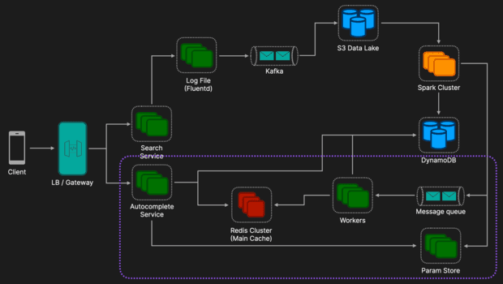
Build: Offline Spark job writes a New Table (V2) in DynamoDB.
Switch: Job updates a config flag in AWS Parameter Store (ActiveTable: V2).
Sidecar Pattern: An AppConfig Agent on every Autocomplete Service Host polls this config (via localhost), detects the change, and signals the app to switch reads to V2 instantly.
Cache Warming: A background worker reads the top 50k keys from V2 and overwrites them in the Redis Main Cluster.
Deep Dive 4: Ranking & Real-time Trends (Lambda Architecture)
We combine historical accuracy with breaking news speed.
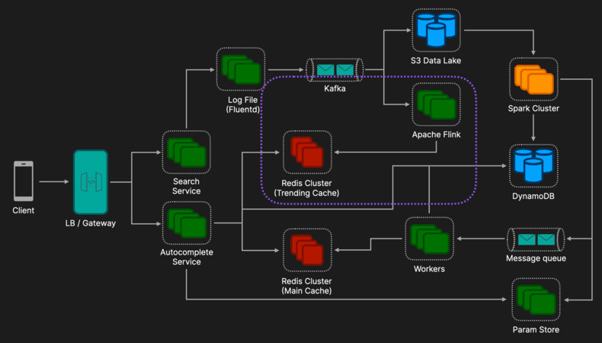
Cold Path (Batch): A nightly Spark Job processes petabytes of historical logs from S3 to build a highly accurate "Main Trie" (stored in DynamoDB/Redis).
Hot Path (Streaming): Apache Flink processes the Kafka stream in real-time. It maintains a Sliding Window (e.g., last 15 minutes) to detect spiking queries and writes them to a separate Redis Trending cluster.
Merge Logic: The Autocomplete Service queries both caches. If a "Trending" result exists, it is force-injected at Position #1 or #2 in the final list.
Complete Architecture
Here is the step-by-step walkthrough of the complete architecture.
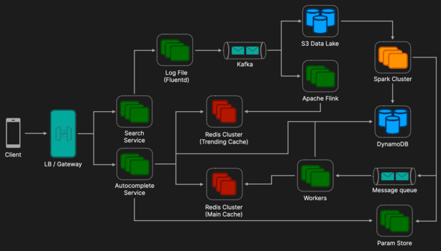
1. User Autocomplete (The Read Path)
Timeframe: Real-time (< 100ms): The user begins typing "sys". The goal is to return suggestions instantly.
Browser Cache: The client checks the browser's HTTP cache. If valid, it returns without touching the network.
Request: The client sends GET /autocomplete?q=sys (via HTTP/2).
L1 Cache (Service RAM): The Autocomplete Service checks its local in-memory cache (Guava/Caffeine).
Hit: Returns immediately (Microseconds). This protects against "Hot Key" floods.
L2 Cache (Redis Cluster): On an L1 miss, the service queries Redis for two keys in parallel:
main:sys (Historical Top 5).
trend:sys (Breaking News).
Merge & Response: The service combines the lists. It might inject a trending topic (e.g., "system failure") at position #2. The result is returned to the user.
2. User Search (The Write Path)
Timeframe: Real-time (Async): The user sees "System Design Interview" and hits Enter. We must capture this "Golden Signal" without slowing down the page load.
Search Request: The browser requests GET /search?q=system+design+interview.
Search Service: Fetches web results and returns the HTML page immediately.
Async Logging: In the background, the service appends the search event to a local log file: /var/log/search_events.log.
Sidecar Ingestion: A Fluentd Agent tails this file and pushes the event to the Kafka topic search-logs using a Round-Robin partition strategy.
3. Trending Updates (The Hot Path)
Timeframe: Seconds to Minutes: The log event flows into the "Speed Layer" to capture breaking news.
Stream Processing: Apache Flink (or Spark Streaming) consumes the Kafka stream.
Windowing: It aggregates counters in a Sliding Window (e.g., last 15 minutes).
Filtering: It drops noise (low volume queries) and keeps only high-velocity spikes.
Cache Update: Flink writes the result directly to the Redis Trending Cluster with a short TTL (e.g., 15 minutes).
Result: The next user who types "sys" will instantly see this new trending query.
4. Nightly Batches (The Cold Path)
Timeframe: Daily (Offline): The log event also flows into the "Batch Layer" for long-term accuracy and storage.
Archival: Kafka Connect dumps the raw logs into an S3 Data Lake in Parquet format.
Spark Job: Every night, a Spark cluster spins up to process the last year's worth of data.
Aggregation: It applies "Time Decay" formulas (weighting recent searches higher).
Bubble Up: It calculates the top 5 suggestions for every possible prefix in the dataset.
New Table: Spark writes the optimized index to a fresh DynamoDB Table (e.g., Table_V3).
5. Param Updates & Warming (Zero Downtime Switch)
Timeframe: Minutes (Post-Batch): Once the new data is ready, we safely swap it in.
Config Update: The Spark job updates AWS Parameter Store: ActiveTable = Table_V3.
Detection: The AppConfig Sidecar on the Autocomplete Service detects this change.
Cache Warming: A background worker reads the top 50,000 most popular keys from Table_V3 and aggressively populates the Redis Main Cluster.
Cutover: The Autocomplete Service begins reading from Table_V3 for any cache misses. Table_V2 is deprecated and eventually dropped.
Additional Discussion Points
Personalization: Global popularity isn't enough; users expect their recent history to appear instantly. We can store the last 50 searches in a dedicated User History Service (or even client-side in cookies). During the "Merge & Rank" phase, the service fetches these personal keys and force-ranks them at position #1, overriding global trends.
Privacy & Compliance (GDPR): We must comply with the "Right to be Forgotten." The offline Spark job must include a Filter Stage that joins raw logs against a "User Deletion Request" table. This ensures that data from users who requested deletion is scrubbed before it contributes to the public Trie.
Content Moderation: To prevent the system from suggesting offensive or illegal terms, we apply a Blocklist Filter (Bloom Filter or Hash Set) during the Trie build process. This sanitizes the dataset effectively without slowing down read-time lookups.
Edge Caching (CDN): The top ~100 global queries (e.g., "Facebook", "YouTube", "Amazon") account for a massive percentage of traffic. These static JSON responses can be cached directly on CDNs (CloudFront/Akamai) or Edge Workers, serving millions of users with near-zero latency without ever touching the backend servers.
Spell Check (Fuzzy Search): If the Trie lookup returns zero results (a "miss"), we can trigger a secondary lookup using Levenshtein Distance. This checks a smaller dictionary of "Most Common Terms" to find close matches (e.g., mapping "amzon" → "amazon") and returns a "Did you mean...?" suggestion.

Top-K Leaderboard
Editorial Solution
Quiz
AI Whiteboard
Overview
Introduction
Requirements
Data Model
API Design
High Level Design
Redis ZSET: Internal Implementation
Deep Dive 1: Real-time Counting at Scale
Deep Dive 2: Scaling the Leaderboard (Partitioning)
Deep Dive 3: Historical Data and Time Windows
Complete Architecture
Summary of Data Flow
Additional Discussion Points
Introduction
A Top-K or Leaderboard system tracks and displays the highest-ranking entities based on a specific metric (score, points, sales volume, etc.).
While conceptually simple, the challenge lies in maintaining accurate, sorted rankings in real-time as millions of score updates flood the system simultaneously.
Common use cases include gaming leaderboards (high scores), most commented posts, trending hashtags, or top-selling products.
Requirements
Functional Requirements
Update Score: Users should be able to update their score.
Get Top K: Users can view the top K users (e.g., Top 10 globally).
Get User Rank: A user can see their specific rank and score, even if they aren't in the top K.
Non Functional Requirements
Scalability:
DAU: 10 Million.
Write Throughput: Handle 50k updates/second at peak (assuming high-frequency game updates).
Read Throughput: Handle 500k requests/second (High Read-to-Write ratio, as users check leaderboards frequently).
Latency (Performance)
Read Latency: < 20ms at p99 for fetching Top K.
Write Visibility: Updates should be reflected in the leaderboard within 1-2 seconds (Near Real-time).
Availability: 99.99% uptime for the Read path (users must always see some leaderboard, even if slightly stale).
Storage (Capacity): RAM usage for 10M users, a Redis ZSET entry is small (~100 bytes). Total RAM needed: ~1GB - 2GB (fits easily in memory).
Data Model
We need to store user profiles and their corresponding scores.
1. Relational Database (SQL)
Good for the "source of truth" regarding user profile data.
Tables:
Users: user_id (PK), username, metadata.
Scores Table: user_id (FK), game_id, score, timestamp.
2. In-Memory Data Structure
Using SQL for sorting and ranking (ORDER BY score DESC LIMIT K) performs poorly at scale because sorting is O(N log N) or requires expensive index maintenance on every write.
Instead, we typically use Redis Sorted Sets (ZSETS). Redis ZSETs use a Skip List internally, allowing for O(log N) updates and retrievals.
API Design
We define the interface using REST or gRPC.
1. Update Score
POST /v1/scores
Body: { "user_id": "u123", "score": 1500 }
2. Get Global Leaderboard
GET /v1/leaderboards/{lb_id}/top?k=10
Response: [{ "user_id": "u55", "rank": 1, "score": 9000 }, ...]
3. Get User Rank (and neighbors)
GET /v1/leaderboards/{lb_id}/users/{user_id}/context?range=5
Response: Returns the user's rank plus 5 users above and 5 below.
High Level Design
At a high level, the system is designed to separate the real-time ranking mechanics from the persistent data storage. We prioritize low latency for the end-user while ensuring data durability in the background.
The architecture consists of five core components:
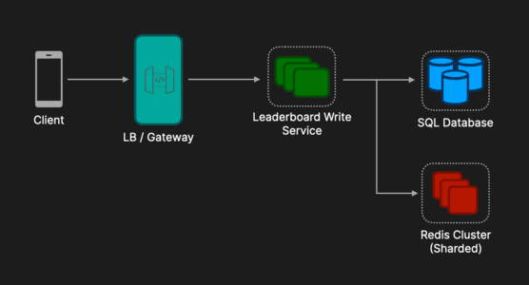
Client:
The entry point is the user's device. It is responsible for sending score updates (e.g., after a game level is finished) and requesting leaderboard views.
Load Balancer / API Gateway:
Traffic Distribution: It distributes incoming requests across multiple stateless instances of our leaderboard service to prevent any single server from becoming a bottleneck.
Security & Auth: It handles SSL termination (decrypting requests) and validates user session tokens (JWT) before passing the request further. This ensures our internal services focus purely on business logic.
Leaderboard Write Service:
This is a stateless backend service (written in Go, Java, or Node.js) that orchestrates the data flow. It contains the business rules.
Validation: When a score comes in, this service verifies it is legitimate (e.g., preventing a user from scoring 1 million points in 1 second).
The Coordinator: It decides where data goes. It sends ranking-related data to Redis and profile-related data to the SQL database. It abstracts the complexity of the storage layer away from the client.
In-Memory Score Storage (Redis)
This is the heart of the leaderboard's performance. Since traditional databases are too slow for real-time sorting of millions of rows, we use Redis specifically for its Sorted Set (ZSET) data structure.
Role: It acts as a high-speed, temporary index. It maintains the list of User IDs and Scores in a pre-sorted order.
Performance: It allows us to perform operations like "Update Score" or "Get Rank" in O(log N) time, meaning it remains fast even as the number of users grows.
Persistent Database (SQL / NoSQL)
While Redis is fast, it is in-memory and expensive. We need a reliable, long-term storage solution.
Role: The Source of Truth.
Data Stored:
User Metadata: Full profiles (Avatars, Display Names, Country) mapped to the User IDs stored in Redis.
Score History: A transactional log of every score update (e.g., "User A scored 10 points at 12:01 PM"). This allows us to rebuild the leaderboard if Redis ever crashes or data is corrupted.
Redis ZSET: Internal Implementation
plaintext
Copy code
1. THE HASH MAP (For O(1) Lookups)
Maps Member -> Score
[ "Alice" ] --> 100
[ "Bob" ] --> 150
[ "Carol" ] --> 300
[ "Dave" ] --> 300

2. THE SKIP LIST (For O(log N) Ranking/Sorting)
A multi-layer linked list. Higher levels act as "express lanes".

Level 3: [HEAD] -----------------------------------------> [Carol:300] -> NULL
| |
Level 2: [HEAD] ---------------------> [Bob:150] --------> [Carol:300] -> NULL
| | |
Level 1: [HEAD] ------> [Alice:100] -> [Bob:150] -> ...... [Carol:300] -> [Dave:300] -> NULL
The Hash Map (For O(1) Point Lookups)
Purpose: Instant access by Member Name.
Scenario: You run ZSCORE Leaderboard Bob.
Mechanism: Redis ignores the sorting entirely. It consults the internal Hash Map, finds the key "Bob", and instantly returns 150. It does not traverse any list.
The Skip List (For O(log N) Range Queries)
Purpose: Fast traversal by Score or Rank.
Scenario: You run ZRANGE ... (100 ("Find the first person > 100").
Mechanism: Redis cannot use the Hash Map here (because it doesn't know who has the score). Instead, it traverses the Skip List.
It uses upper-level "express lanes" to skip over millions of low-score users (like Alice).
It drops down to the base level only when it nears the target, landing directly on the first match.
Deep Dive 1: Real-time Counting at Scale
If we have 10 million DAU and users score points every second, hitting Redis directly for every point is inefficient and can overload Redis.
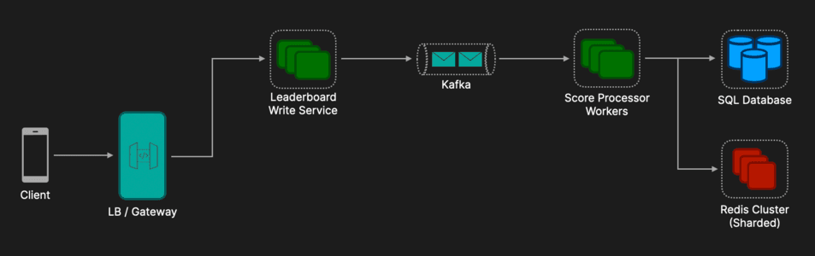
Solution: Write-Back Cache / Buffer
Local Aggregation: The Leaderboard Write Service aggregates score increments for a specific user over a short window (e.g., 5 seconds) or until the buffer is full.
Batch Update: Send +50 instead of ten +5 requests.
Kafka Queue: For durability and smoothing bursts, push score updates to a Kafka topic. A consumer worker reads these and updates the Redis ZSET. This decouples ingestion from processing.
Summary of Benefits
Reduced Load: Instead of 10 million writes per second, Redis might only see 200,000 writes per second (because we grouped them).
Stability: If the game has a massive spike in traffic, Kafka absorbs the shock, and Redis is updated at a safe, steady speed.
Handling Server Outage
Instead of relying on the server to never crash, we rely on the Client (the mobile app/browser) to keep track of the score.
Retry Logic: The Client sends Score Update (+10). If the Server crashes and doesn't send back a "Success" confirmation, the Client waits and sends it again.
Idempotency (Crucial): To prevent double-counting (e.g., the server processed the score but crashed before sending the confirmation), we attach a unique ID to every request.
Request: User: A, Score: +10, Request_ID: "req_55"
Server Check: The server checks Redis: "Have I already processed req_55?"
No: Process it. Save req_55 as "seen".
Yes: Ignore it (it was a retry).
Deep Dive 2: Scaling the Leaderboard (Partitioning)
A single Redis instance cannot hold 100 million users. We must shard.
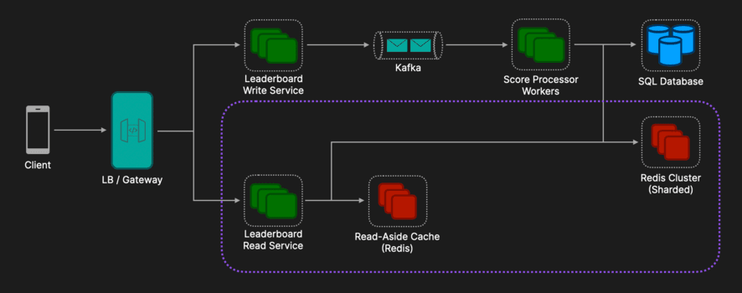
Strategy A: Fixed Range Partitioning (Tiered) This is useful if scores are somewhat predictable or bounded (Shard 1: Scores 0 - 1000, Shard 2: Scores 1001 - 5000, Shard 3: Scores 5001 - ∞)
Pro: Easy to get Top K (just query the highest range shard).
Con: Hotspots. If everyone is a beginner, Shard 1 melts.
Strategy B: Hash Partitioning (The "Scatter-Gather" Approach) We shard users based on hash(user_id) % N. Every shard holds a subset of users.
To Write: Hash the user ID, update the specific shard.
To Read Top K: You must Query ALL N shards for their top K users.
The Leaderboard Read Service collects N * K entries.
The Service sorts these N * K entries in memory.
Return the top K from that merged list.
Pro: Perfectly distributed write load.
Con: Read operation is more expensive (Scatter-Gather). This is acceptable because Top K is usually small (e.g., Top 100).
Read-Aside Cache: To minimize the read load on the Redis Cluster we can add a Read-Aside cache which stores the latest results computed from Scatter Gather approach with a short TTL.
Deep Dive 3: Historical Data and Time Windows
Handling "Weekly" or "Monthly" leaderboards requires different strategies depending on whether the time window is static or moving.
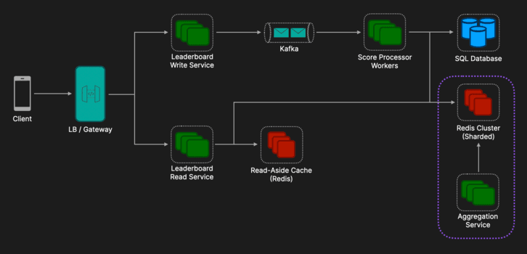
1. Fixed Windows (e.g., "October Leaderboard")
Concept: Time is segmented into static buckets.
Mechanism: Create a separate ZSET for every period (e.g., lb_oct_2026).
Lifecycle: When the period ends, the key becomes read-only.
Retrieval: O(1) access to a specific key.
2. Rolling Windows (e.g., "Last 7 Days")
Concept: A moving window where data expires daily. A single ZSET cannot efficiently handle this (removing old points is too expensive).
Mechanism (Partition & Merge):
Store Daily: Users write to granular daily ZSETs (lb_day_1, lb_day_2...).
Merge (ZUNIONSTORE): To get the weekly view, we mathematically sum the active daily lists.
Optimization (Aggregation Service):
Problem: Merging 7 lists on every read is too slow.
Solution: An Aggregation Service runs a Cron Job (e.g., every 60s). It performs the merge in the background and writes the result to a single cache key (lb_rolling_week).
Read: Users query the cache key for instant results.
Complete Architecture
Here is the detailed Complete Architecture for a scalable Leaderboard System. This design separates the Write Path (Ingestion) from the Read Path (Serving) to ensure that heavy write loads (e.g., end of a match) do not slow down users trying to view the leaderboard.
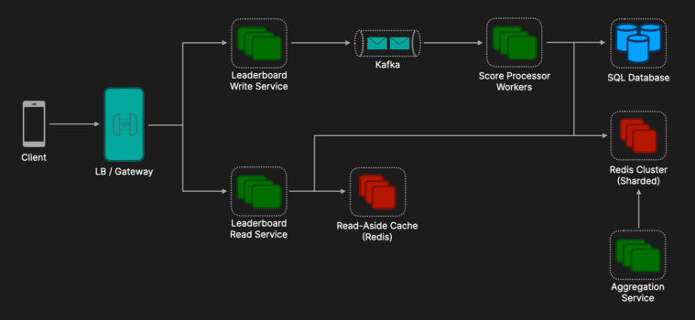
1. The Write Path (Ingestion)
How a score moves from the user's device to the database.
Client (Mobile/Web):
Sends a POST /score request.
Smart Logic: Implements retry logic with idempotency keys (unique IDs) to handle network failures without double-counting points.
Load Balancer / API Gateway:
Distributes traffic across service instances.
Handles SSL termination and Authentication (validating the user session).
Leaderboard Write Service:
Validation: Checks if the score is realistic (anti-cheat).
Local Buffer: Aggregates increments in memory (e.g., sums +10 and +5 into +15) for a few seconds.
Producer: Flushes the aggregated score to the Event Bus.
Event Bus (Kafka):
Purpose: Acts as a shock absorber. If 1 million users score simultaneously, Kafka holds the data so the database isn't overwhelmed.
Partitioning: Messages are partitioned by a has of the user_id to ensure strict ordering of updates for a single user.
Score Processor Workers:
Reads batch messages from Kafka.
Redis Writer: Executes ZINCRBY commands against the Redis Cluster.
SQL Writer: asynchronously updates the permanent Scores table in the SQL database for data durability (audit trail).
2. The Storage Layer (State)
Where the data actually lives.
Redis Cluster (The "Hot" Store):
Stores the ZSETS (Sorted Sets).
Sharding: Users are distributed across multiple Redis nodes using Hash Partitioning (based on user_id) to balance memory and CPU usage.
Persistence: Configured with AOF (Append Only File) to recover data if a node restarts.
SQL Database (The "Cold" Store):
Stores the "Source of Truth": User Profiles, Game Metadata, and a historical log of every score transaction.
Used for reconstructing the leaderboard if Redis completely fails (Disaster Recovery).
3. The Read Path (Serving)
How we get the data back to the user fast.
Leaderboard Read Service:
Scatter-Gather Logic: When a user asks for "Global Top 10":
The service queries all Redis shards for their local top 10.
It merges the results in memory.
It sorts them and returns the final global Top 10.
Direct Lookup: When a user asks for "My Rank", the service hashes the user_id, determines the correct shard, and queries that single Redis node directly.
Read-Aside Cache (Memcached/Redis):
Purpose: To protect the Redis Cluster from "Global Top 10" spam.
Logic: The result of the "Scatter-Gather" operation is cached for 1-5 seconds. 99% of "Get Top 10" requests hit this cache, not the main storage.
4. Historical & Analytics Path
Handling "Last Week" or "Last Month".
Aggregation Service (Background Cron Jobs):
Runs periodically (e.g., every 10 minutes).
Performs ZUNIONSTORE operations on daily ZSETS to create "Weekly" or "Monthly" views.
Writes these pre-calculated lists to a separate Redis instance or cache key (e.g., lb_weekly_cached_01_2026) for fast retrieval.
Summary of Data Flow
User scores 50 points.
Write Service buffers it -> pushes to Kafka.
Worker picks it up -> Updates Redis ZSET (memory) and SQL (disk).
Redis re-sorts the Skip List in O(log N) time.
Another User requests "Top 10".
Read Service checks Cache (miss) -> Scatters to Redis Shards -> Gathers results -> Returns JSON.
Additional Discussion Points
Tie-Breaking: If two users have the same score, who is ranked higher? Use time as a decimal offset. Score = TotalPoints + (1 / Timestamp). The user who achieved the score earlier gets a slightly higher floating-point value.
Global Rank Approximation: In a sharded system, finding the exact rank of a low-tier user (e.g., Rank 5,402,100) is expensive (requires counting all users in all shards above them). Use a probabilistic structure or cache the total counts of each shard periodically to estimate the global rank instantly.

Music Streaming Service (Spotify)
Editorial Solution
Quiz
AI Whiteboard
Overview
Introduction
Requirements
Data Model
API Design
High Level Design
Deep Dive 1: Multiple Bitrates & Data Synchronization
Deep Dive 2: ML Recommendation Pipeline
Deep Dive 3: Royalty Payments
Additional Discussion Points
Introduction
A music streaming service provides millions of users with on-demand access to a vast library of audio content.
Designing a robust music stream service goes beyond simple music playback. It also tackles tough technical challenges concerning availability, low latency (minimizing "Time to First Byte"), and supporting multiple bitrates for playback across varying network conditions.
Requirements
Functional Requirements
Artist Upload: Creators can upload high-res audio and manage metadata.
Audio Streaming: Users can play music with adaptive quality based on network.
Search: Sub-second fuzzy search across artists, albums, and tracks.
ML Recommendations: Recommend songs that users would like.
Royalty Payments: Accurate tracking of "valid" listens for payment disbursement.
Non Functional Requirements
Scalability: Support 500M+ DAU and 100M+ tracks.
Low Latency: < 200ms "Time to First Byte" for audio playback globally.
Availability: 99.99% for the playback path; 99.9% for the ingestion path.
Consistency: Strong consistency for royalty ledgers; Eventual consistency for social signals (likes/follows).
Data Model
For a system of this scale, a Polyglot Persistence strategy (using multiple types of databases simultaneously to handle different data needs) is required.
Relational (PostgreSQL): Serves as the system’s "Source of Truth" for structured metadata. ACID compliance is non-negotiable for financial-grade royalty calculations and relational indexing enables the complex joins required for large-scale playlist metadata management and artist-track relationships.
Object Storage (S3/GCS): Acts as the immutable storage layer for high-resolution audio assets. By storing audio segments as BLOBs, we decouple storage from compute, enabling massive horizontal scalability and seamless integration with CDNs for global edge delivery. Also used as a data lake for high-volume user activity logs (every play, skip, and like).
Elasticsearch: A distributed search and analytics engine that powers the "Discovery" experience. It utilizes inverted indices to provide sub-second fuzzy matching and prefix searching (autocomplete), ensuring high-quality results even with user typos or incomplete artist names.
NoSQL (DynamoDB): Provides a high-performance Key-Value store for Pre-computed Recommendations. It is used to store the "Candidate Sets" generated by Spark (e.g., user_id -> list_of_recommended_songs), offering single-digit millisecond retrieval when a user logs in.
API Design
For a music streaming service we will use a classic RESTful API to interact with the data. RESTful APIs are simple, widely used, stateless, and support caching which make it a good candidate for our system.
Ingest Track: POST /v1/ingest/upload (returns presigned S3 URL).
Search: GET /v1/search?q={query}&type=track (returns ranked results).
Get Stream: GET /v1/tracks/{id}/manifest (returns HLS manifest and signed URLs).
Heartbeat: POST /v1/me/play-event (telemetry for royalties).
High Level Design
At a high level, the system can be broken down into two core paths:
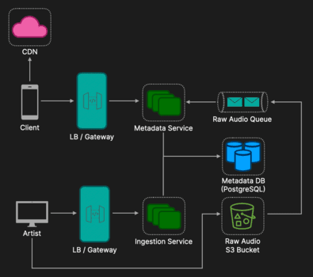
1. The Media Ingestion Path (Control Plane)
This path focuses on getting content from the creator to the storage layer.
API Gateway: Acts as the entry point for artists, handling identity verification, SSL termination, and routing requests to internal services.
Ingestion Service: Orchestrates the upload process by initializing track records in the database and generating presigned URLs for direct-to-S3 uploads.
Raw Audio S3 Bucket: Serves as the durable object store for high-resolution files. It is configured to emit Object Created events upon successful file finalization.
Raw Audio Queue (SQS): Decouples the storage layer from the metadata layer, holding ingestion events to ensure the system can handle bursts of uploads reliably.
Metadata Service: Consumes messages from the queue to finalize track status and ensure the Metadata DB reflects the most recent uploads.
Metadata DB (PostgreSQL): The relational "Source of Truth" that stores artist profiles, track information, and the current state (e.g., PENDING vs PUBLISHED) of every asset.
2. The Media Delivery Path (Data Plane)
This path focuses on how a consumer discovers a track and retrieves the audio data.
API Gateway: Manages consumer traffic, providing a unified interface for search and playback requests.
Metadata Service: Interfaces with the database to retrieve track manifests and location metadata for the requesting client.
Metadata DB (PostgreSQL): Supplies the structured data required to populate the user's interface and the URLs for the streaming manifest.
CDN (Content Delivery Network): A distributed network of edge servers that caches audio files from the Raw Audio S3 Bucket to serve them to users with minimal latency.
While this implementation technically facilitates playback, it contains significant architectural "anti-patterns" and missing features (e.g. efficient search, royalty payments, ML recommendations) that are preventing us from fulfilling both the functional and non-functional requirements.
Deep Dive 1: Multiple Bitrates & Data Synchronization
To meet the requirements for low latency and efficient search, the system needs to transition from a simple skeleton to a dynamic, event-driven pipeline.
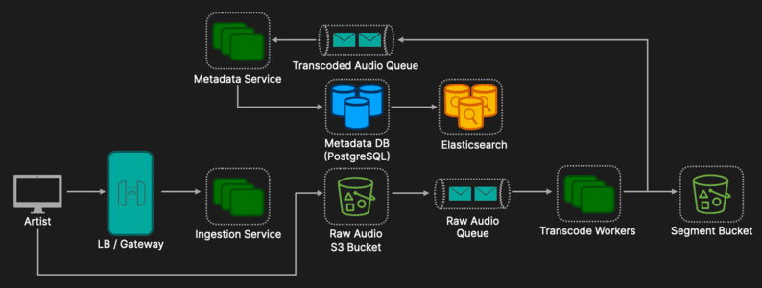
Adaptive Bitrate Streaming (ABR)
Serving raw high-resolution files (WAV/FLAC) is unsustainable for mobile networks. We implement an asynchronous transcoding pipeline to support Adaptive Bitrate Streaming:
Segmented Transcoding: Workers pull messages from the Raw Upload Queue and use FFmpeg to encode audio into 96kbps, 160kbps, and 320kbps bitrates which is then stored in the Segment S3 bucket.
Chunking: Audio is partitioned into 5-second segments (e.g., .m4s). This allows the client to "upshift" or "downshift" quality every 5 seconds based on network speed, preventing playback stalls.
Manifest Generation: Workers create a Master Manifest (HLS/DASH) that serves as a coordinate map for the client to retrieve specific segments.
Metadata Synchronization via Change Data Capture (CDC)
PostgreSQL is our "Source of Truth," but it lacks the sub-second fuzzy search capabilities of Elasticsearch. To keep them in sync without the risks of "Dual Writes" (where one write succeeds and the other fails), we use Change Data Capture (CDC):
Atomic Persistence: The Ingestion Service performs a single write to PostgreSQL.
Log-Based Extraction: Debezium monitors the Postgres Write-Ahead Log (WAL) to capture changes at the storage layer.
Event Streaming: Changes are streamed into Kafka as a durable, replayable log.
Downstream Indexing: An Elasticsearch Sink Connector consumes these events to update the search index.
Architectural Benefit: This ensures Eventual Consistency and high reliability. If Elasticsearch is down, Kafka retries the update, ensuring the search index never permanently drifts from the database.
Deep Dive 2: ML Recommendation Pipeline
The system utilizes a Lambda Architecture to merge historical data with real-time session behavior to generate personalized content.
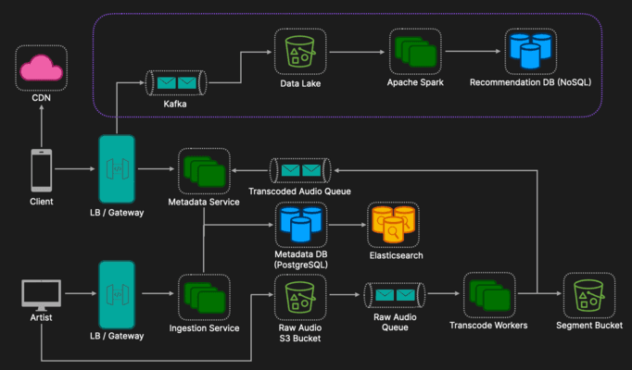
Client: User behaviors (likes, skips, plays) are sent via the API Gateway to Kafka.
Kafka: Acts as the central event bus, simultaneously streaming live interactions to real-time processors and a persistent archival sink.
S3 (Data Lake): Receives raw event dumps from Kafka, serving as the immutable historical record of all user activity for the system.
Apache Spark (Batch): Runs nightly jobs on the S3 Data Lake to perform Collaborative Filtering, identifying deep patterns across the entire user base to generate "Candidate Sets."
Recommendation DB (NoSQL): Stores the nightly Spark outputs (e.g., "Top 50 recommended songs for User X") for low-latency retrieval when the user logs in.
Deep Dive 3: Royalty Payments
To ensure financial integrity and legal compliance, this subsystem prioritizes Strong Consistency over availability.
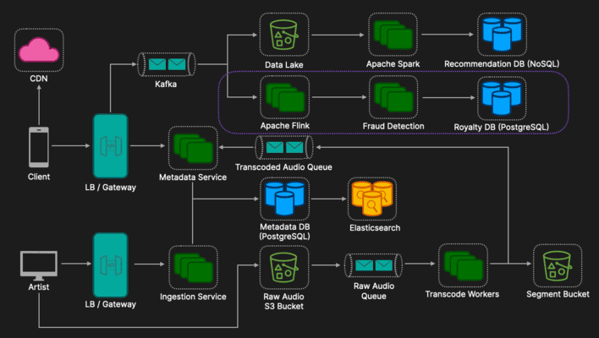
API Gateway: Receives client playback heartbeats (emitted every 30 seconds), validates user sessions, and handles request ingress.
Kafka: Acts as a durable message buffer; events are partitioned by a hash of the User ID to ensure chronological processing of a user's stream.
Apache Flink: Consumes from Kafka using exactly-once checkpointing to aggregate heartbeats into billable units without data loss or double-counting.
Fraud Detection Service: Integrates with the Flink pipeline to identify bot patterns (e.g., 24/7 loops) and diverts suspicious events to an audit log.
Royalty DB (SQL): Serves as the final financial ledger, using idempotency keys and ON CONFLICT clauses to prevent duplicate writes during retries.
Additional Discussion Points
Cost Optimization: Automatically moving "cold" (rarely played) songs to cheaper storage classes like S3 Glacier.
Gapless Playback: The client-side player pre-fetches the first few segments of the next song in the background to ensure zero silence between tracks.
DRM & Security (License Service): To protect intellectual property, audio segments on the CDN are encrypted. The client must hit a License Service to exchange a session token for a DRM decryption key. This service acts as the final gatekeeper for Geo-blocking, verifying if the user’s current IP/region aligns with the track's licensing rights before releasing the key.
The "Hot Key" Problem: High-profile releases (e.g., a viral new album) create extreme read hotspots. We mitigate this using PostgreSQL Read Replicas to scale metadata lookups and Redis Cluster with Key Salting. By appending a random suffix to hot keys (e.g., track_123:1, track_123:2), we spread the request load across multiple cache shards to prevent CPU bottlenecks on a single node.

8 Steps to Land Software Engineering Offers
Blog / 8 Steps to Land Software Engineering Offers
I just got software engineering offers from Amazon, Stripe & Palantir.For years I struggled to make it through interview rounds and was constantly getting rejected.Once I understood the hidden structure behind interviews, everything changed.I went from getting all rejections to offers from top tech companies.If you are actively applying for jobs or will be in the future these are the 7 steps I would follow to maximize the chances you get the offer for any company you apply to.

8 Steps to Land the Offer1. Resume OptimizationFirst, to maximize the probability of passing the Resume Screening, use the Resume Opimizer to ensure it includes all the key terms and skills that automated filters look for when deciding to which candidates to move forward to interview.2. Behavioural PracticeFor behavioral interviews, prepare answers to the 29 questions in the Behavioral Playbook. This will ensure you’re ready for anything an interview asks and will only take an hour or two and you can reuse them for every interview. Also don’t forget to use the Behavioural Course for STAR principle understanding and negotiation best practices.
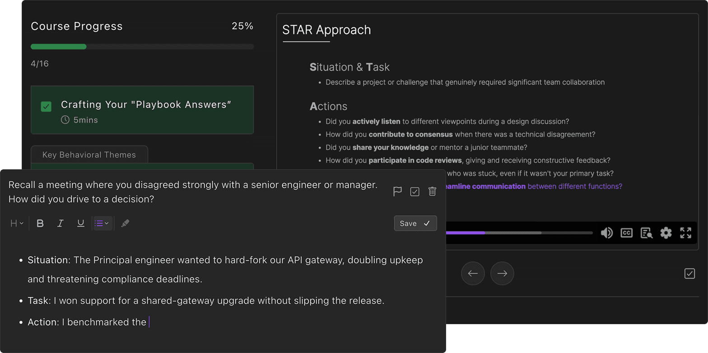
3. Data Structures & Algorithms StudyIf it’s your first time studying data structures and algorithms and you have plenty of time, practice the Blind 75 questions to build a solid understanding of the core DSA patterns.
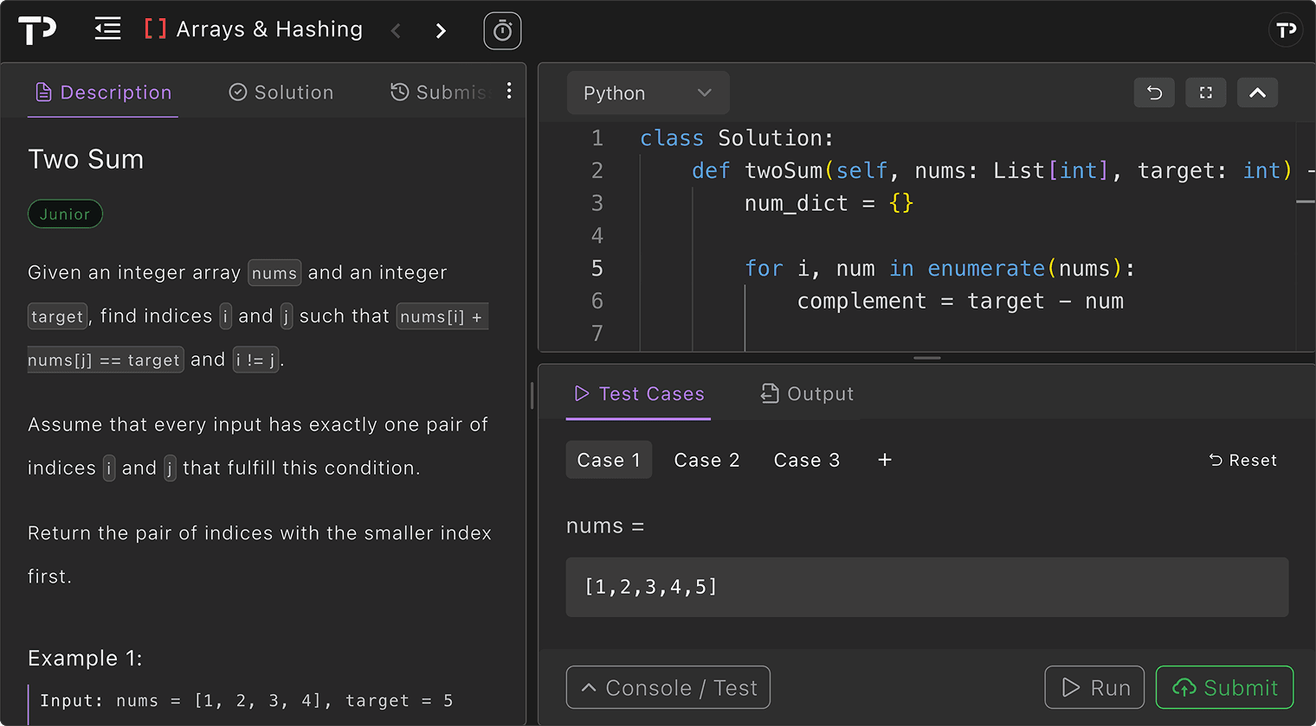
If you’re short for time or are already familiar with the fundamentals, skip straight to the TechPrep 100. These are the most commonly asked DSA questions by Big Tech and so it is the most time efficient way of studying for DSA interviews.4. System Design PrepSystem design interviews draw from a well defined list of questions, so study as many as you can from the list in TechPrep. For each watch the videos, study the editorial solution, and most importantly test yourself with the AI Whiteboard.
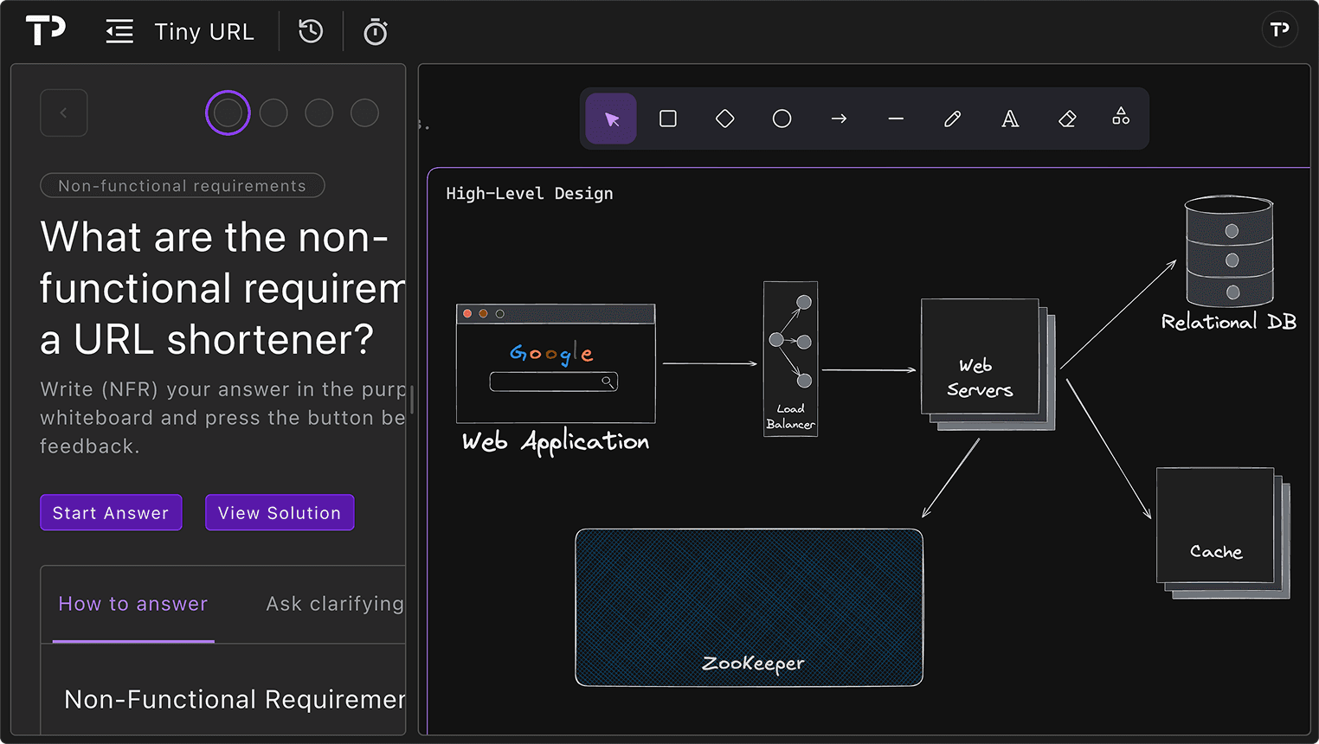
Practice drawing the system and describing it out loud. This closely mimics the real interview format and helps you get comfortable with both the tooling and the flow interviewers expect, which makes system design interviews so much easier.5. Low Level Design PracticeFor low-level design, work through as many examples from the TechPrep list as you can. After practicing, you will naturally become comfortable showing off the core skills interviewers are looking for, including:
Strong object-oriented design
Clean and maintainable code
Proper use of design patterns
6. Full Stack StudyFor full stack coding questions work through as many React frontend questions and REST API questions as you can. This will prepare you well for anything an interviewer may ask you.
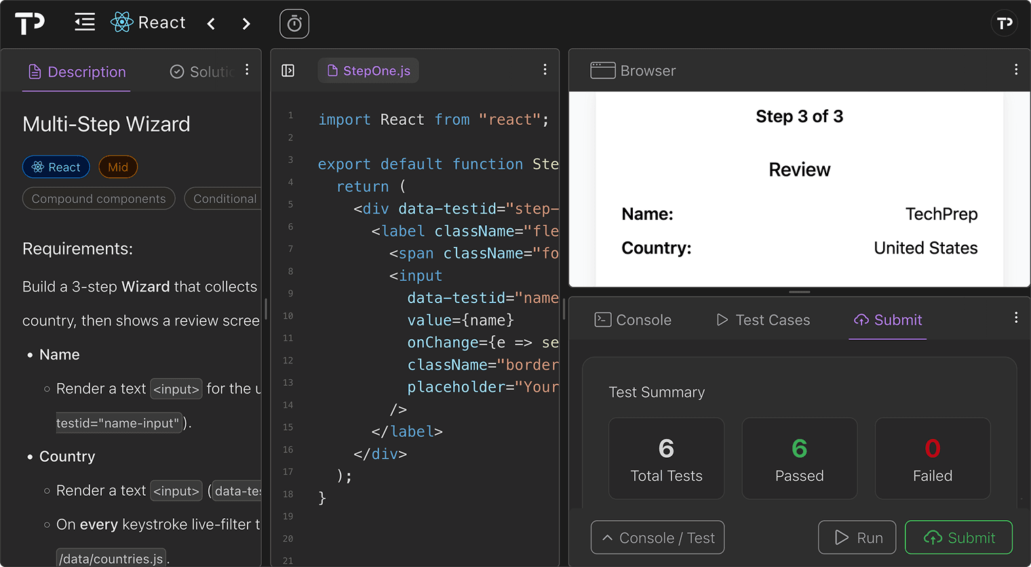
Because these questions have only recently become popular, most candidates don’t practice them, so even a small amount of preparation here can help you stand out from the competition.7. Take Home Project PracticeIf you’re applying to startups, it’s worth practicing these commonly asked take home projects so you can clearly demonstrate that you can contribute from day one. If you’re not targeting startups, you can safely skip this step.
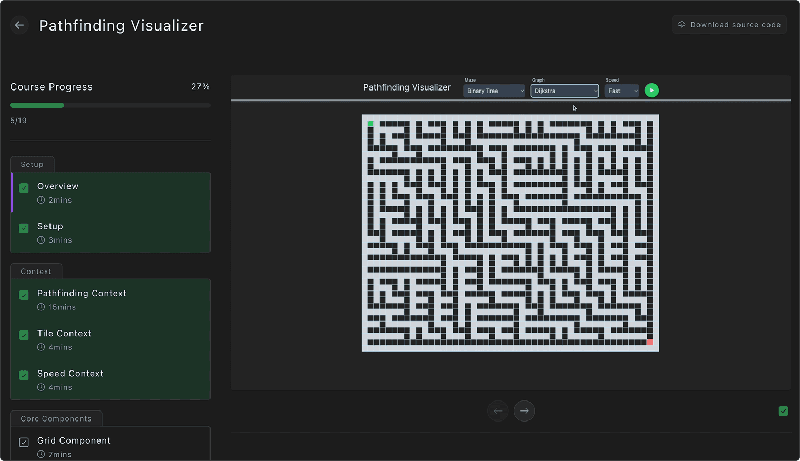
8. Company Specific PrepIf you know which companies you’re applying to, I highly recommend using the company-specific sections. They show the most commonly asked questions for each company, making it the most efficient and targeted way to prepare.9. BonusIf you want to see the exact set of questions I used to land offers from Amazon, Stripe, and Palantir, I highly recommend checking out the Elite Candidate Roadmap.
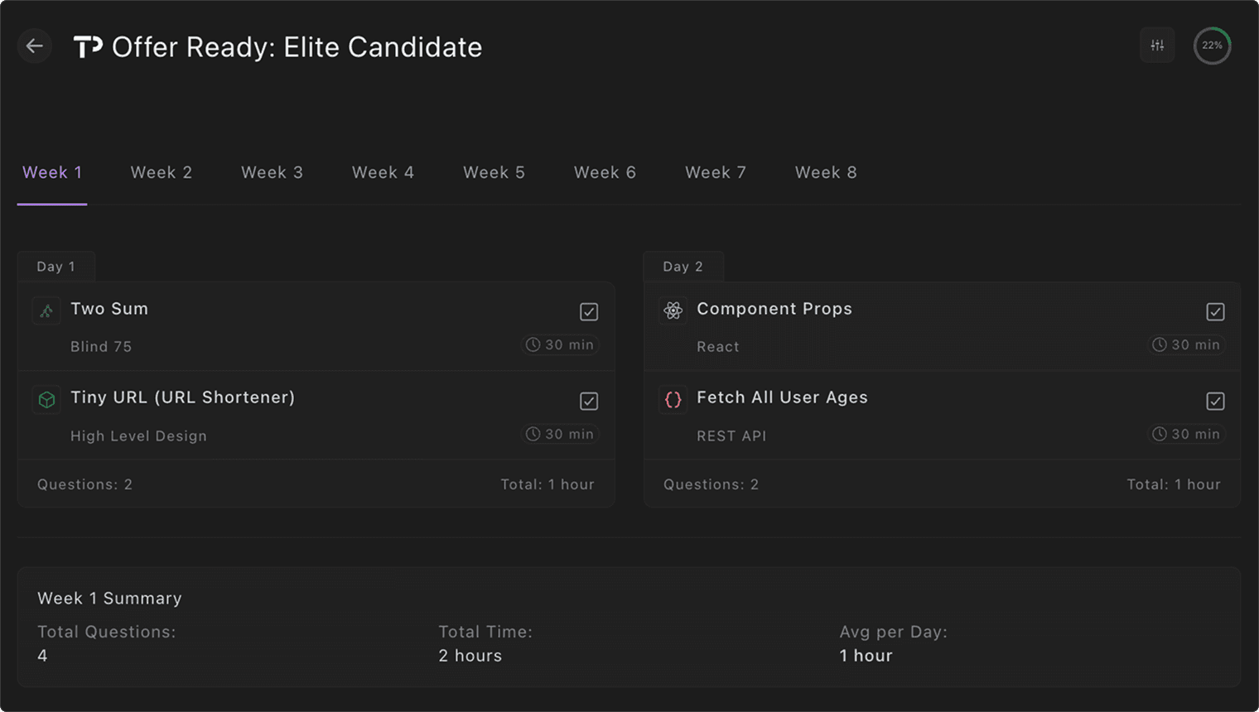
It lets you build a fully customized study plan, choosing your timeline, weekly schedule, daily hours, and the specific questions you want to cover, so you can fine-tune your prep and land offers from any company you’re applying to.

Low Level Design Coding Questions

Low Level Design
Flagged
Completed
0%

How to Pass Low Level Design Interviews in 2026

LRU Cache
Problem Statement · Editorial Solution

Parking Lot System
Problem Statement · Editorial Solution

Splitwise (Expense Sharing)
Problem Statement · Editorial Solution

Vending Machine
Problem Statement · Editorial Solution

Elevator System
Problem Statement · Editorial Solution

Restaurant Booking System
Problem Statement · Editorial Solution

Token Bucket
Problem Statement · Editorial Solution

Library Management System
Problem Statement · Editorial Solution

Locker Allocation System
Problem Statement · Editorial Solution

Access Management System
Problem Statement · Editorial Solution

Notepad System
Problem Statement · Editorial Solution

Account Balance Tracker
Problem Statement · Editorial Solution

Sliding Window
Problem Statement · Editorial Solution

Go Fish (Card Game)
Problem Statement · Editorial Solution

